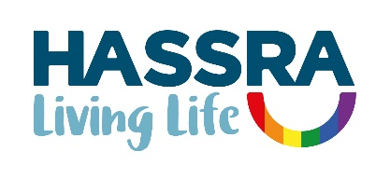

**Annual Report 2022**

|  |  |
| --- | --- |
| **Contents** | **Page** |
| Presidents | 3 |
| Glossary | 3 |
| Foreword | 4 |

1. Summary 5
2. National Programme 5-8
3. Building Membership 8-9
4. Supporting Clubs and Volunteers 9-11
5. Promoting Equality and Diversity 11
6. Building Sponsorship 11
7. Building our Business 12-13
8. Managing our Business 13-14

Appendices

1. National and Regional Management Committees 15
2. 2021/2022 National HASSRA Decision-Making Bodies 16
3. Awards Committee Report 17
4. Programme and Delivery Committee Report 18
5. Finance Committee Report 19
6. Diversity and Inclusion Committee 20
7. Membership Benefits 21-26
8. HASSRA Membership 27-30
9. HASSRA Live Visitations 31
10. Finance Transactions 32
11. Online Programme MI 33-34
12. Development Fund 35
13. Charity Fundraising 36

**President**

Peter Schofield CB, Permanent Secretary, Department for Work and Pensions

**First Vice President**

Sir Chris Wormald KCB, Permanent Secretary, Department of Health and Social Care

**Glossary**

AGM Annual General Meeting

BOM Board of Management

CMT Communications and Marketing Team

CSiS Civil Service Insurance Society

CSSC Civil Service Sports Council

DHSC Department of Health and Social Care

D&I Diversity and Inclusion

DWP Department for Work and Pensions

FC Finance Committee

PDC Programme and Delivery Committee

# Foreword

I am pleased to introduce the 2022 Annual Report. It is my second year as the HASSRA National Chairperson and so much has happened.

Recruitment of new members was our highest priority in 2022 and collectively we recruited more than 4,000 new members. Although membership dropped slightly by 3%, the team remain committed to the recruitment of members in 2023. We know there is still scope to recruit new members, so look out for new initiatives and please continue to take every opportunity to promote HASSRA. I will be playing my part by promoting HASSRA to Senior Civil Servants at Away Days, Executive Meetings and more.

Many of you will know that HASSRA had to take the difficult decision to cancel one of its flagship Festivals in September 2022 due to the passing of HRH the Queen. The decision was not an easy one to take but it was the right one under the circumstances. Thanks to all of you for your understanding. An additional Festival will be held in 2023 so that members do not miss out.

Equality and Diversity is one of my passions and I am delighted and fully endorse the work of the HASSRA Equality and Diversity Committee. HASSRA has always striven to provide an open and inclusive programme and this committee will help HASSRA ensure inclusion is considered in the design and delivery of everything it does.

Our online digital platform HASSRA Live grows from strength to strength as we now rely on it to provide a first-class service to members. Last year we introduced several new features which you can read about in this report. The report also contains a wealth of information about the year just gone and information on our policies and programme development in the years to come.

Please read this year’s report and share it with colleagues far and wide as it provides a powerful testament of the good that HASSRA does, and to support the reasons for joining and remaining a HASSRA member. Finally, I wish to thank you all for your hard work and commitment to the Association.

Dave Barrow

HASSRA National Chair

May 2023

# Summary

1.1 Formed in 1935, HASSRA has been providing sports and leisure opportunities to staff in

DWP and DHSC and associated agencies for 87 years. It is a national organisation of 58,000 members with income of £3.5m, and strong foundations in 352 local clubs (16 fewer than the previous year due to some club mergers) organised in 12 regions. Operating on this scale gives HASSRA a formidable delivery capability unrivalled amongst public sector staff associations. Our aim is to provide broad range of sports and leisure opportunities at work and at home which helps members achieve a happy and healthy work-life balance, and to be at their best at work.

1.2 In 2022 that included:

• benefits, discounts and offers worth **£5m**

• HASSRA Lottery paying out a guaranteed £756k plus a double money draw worth an extra £63k

* free draws and competitions worth £148k

• weekly prize puzzles and monthly on-line quizzes live on YouTube

• national and regional sports and fitness, arts and crafts and cultural activities

• a Development Fund to help members achieve their potential

• July Festival for 600 members (September Festival postponed until April 23)

• and much, much more totaling 247k member participations in 2022.

1.3 This report describes these activities in the period year ending 31st December 2022. It broadly follows the format of the 2022 HASSRA National Work Programme to help readers view outcomes against objectives.

# National Programme

# 2.1 Many will remember 2022 for the sad passing of Queen Elizabeth II. Our decision to postpone the September Festival till April 2023 as a mark of respect for the late Queen was widely supported. More generally, 2022 saw the continuing maturation of a broadly based balance of physical and virtual offers, which began in earnest during the Covid lockdown in 2020 and was facilitated by the ongoing roll-out of new functionality on HASSRA Live. Of particular note were some hybrid activities – a choir singing together via Teams, quizzes delivered via YouTube – which demonstrated the value of digital in facilitating very real human interaction where none was previously possible. It was also pleasing to see some very strong financial offers, such as the Summer Promotion, which helped members and their families to get out and about during the long summer vacation despite the cost-of-living crisis. Going forward, the challenge remains the same: to provide a broad and valuable offer, with something for everyone, and which is capable of sustaining high levels of recruitment and retention.

## National Conference and Awards Ceremony

2.2 The Annual Conference was held at Warwick University on Thursday, 12th May 2022. Sixty-five delegates, officers and observers attended the meeting. Three motions were submitted, and elections were held for BOM, FC and AC vacancies.

2.3 The Awards Dinner was held on 12th May 2022 at Warwick University. The winners from 2021 are listed below.

|  |  |
| --- | --- |
| **HASSRA Major Awards** | **Winners for 2021** |
| **The President’s Trophy**  for Best Association  **Highly Commended** | West Midlands  Yorkshire and the Humber |
| **Sir Philip Rogers Trophy**  for Best Large Club  **Highly Commended** | Doncaster/Thorne (YH)  Atlantic Quay (SC) |
| **Sir Michael Partridge Trophy**  for Best Small Club  **Highly Commended** | Great Yarmouth (EofE)  Wear (NE) |
| **Rachel Lomax Trophy**  For Best Volunteer  **Highly Commended** | Kevin Donegan (NW)  Paula Burman (EofE) |
| **Sir Leigh Lewis Trophy**  for Best Contributor | Rob Fawcett (EofE) |
| **Lesley Strathie Trophy** for Best Business Sponsor  **Highly Commended** | Ged Ross (EM)  Mark Lawrence (YH) |

**HASSRA Online Programme**

## *Let’s Get Moving- 12 Days of Christmas*

2.4 Over Christmas HASSRA members were encouraged to get out on their cycles or don their running or walking boots and do some level of activity over the 12 days of Christmas with a chance of winning a Love to Shop voucher. Over 50 members took part covering nearly 2000 kms.

## *National Art Competition*

## 2.5Following the recent success of the online format, the art competition was hosted on HASSRA Live during August and September. Once again, there was no shortage of talent and hard work, with over eighty entries in the categories of painting, drawing, and mixed media & 3D. Deserved winners shared £620 in prizes. All entries can be viewed in the Online Library on HASSRA Live and in HASSRA’s Flickr pages.

## *National Photography Competition*

2.6 This was another national competition usually staged at HASSRA Festivals but held virtually over the last two years. We again invited members to submit their photographic entries online during August and September. We received almost six hundred images of an exceptionally high standard in the categories of Landscapes, People & Animals and World in Motion. Deserved winners shared £960 in prizes. Every entry can be viewed on HASSRA’s Flickr pages and in the HASSRA Live Online Library.

## *Let’s Get Singing*

2.7 Over 620 members spent their Thursday lunch breaks joining the ‘Let’s Get Singing’ sessions via Teams. The hosts provided various themed songs in keeping with occurrences in everyday lives.  Members returned week after week to sing along and provide feedback on current and future song choices.  Feedback from members demonstrated the camaraderie and feel-good factor created by the sessions.

## *Monthly Quiz*

## 2.8 Hosted on the HASSRA YouTube channel by our partners at Redtooth, these fun and interactive monthly quizzes attracted 1,870 participations during 2022 and paid out over £7,000 in prizes to over 300 winners. This popular format will continue throughout 2023.

## *Weekly Puzzles*

## 2.9 HASSRA members continued to enjoy our weekly puzzles throughout 2022. Whether emojis, abstract pictures, word searches and other conundrums, there were 30,000 participations and over a thousand winners sharing more than £10,000 in prizes, making this one of our most popular offerings in 2022. Puzzles will continue through 2023.

## Christmas Cracker

## 2.10 The 2022 winter promotion was a hugely popular free prize draw for cash and electronics. With over 18,500 entries during October and November, two hundred lucky winners shared £50,000 worth of prizes.

## Fun ‘n’ Free Competitions

## 2.11 In addition to the foregoing, we ran 27 competitions which attracted a total of almost 190,000 entries. Three hundred and sixty-eight winners shared £38,000 in prizes, including several complimentary or discounted offers from commercial partners.

## Development Fund

2.12 During 2022 members received awards totaling £6,700 (including £1,755 funded by CSiS). This represented a decrease in value of awards of £2,660 (or 28%) over the previous year. A breakdown of awards by region can be found at appendix 11.

## Summer Promotion

2.13Our usual Summer Promotion offering heavily discounted theme park and attraction tickets ran from 1st June until 31st August. After the previous two summers when Covid-19 restrictions were operating, we were back to pre-pandemic ‘normal’, but with even more attractions using e-codes, providing a better service. In total we sold 22,000 tickets and delivered member savings of £336k. This was our second-highest volume of ticket sales and savings since the inception of the Summer Promotion in 2011.

**Lottery**

2.14 Our lottery scheme grew from strength to strength with 8,668 applications for new or increased tickets, an increase of 1,139 (+15%) over the previous year. This beat the record set in 2021 for the highest number of ticket applications in a calendar year. In October we held a Double Money draw where every winner received twice as much prize money as usual. This saw one lucky member scoop a life-changing top prize of £30,000.

*Details of all membership benefits can be found at Appendix 7.*

**HASSRA Festivals**

2.15 Approximately 600 members, volunteers and national team staff attended the July festival. Our event coincided with the hospitality sector still recovering from Covid-19, university catch-up graduations ceremonies and the campus transforming into an athlete’s village for the Commonwealth Games. Attendee feedback reflected a slip in the usual high standards of service and facilities previously enjoyed at Warwick. We subsequently raised our concerns with the university who apologised and offered a substantial refund.

2.16 The September festival was cancelled at the last minute due to the passing of HRH Queen Elizabeth II. The national staff team worked with regional team managers and volunteer organisers to quickly communicate the message to all festival attendees. Our close working relationship with the university enabled us to minimise cancellation charges. The rescheduled festival will be hosted in April 2023.

# Building Membership

3.1 HASSRA is an organisation which thrives on high levels of membership. In 2022 it recruited over 4,000 new members, which was an excellent result following the difficulties of the Covid years. However, in the same period DWP’s headcount reduced by over 7,700 or 8%, so it was no surprise that HASSRA’s membership also saw a net reduction of just over 1,800 or 3%. Currently the rate of HASSRA membership in DWP stands at 59%, two percentage points higher than in 2021. But in the past, pre-Covid, it has been as high as 68%, so there remains huge scope to recruit more deeply in DWP and other qualifying employers. As ever, retention remains as important as recruitment, especially when members may be leaving DWP’s employment through retirement or resignations. The key to staying big remains close coordination of local, regional and national activities, and a valuable programme of offers and activities that existing and potential members want.

**Spring Forward Campaign**

3.2 We ran two successful cash giveaways in 2022 with two hundred members sharing a total prize fund of £50,000. The spring draw saw over 16,000 entries and the summer draw was slightly more popular with almost 17,000 participations. In addition to the foregoing, the National Team undertook a widescale replenishment of updated marketing materials, including posters and membership benefit leaflets, which were sent to all 350 clubs around the country to help increase recruitment and retention.

**Livelife Challenge**

## 3.3 HASSRA and the Charity for Civil Servants (CFCS) worked together to deliver the Livelife Challenge in 2022. CFCS developed a new website that allowed members to sign up and record their activity virtually. The theme was “Around the World in 180 Days.” Registration was on an individual or group basis and permitted running, walking, cycling, dance and even housework and gardening to travel virtually to different countries and continents. Members were also invited to raise money for the charity. Nearly 200 HASSRA members took part with over 50,000 miles covered and more than £2,000 being raised along the way in support of The Charity for Civil Servants. Prizes totalling £670 were awarded to clubs and members who travelled furthest, raised the most money and undertook the Challenge in the most diverse ways.

**Buddy Draw**

3.4 There was a final £10,000 Buddy Draw which saw 200 lucky new members win £50 each after a draw was undertaken following the 31st March deadline. Existing members who between them recruited 200 new members were also rewarded with £50 each.

**HASSRA Video**

3.5 The HASSRA promotional video which provides an engaging overview of HASSRA’s programme was updated to reflect changes in the offer and continues to be used on HASSRA Live and YouTube, and by the Association’s volunteer network, to increase recruitment and retention.

*Details of membership figures are shown at Appendix 8.*

# Supporting Clubs and Volunteers

4.1 HASSRA is nothing without its dedicated and resourceful cadre of volunteers at club, regional and national levels. As always, we are grateful for their wonderful work throughout the year. Our commitment to them was to continue to develop the tools and support they need to perform their roles professionally and safely; because when our clubs and volunteers are at their best, HASSRA is at its best too. Our commitment going forward is to go on listening and acting on what they tell us they need.

## Volunteer Toolkit

4.2 The revamp of the Volunteer section of HASSRA Live will eventually provide a more engaging experience for volunteers. The aim is to make it easier to navigate and quickly find the resources required to effectively carry out their roles.

4.3 The new Volunteer section has already been designed and will feature Tiles – similar to the Offers page - including:

• a new “How To” guide showing how to complete volunteer tasks

• a Year in the Life of a Region, listing the tasks a region will complete in a calendar year, with links to the “How To” guide

• a Year in the Life of a Club, listing the tasks a club will complete in a calendar year, with links to the “How To” guide

• volunteer roles, including key responsibilities

• National Constitution and model constitutions for regions and clubs.

The revamp is progressing well and will continue in 2023. Once completed, the new Volunteer section will be published on HASSRA Live.

## Quarterly MI Reports

## 4.4 Comprehensive reports, providing intelligence on finance, membership, recruitment, lottery, online shop and membership benefits were issued to regions at each quarter-end throughout 2022 to support evidence-based decision-making throughout the Association.

## Chairs Meeting 2022

4.5 The eighth annual joint meeting of the National Board and regional chairs was held in February at Warwick University. Attendees reviewed the Spring Relaunch package in syndicates. New HASSRA Live functionality was demonstrated, including mega menus and offers page, chairs certificates and submitting accounts. Future system developments were also discussed, including bingo and raffles.

**HASSRA Live Club Support**

4.6 When new functionality is rolled out for regions and clubs, such as the uploading of chair’s certificate and club year end accounts to HASSRA Live, ‘how to’ videos have been produced which are also available on YouTube. With many of the improvements we have made to HASSRA Live over the year we have been working closely with regions to make their pages in the ‘tile’ design following on from the redesign of HASSRA Live. We have also highlighted to the regions about using copyright images and suggested where images can be obtained at no cost and avoiding copyright breaches.

4.7 We have investigated the possibility of running a HASSRA Live native app. The cost to develop an app would exceed £60k and would also require another operating system outside of HASSRA Live. This will be a major piece of work and will need further investigation.

4.8 For 2023 we have several new developments planned, such as message boards allowing members to post comments about HASSRA related topics, new online raffle and bingo, fully automated membership process, improved HASSRA Live search process, a new payment functionality allowing members to pay for events direct into regions bank accounts, new merchandise pages allowing members to buy HASSRA branded clothing. Following on from the informal consultation from regions on improvements to HASSRA Live we will create a steering group. We see this as key development to enhance and improve HASSRA Live.

**Charity Collections**

4.9 During the year, members and clubs found many ways to support their favourite charities and collected a fantastic total of more than £96k. As in previous years, this figure is likely to under-report the actual sum because not all clubs submit returns. We will continue to find ways of ensuring all charitable donations are recorded.

*Details of charity figures are shown at Appendix 13.*

## 5. Promoting Equality and Diversity

5.1 HASSRA has always prided itself on being an open and welcoming association that values every one of its members. It has also sought to provide an offer of broadest appeal, with something for everyone. In 2021 the National Board put in place measures to ensure these values were enshrined in everything HASSRA does, from design to delivery. HASSRA now has a Diversity and Inclusion Statement, a diversity champion on the National Board. This year a Diversity and Inclusion Committee has been set up to provide advice and drive policy development going forward.

## 6. Building Sponsorship

6.1 HASSRA remains committed to supporting members’ wellbeing and to encouraging positive engagement in the workplace. The broadly based programme of offers and activities provides a powerful vehicle for pursuing these objectives and underlines HASSRA’s commitment to sponsor departments. In 2022 we continued to work collaboratively at all levels to deliver these shared objectives.

## Departmental Sponsorship

6.2 Dave Barrow has championed HASSRA with Senior Managers at Departmental Away Days and at other DWP Senior Leaders Meetings. His Business Support Office has followed this up by sending HASSRA merchandise to those managers.

**Financial Sponsorship**

6.3 The CSiS Charity Fund, who provide funding for disabled/disadvantaged members in our Development Fund, generously awarded us a grant of £2,000 for the year. This was despite a drastic reduction in their grant-giving programme resulting from the Covid-19 pandemic. This was a special award because we declined a grant the previous year. We are very grateful to the CSiS Charity Fund for their long-standing commitment to HASSRA.

# 7. Building our Business

7.1 National HASSRA has transformed into an efficient and professional business so that the Association can remain a people-focused club. HASSRA Live is now the hub of business delivery as well as member engagement. In 2022 we continued to augment functionality to improve support for volunteers and delivery channels for members. As before, we urge everyone – members and volunteers – to embrace this technology to maximize the value of their HASSRA experience.

## HASSRA Live

7.2 HASSRA Live continues to provide a vibrant and exciting platform for HASSRA members. The National Team deliver most of the member services and back of office functions using HASSRA Live. A major piece of work was conducted where all payroll schedules are managed and processed on HASSRA Live by the National Team. Running alongside HASSRA Live, a new helpdesk was introduced allowing members to raise queries where a team member will respond back answering the members question.

7.3 Over 450,000 unique visits to HASSRA Live in 2022, compared to 400,000 in 2021. HASSRA members have viewed 8.5 million pages an increase of half million from the previous year. As members become more familiar with HASSRA Live we have noticed a reduction in chat enquires for the year to 7,473 compared to 9,453 in 2022. The automated knowledge base was able to respond to many of the members questions but over 3,000 enquiries were managed by the National Team with most of these enquiries being requests to change a work location or password resets.

7.4 The National Team have continued to develop new functionality. Some of these new functions include a map function allowing members to search for HASSRA benefits no matter where they are in the country using Google search.

## *See appendix 9 for visitation statistics.*

## Communications

## 7.5 Working closely with internal and external partners, the Communications and Marketing Team (CMT) has continued to deliver timely communications to keep members informed about the national programme and latest news stories and special offers.

**Social Media Channels**

7.6 HASSRA’s social media pages continue to play an increasingly important role in promoting membership benefits. By the end of 2022 we had nearly 8,000 Facebook and nearly 900 Twitter followers. Instagram was introduced to support other social media channels and has continued to grow throughout 2022.

7.7 Flickr was once again pivotal in the judging of the National Art and Photography competitions. National HASSRA continues to collaborate with regions by hosting many of their competitions on our Flickr pages.

7.8 The HASSRA YouTube channel has been utilised to host regular Smart Quizzes and the Let’s Get Physical fitness sessions, and as a platform for the newly produced HASSRA video to promote our offer.

**Programme Review**

7.9 The Covid Lockdown resulted in the suspension of key traditional elements of the national programme and the introduction of a range of alternative activities and offers delivered digitally via HASSRA Live. These new digital elements were immensely popular and delivered a substantial up-turn in participation, so last year we undertook a comprehensive review of the national programme to determine an appropriate balance of traditional and digital activities and offers going forward.

7.10 The review took a high-level look at all programme categories, and evaluated them by member participation, demographics, cost, affordability, impact on recruitment and retention and fit with Association’s aims and objectives. The outcome was a series of recommendations to maintain traditional activities while growing the digital offer and increasing income from non-subscription sources such as the Lottery.

## 8. Managing our Business

## HASSRA National Accounts

8.1 The Association’s auditors *Dafferns* conducted an audit of the financial statements of the HASSRA National Revenue and Lottery accounts for 2022. The results are as follows:

* the national revenue account had an excess of expenditure over income of £104k
* the national lottery account had an excess of income over expenditure of £351k

8.2 As is usual, the excess income from the lottery was used to offset expenditure from the revenue accounts. This left an excess of income over expenditure of £247k resulting in a commensurate increase in national reserves, which now stand at £1.541m. This was mainly caused by the underspend resulting from the cancellation of the September 2022 Festival and will be used to fund the ad hoc Easter Festival in 2023.

## Regional Finances

8.3 At 31st December 2022, aggregate funds held by regions stood at £1.625m, a reduction of £49k or 3% over the previous year. Regions made a collective contribution of £100k towards funding the National Spring Forward campaign.

## Investment Accounts

8.4 Income from National and Regional investments remained low at the start of 2022, then increased month-on-month in line with prevailing interest rates. Investments are reviewed regularly to maximise returns.

**CSSC Grant**

8.5 The CSSC Departmental Association Grant for 2022 was £74,500, an increase of £22,500 from the previous year when CSSC’s normal programme of events was curtailed by the Covid-19 pandemic, but a 28% reduction over the pre-Covid levels of grant.

## Ticket Sales

8.6 More of our regular theme parks and attractions re-opened after Covid restrictions and replaced paper tickets with digital tickets, allowing members to purchase and redeem e-codes on demand. In total our online shop fulfilled over 9,000 orders for 26,000 theme park and attraction tickets worth £600k, saving on average 46% off normal admission prices.

8.7 Sales of cinema e-codes during 2022 were once again administered by our partners at The Cinema Society. Over the year, 9,000 HASSRA members registered with The Cinema Society website bringing the total number of registered HASSRA members to 25,000. In total, HASSRA members made 36,000 transactions for 100,000 e-codes worth £575k – a 69% increase from 2021 – and members saved on average 43% against normal cinema admission prices.

## HASSRA National Team

## May 2023

**Appendix 1: National and Regional Management Committees**

The organisation charts below show HASSRA’s National and Regional Committees and the names of their Chairs. Members of these decision-making bodies are at Appendix 2.

## National

**Regional**

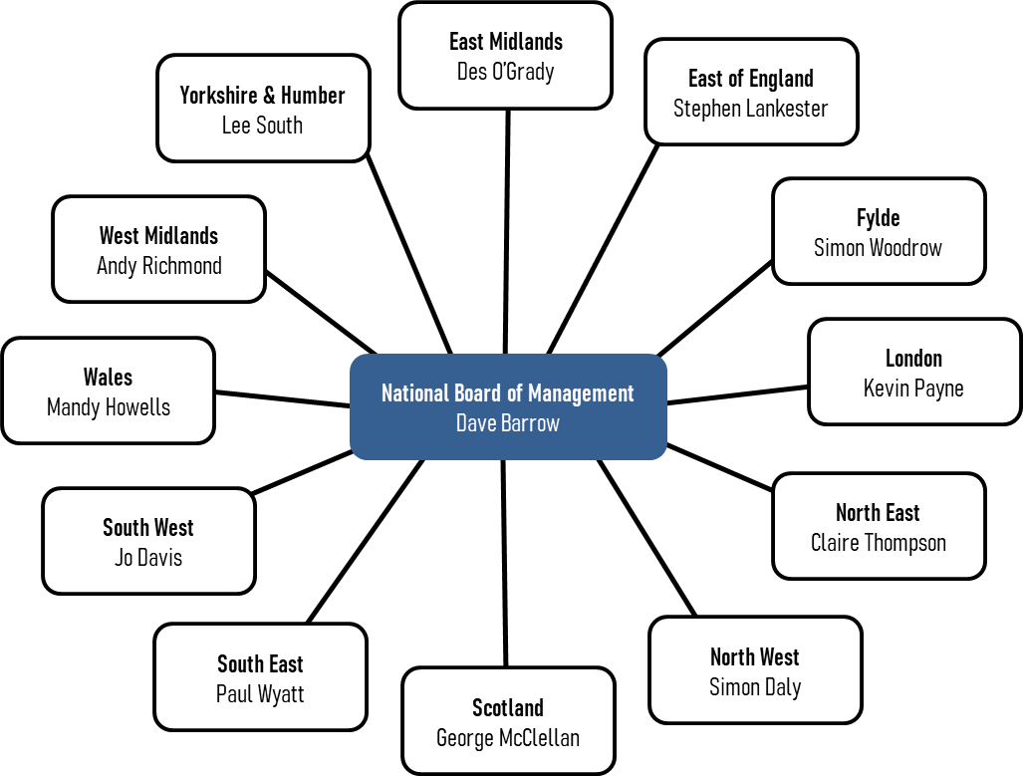

**Appendix 2: 2022/2023 National HASSRA Decision Making Bodies**

## National Officers Subject to Election

Chair Dave Barrow n/a

Operations Director Craig Lewis n/a

Finance Director Harvey Clarke n/a

## Board of Management

Chair Dave Barrow n/a

Operations Director Craig Lewis n/a

Finance Director Harvey Clarke n/a

Elected Member Nigel Thomas May 2023

Elected Member Justine Brown May 2024

Elected Member Sean Mulgrew May 2025

Elected Member Nicki Stowe May 2025 Co-opted Member Gary Thorogood

Secretariat Jenny Richardson

## Finance Committee

Chair Harvey Clarke n/a

Elected Member Di Grossey May 2023

Elected Member Helena Whitehead May 2025

Elected Member Willie Hunter May 2024

Elected Member Martin Gale May 2024

Elected Member Jay Saleem May 2023

Vacancy May 2025

Co-opted Member Sarah Fairclough

Co-opted Member Dave Lees

## Awards Committee

Elected Member (Chair) Ann Nash May 2023

Elected Member Irena Gorbun May 2024

Elected Member Tina Street May 2025

## Programme and Delivery Committee

Chair Jenny Richardson n/a

Elected Member Simon Jowitt May 2024

Elected Member Della Tucker May 2024

National Team Ann Cook

National Team Kerry Cunningham

National Team Jackie Hogarth

National Team Claire Metcalfe

## Diversity and Inclusion Committee

Chair Gary Thorogood n/a

Co-opted Member Steve Waters

Co-opted Member Karen Sinden

Co-opted Member Scott Porter

Co-opted Member Marie McCormick

Co-opted Member Nikki Densham

# Appendix 3: Report from Awards Committee

# In 2022, 43 Development Fund applications were received resulting in 27 awards being made to help towards HASSRA members development. A total of £6635 was awarded of which £1,755 was appropriate to the CSiS Charity Fund (kindly provided for applicants who have a disability or disadvantaged). This compares to 54 applications and 36 awards made in 2021.

# The review of the Development Fund was conducted by the AC from May 2022 and included George Robinson to ensure the AC used his vast experience. The AC were most concerned about many applications not meeting the Development Fund criteria. The first two areas that were reviewed were the award letter templates ensuring references to HASSRA Live, and applicants were advised to keep receipts. The other area was obtaining an agreement with the national team that they would undertake audits to ensure the award money was being spent against the specific reason(s) given for the award decisions.

# The AC then moved on to individually review the application form and publicity information making suggestions and amendments as it was clear to the AC that many applicants were not reading the criteria, or the application guidance notes. The AC proposed a revised application form, publicity information and guidance notes.

# In May the AC conducted a review of the HASSRA Annual Awards due to concerns about the falling number and quality of submissions. This year we will be looking to address the findings in consultation with Regional Chairs, the National BOM and the national team.

# I would personally like to thank Irena, Tina and George for their considerable contribution to two major AC reviews and for ensuring fair and consistent decisions were made throughout 2022 based on the set criteria. The AC is fully committed to recognising HASSRA volunteers who willingly give their own time, support, and share their experience to go the extra mile for other members.

## Ann Nash

## Committee Chair

**Appendix 4: Report from Programme and Delivery Committee**

The Programme and Delivery committee met in October to review the 2022 July and September festivals. The meeting also looked at the proposed events for the April, July and September festivals for 2023.

The committee discussed feedback from the July festival. A significant number of disappointing responses focused on areas out of HASSRA’s control, such as a drop in university service levels, cleanliness, and campus overcrowding. A combination of the hospitality sector recovering from Covid, and the campus being used as a Commonwealth Games athlete’s village were identified as reasons. The University apologised for the drop in standards and HASSRA received a significant refund as a result.

The September festival was cancelled at the last minute due to the passing of HRH Queen Elizabeth II. This festival was re-arranged for April albeit on a smaller scale but still provides the opportunity for as many National HASSRA championships and taster events to be re-staged as possible.

In proposing the programme of festival events for 2023, feedback was reviewed alongside participation figures. The availability of volunteer organisers and suitable venues were also assessed. The postponement of the September festival until April 2023 was discussed. The PDC agreed the festival line-up for April, July, and September festivals.

The PRT look forward to planning and hosting the April, July and September Festivals in 2023 and delivering a varied and exciting programme of events for our membership.

## Jen Richardson

## Committee Chair

**Appendix 5: Report from Finance Committee**

The Finance Committee met twice during the year. At our first meeting in May we undertook a review of the lottery to establish the potential affordability for a one-off Double-Money draw later in the year. We looked at various income forecasts to predict how lottery ticket sales – and income - might increase with the promotion of a bumper draw. We concluded that with sustained marketing, the extra number of tickets purchased would be sufficient to yield the extra £63,000 required to fund the draw. This was endorsed by the National Board and the Double-Money draw was held in October, funded wholly from the predicted rise in lottery ticket sales.

At our second meeting in October we undertook regular key tasks, such as reviewing the cinema ticket subsidy, annual budget and subscription rate. Deciding the subscription rate is always a question of balancing affordability for members while delivering a programme which continues to be valuable and supports recruitment and retention. As we go through the biggest cost-of-living crisis in living memory, affordability has never been more important for members, so the committee recommended freezing the subscription rate while maximising lottery funds to support the wider programme. This recommendation was endorsed by the National Board.

The committee also undertook a review of the Association’s travel and subsistence policies and recommended increases to mileage and subsistence rates and the adoption of a new formal policy on travel to festivals. These were endorsed by the National Board and came into effect from November 2022.

The FC continues to play an important role in financial planning within the Association. I wish to record my thanks to all the committee members for their contributions.

## Harvey Clarke

## Committee Chair

**Appendix 6: Report from Diversity and Inclusion Committee**

The People Vision embedded within the Departmental strategy is for DWP to become a truly flexible, inclusive and continuously learning organisation, ensuring that this really is a great place to work whilst fulfilling our mission to improve people’s quality of life.

As an employee association our Vision for our own members should naturally align with the Department’s wider People Strategy. It makes both business and moral sense that we want and need HASSRA to be a wholly inclusive organisation and one where the demographic of its members is representative of the wider workforce and therefore the customers and communities we serve.

By inclusive, we mean where members, have a voice and are listened to, where they feel they belong, are treated fairly and with respect and where they can be their authentic selves. Our DWP Values will be visible in the way we work and play together enabling everyone in HASSRA to feel trust in their colleagues, and safe and supported in every sense, in order to thrive.

We have now set up a Diversity and Inclusion Sub Committee of the National Board of Management to:

* Regularly report on the demographic make-up of HASSRA membership
* Develop proposals to widen the diversity of national and regional board membership, and in so doing, bring in different voices, insights and lived experience to the way we do things and how we make our decisions
* Continually review our national offer (events, activities etc) to members to ensure they are as inclusive as they possibly can be
* Undertake regular insight gathering exercises (surveys, listening circles etc) to ensure we continue to meet the needs of our diverse membership
* Advise the National Board on the operational impact of departmental and Civil Service policy changes that may impact on Diversity and Inclusion

Part of our work is to better understand the current demographic of our membership and gain wider insight on the inclusivity of our offer by collecting member experiences and feedback and will do that through the Spring survey and through other approaches throughout the year.

Later this year we also want to look at the language, rules and conventions around sporting and other competition events to ensure they are as inclusive as possible as well as reviewing membership of the various Boards of Management across HASSRA to better understand diversity representation.

Once we have done that, we will consider what we need to do to ensure the management of the Association and the delivery of programmes are inclusive of all members and take account of their diverse needs and preferences.

**Gary Thorogood**

**Committee Chair**

# Appendix 7: Membership Benefits



















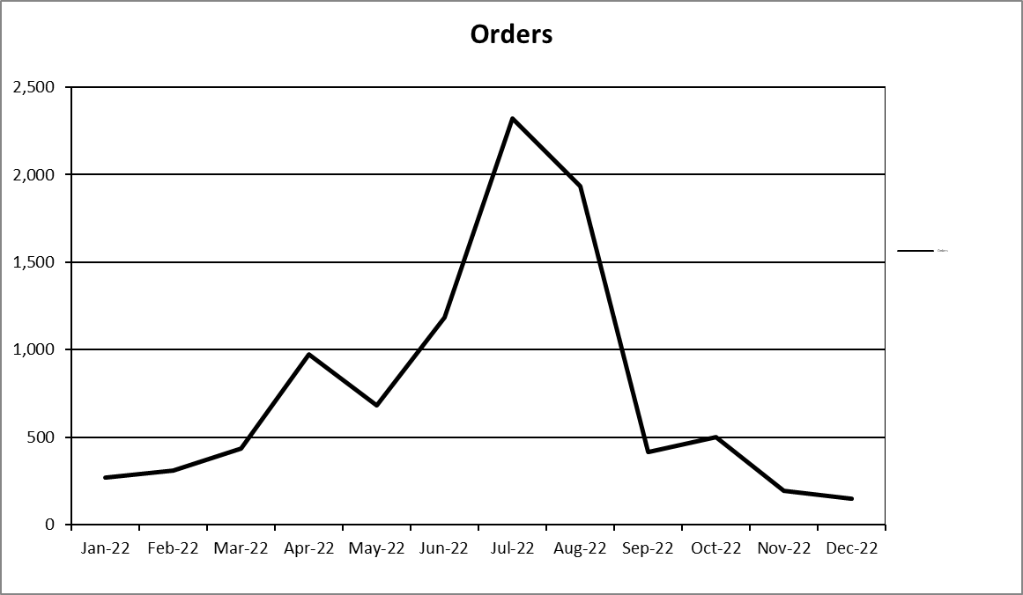

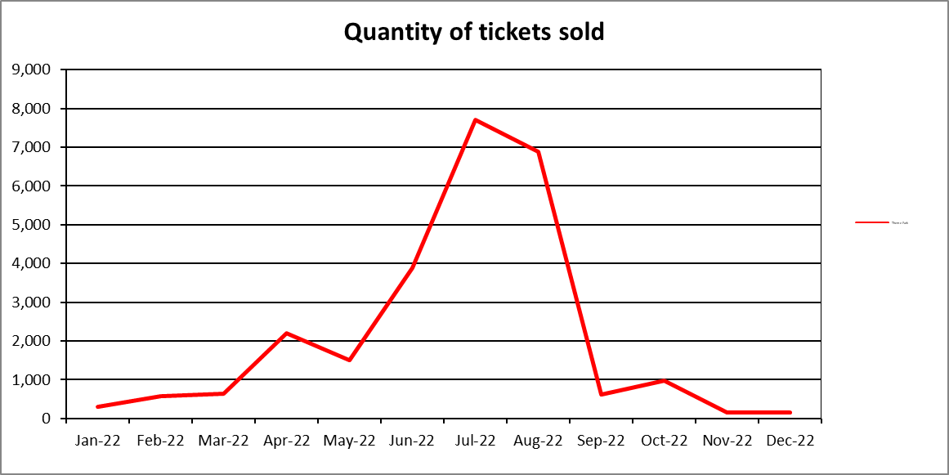

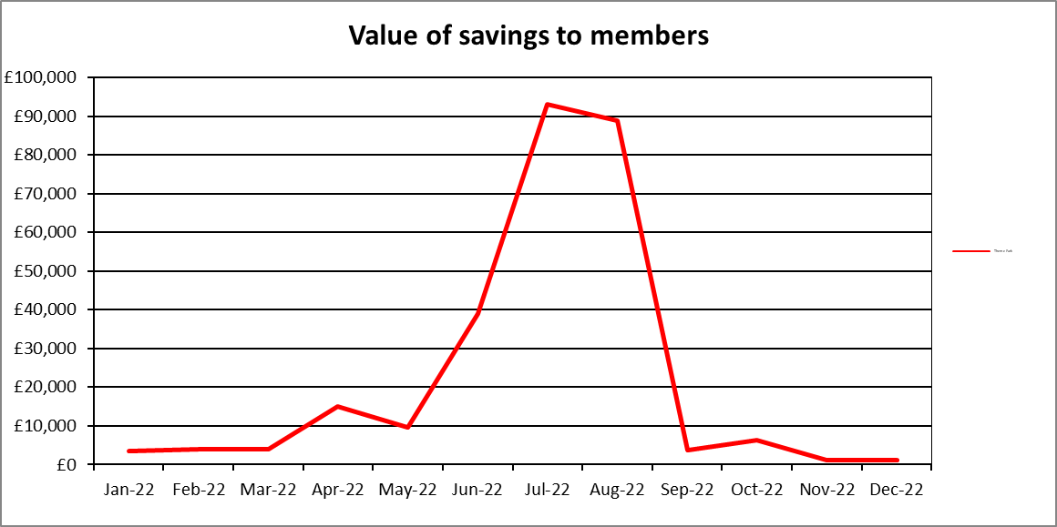



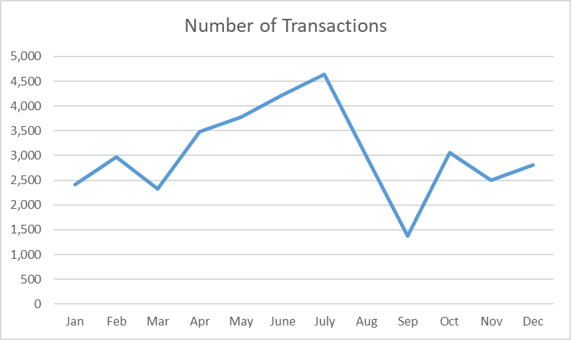

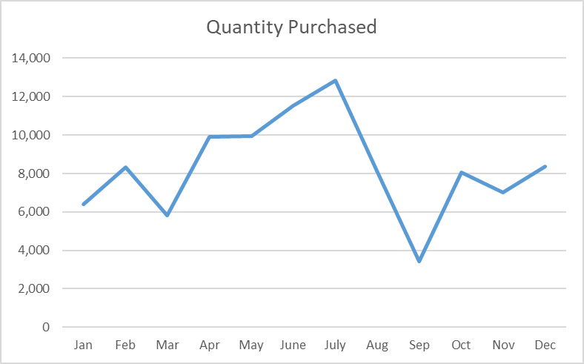

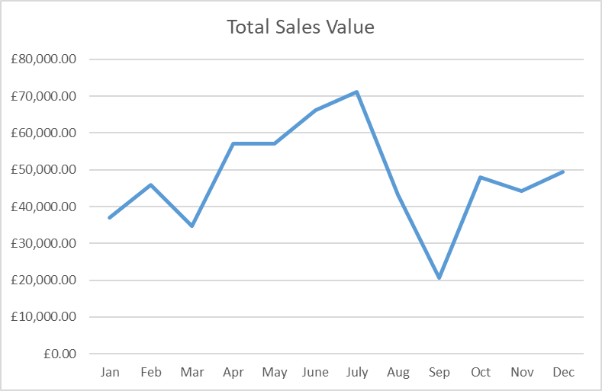

**Appendix 8: HASSRA Membership**



Membership breakdown at December 2022









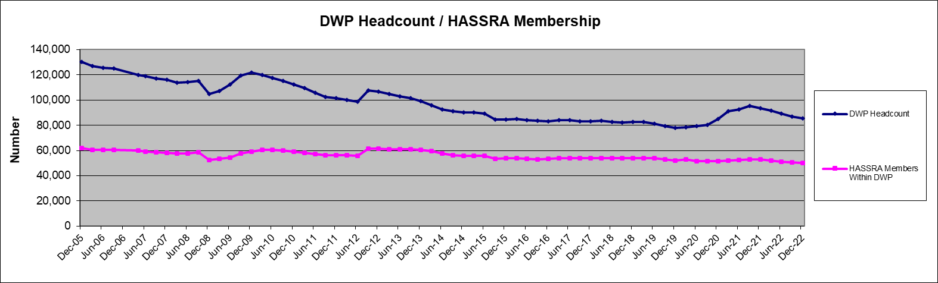

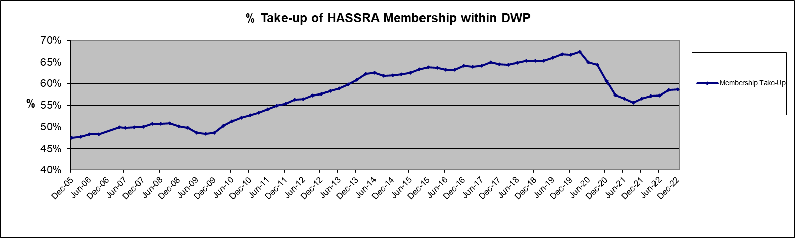

**Appendix 9: HASSRA Live Visitation**



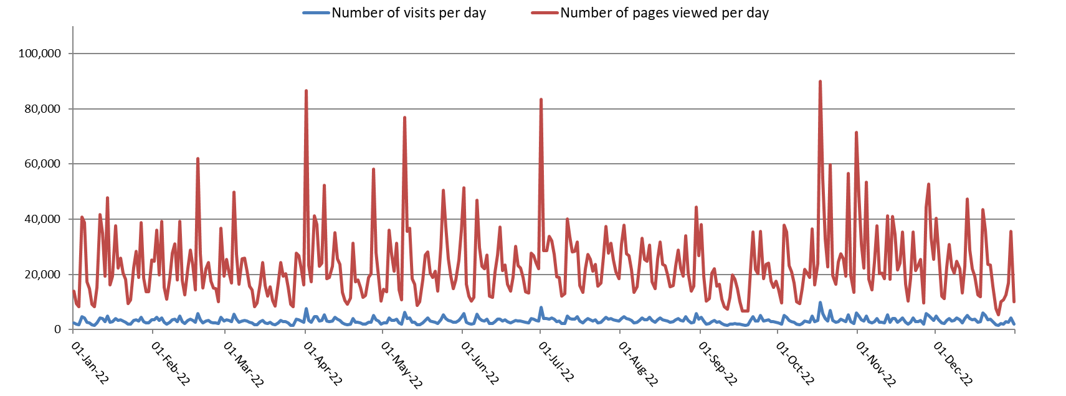

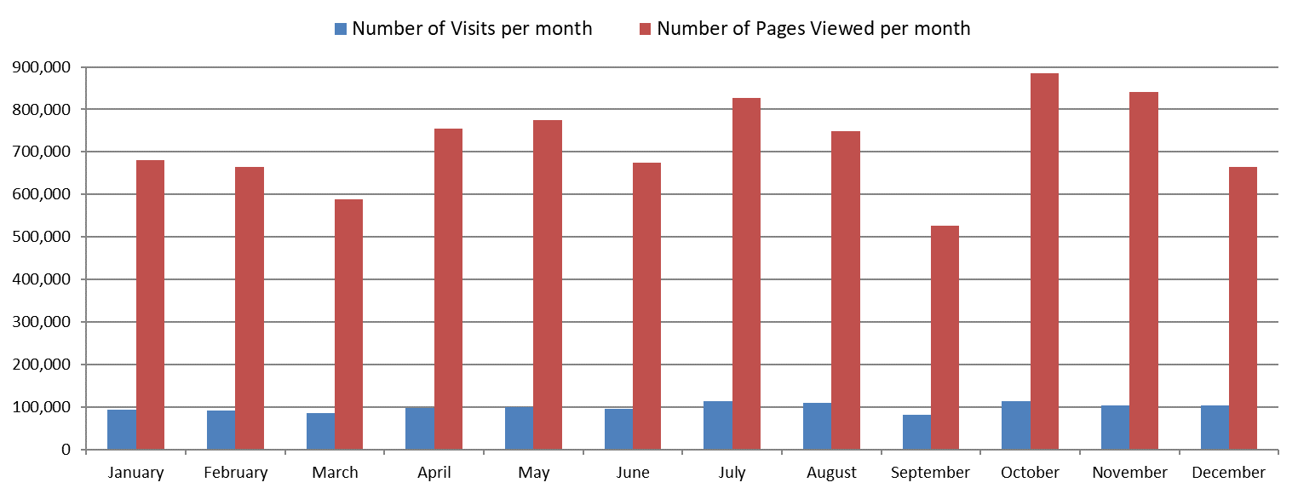

**Appendix 10: 2022 Finance Transactions**



# 

**Appendix 11: Online Programme**





**Appendix 12: Development Fund**





**Appendix 13: Charity Fundraising**



