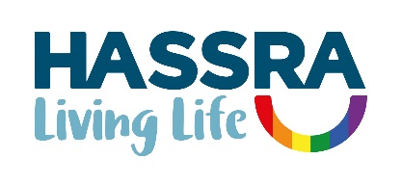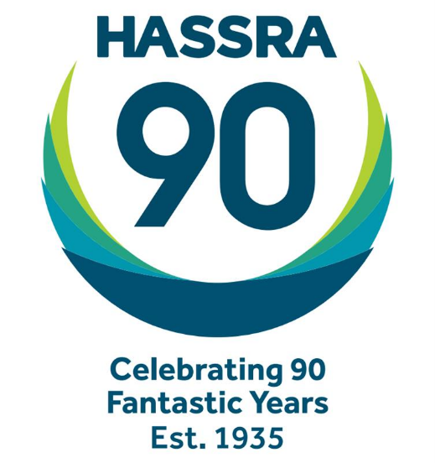

**Annual Report 2024**

|  |  |
| --- | --- |
| **Contents** | **Page** |
| Presidents | 3 |
| Glossary | 3 |
| Foreword | 4 |

1. Summary 5
2. National Programme 5-10
3. Building Membership 10-11
4. Supporting Clubs and Volunteers 11-12
5. Promoting Equality and Diversity 13
6. Building Sponsorship 13
7. Building our Business 14-15
8. Managing our Business 15-17

Appendices

1. National and Regional Management Committees 18
2. 2023/2024 National HASSRA Decision-Making Bodies 19
3. Awards Committee Report 20-21
4. Programme and Delivery Committee Report 22
5. Finance Committee Report 23
6. Diversity and Inclusion Committee 24-25
7. Membership Benefits 26-32
8. HASSRA Membership 33-36
9. HASSRA Live Visitations 37
10. Finance Transactions 38
11. Online Programme MI 39-40
12. Development Fund 41
13. Charity Fundraising 42

**President**

Peter Schofield CB, Permanent Secretary, Department for Work and Pensions

**First Vice President**

Professor Chris Whitty, Permanent Secretary, Department of Health and Social Care

**Glossary**

AC Awards Committee

AGM Annual General Meeting

BOM Board of Management

CCM Contactless Card Machines

CMT Communications and Marketing Team

CSiS Civil Service Insurance Society

CSSC Civil Service Sports Council

DHSC Department of Health and Social Care

D&I Diversity and Inclusion

DWP Department for Work and Pensions

EDIW DWP Centre for expertise for Equality, Diversity, Inclusion and Wellbeing

FC Finance Committee

HDF HASSRA Development Fund

IA Inter Association

MI Management Information

PDC Programme and Delivery Committee

# Foreword

As always, it’s been a really busy year!

Recruiting new members has been our highest priority and HASSRA National has improved the information it sends to regions and clubs to help them know where new staff have started in DWP offices and that has helped clubs, regions and national to target their recruitment efforts. We are pleased to tell you that this has resulted in the second best recruitment figures in recent years behind 2017. We have smashed our target to have 60,000 members by the end of 2025 and we have now set the ambitious target of 65,000 members by that same target date.

We know that the cost of living increases mean members are feeling the pinch. Our regular Summer Promotion was as popular as ever although they are still purchasing more of the less expensive attraction tickets and fewer expensive ones. Clearly saving members money is really important and we have set up a membership benefits forum this year to help us with suggestions to expand our membership benefits portfolio. If you have any ideas for new and exciting membership benefits, please let us know. Although it might not always be possible to strike a deal, we will always try our best.

Most of our sports and leisure events continue to be delivered locally by our army of more than 2,000 club and regional volunteers. In addition, our national flagship HASSRA Festivals have remained popular with members, and we have been testing out how we can make them more inclusive with the help of the Activity Alliance. We are grateful to our army of volunteers without whom this would not be possible. If you want to get involved, we would love to hear from you!

We have also continued to build on our online events programme including regular puzzles and smart quiz. These competitions are always really popular with members and are so important as they are accessible to everyone and reinforce our inclusivity commitment. These are all available on our digital platform HASSRA Live which is continually growing with new functionality. This year we have been incentivising clubs to use this functionality as it makes life much easier for them. Message Boards were also launched at the end of 2024 which will allow members, and regional and national committees to easily interact with each other digitally in the future.

This report gives much more detail of what has been achieved last year. Please take some time to read more of the detail.

Dave Barrow

HASSRA National Chair

May 2025

# Summary

1.1 Formed in 1935, HASSRA has been providing sports and leisure opportunities to staff in

DWP and DHSC and associated agencies for 89 years. It is a national organisation of **61,600** members with income of **£3.6m**, and strong foundations in 325 local clubs organised in 12 regions. Operating on this scale gives HASSRA a formidable delivery capability unrivalled amongst public sector staff associations. Our aim is to provide broad range of sports and leisure opportunities at work and at home which helps members achieve a happy and healthy work-life balance. HASSRA supports DWP’s vision to make DWP a great place to work.

1.2 In 2024, that included:

• benefits, discounts and offers worth **£5m**

• HASSRA Lottery paying out a guaranteed £756k plus a double money draw worth an extra £63k

• free draws and competitions worth £128k

• fortnightly prize puzzles and monthly online quizzes live on YouTube

• national and regional sports and fitness, arts and crafts and cultural activities

• local office and single activity club programme of sports and leisure events

• a Development Fund awarding £13.5k to help members achieve their potential

• two HASSRA Festivals (July and September) hosting 1,157 members and volunteers

• and much, much more totaling 272k member participations in 2024.

1.3 This report describes these activities in the period year ending 31st December 2024. It broadly follows the format of the 2024 HASSRA National Work Programme to help readers view outcomes against objectives.

# National Programme



***We deliver***

*HASSRA delivers a diverse programme of sporting and social activities at our popular Festivals, plus various regional and local events - bringing members with shared interests together to compete, network and thrive.*

# We care

***We care***

*HASSRA offers members a range of discounts including household items, holidays and days out, ensuring more money stays in their pockets. Members save even more with our Summer Promotion, plus lots of chances to win in our regular competitions and Lottery.*

# 2.1 The HASSRA Awards Dinner is always the highlight of the HASSRA calendar because it is when we reward our fantastic HASSRA volunteers and showcase the fantastic achievements of our regions and clubs.

## National Conference and Awards Ceremony

2.2 The annual AGM was held at Warwick University on Thursday, 16th May 2024. 83 delegates, officers and observers attended the meeting. No motions were submitted, and elections were held for BOM, FC, AC, PDC and D&I committee vacancies.

2.3 The annual Awards Dinner was held on the same evening following the AGM.It was a fantastic event attended by 155 HASSRA members. We were joined by 20 senior civil servants who were able to get a unique insight and appreciation of HASSRA, enabling them to promote and champion HASSRA to their colleagues and business areas on their return.

2.4 We introduced HASSRA Heroes at the Awards Dinner to recognise the unsung heroes from each region. This will continue in 2025 when we will reward more volunteers for their outstanding contributions to the health and wellbeing of other staff. A raffle was held in aid of the Charity for Civil Servants which raised a fantastic £900 from the generous donation of prizes from our corporate partners.

The winners from 2023 are listed below.

|  |  |
| --- | --- |
| **HASSRA Major Awards** | **Winners for 2023** |
| **The President’s Trophy**  for Best Association | Yorkshire and the Humber |
| **Sir Philip Rogers Trophy**  for Best Large Club | Trafford Quays  North West |
| **Sir Michael Partridge Trophy**  for Best Small Club | Great Yarmouth  East of England |
| **Rachel Lomax Trophy**  For Best Volunteer | Marion Beagle  East Midlands |
| **Lesley Strathie Trophy** for Best Business Sponsor | Helen Matthews  Wales |
| **Andy Graham Trophy**  for Best Newcomer | Jenna Williams  Wales |
| **John Nunn Trophy**  for Best Single Activity Club | North West Drama Club  North West |
| **Terry Green Trophy**  for Best Sportsperson | Jayne Baldock  South East |
| **Sir Robert Devereux Trophy**  for Wellbeing | Lincoln HASSRA  East Midlands |
| **Best Innovation Trophy** | Maggie Smith  South East |
| **Sir Leigh Lewis Trophy**  for Best Arts, Crafts & Non-Sporting Contributor | Della Tucker  East Midlands |
| **Neil Couling Trophy**  for Best Recruiting Club | Dover BC  South East |
| **Cinema Society Trophy**  For Most New Regional Cinema Members | West Midlands |

**HASSRA Online Programme**

## *Let’s Get Moving- November Challenge*

2.5 To make the 2024 Physical Challenge more inclusive, all members were encouraged to be active in November by undertaking at least three activities per week over the month. Activities could be walking, swimming, cycling or running. This was recorded on Strava by the 425 participants. A prize pot of £4k was shared between 14 winners, randomly chosen from all participants with a combination of prizes worth £500 and £200.

## *National Art Competition*

2.6We received 161 entries for the National Art competition. The categories were Painting, Drawing and Mixed Media. The standard was high and made it difficult for the Awards Committee to come to a decision. A total of £2k in prize money was shared between 18 winners with the overall winner receiving £300. The entries have been added to the HASSRA Flickr pages and winners will feature in the spring edition of the Livelife magazine.

## *National Photography Competition*

2.7 This competition was held online, and 343 entries were received with the themes being Celebrations, Reflections and Memories. The prize structure mirrored the Art competition with £2k being shared between 18 winners ranging between £300 for the overall winner and £50 for highly commended.

***Let’s Get Singing***

2.8 The HASSRA ‘Let’s Get Singing’ choir began during Covid and was a popular Thursday lunchtime session. With numbers dwindling, it was relaunched again in January 2024, but participation began to decline as the year went on. After much consideration and discussion, Let’s Get Singing was brought to an end in December.

## *Monthly Quiz*

2.9 This continues to be a popular event in the HASSRA Calendar, professionally delivered via YouTube by our partners at Redtooth. The top 28 scorers each month win vouchers as prizes and an additional random player is also selected to win a prize. The Quiz runs over 11 months and pays out a monthly prize pot of £650 to 29 winners.

## *Fortnightly Puzzles*

2.10 Members have enjoyed entering the fortnightly puzzles where we provide a variety of puzzle types to challenge our members including Singonym, Anagrams, Picture Puzzles, Emoji Puzzles and Answersmash. There were 26 different puzzles published in 2024, over 17,000 entries were received and £10k paid out in prizes to 20 lucky winners each fortnight.

## *Christmas Cracker*

2.11 We received 22,141 entries for the Christmas Cracker competition. 121 cash prizes were won with a total value of £31,300 and a variety of 80 electrical and personal items were also distributed including flat screen TVs, X-Boxes, Play station bundles, Air fryers, Dyson hairdryers and Chromebooks etc. Total value of items was £18,737.

## Fun ‘n’ Free Competitions

## 2.12 25 national competitions were created for members to take part in, and 258,079 entries were received. We added a new initiative which was a daily competition for the Twelve Days of Christmas which was very popular. In addition, when presented with a gift voucher from a supplier, we created an extra competition to encourage members to ‘Switch and Win’ by changing from a DWP to a personal email address. £58,858 was paid out in total for Fun ‘n’ Free competitions.

## Development Fund

2.13 During 2024, members received awards totaling £13,237 (including £5,662 kindly provided by The CSiS Charity Fund). This represented an increase in the value of awards of £4,692 (+55%) over the previous year. A breakdown of awards by region can be found at Appendix 12.

## Summer Promotion

2.14 Our usual Summer Promotion offering heavily discounted theme park and attraction tickets all around the country ran from 1st June to 30th September. In total we sold 24,000 tickets and delivered member savings of £398k.

2.15 In addition to the national subsidy, regions were invited to contribute some of their own funds to further reduce the cost of tickets to their members. North East, North West, Wales and Y&H took up this invitation and saved their members an additional combined total of £24k.

**Lottery**

2.16 Another record-breaking year for our lottery scheme saw 9,335 applications for new or increased tickets - an increase of 429 (+5%) from the previous year. For the third year in a row, we held a Double-Money draw in October where every winner received twice as much prize money as usual. This saw one lucky member scoop a massive top prize of £30,000! The Double-Money draw has proved so popular that it’s now a regular component of our annual lottery programme.

2.17 The number of lottery tickets purchased by members each month has grown so much over the last few years that we managed to increase the annual prize pot from January 2025 to over £1million, with more monthly prizes than ever before and a bigger monthly jackpot of £20,000. So our Double-Money draw later this this year will see our first ever £40,000 winner. It could be you!

*Details of all membership benefits can be found at Appendix 7.*

**HASSRA Festivals**

2.18 In 2024, two HASSRA festivals were organised hosting a total of 29 different activities (15 in July and 14 in September). Some new activities for 2024 included wild swimming and walking football which proved popular with attendees. Activity Alliance who are a leading voice for disabled people in sport and activity joined us at both festivals. They demonstrated several sports and activities adapted for disabled and less abled members to be able to take part. We are working with them again for 2025 and have asked our event organisers to undergo Activity Alliance training to be able to adapt their events where needed to include all our members.

2.19 A total of 1,157 members attended the Warwick University campus during the year (July 573, and Sept 584) and we will be holding two festivals again in 2025.

**Inter Association (IA) Competitions**

2.20 In October 2024, HASSRA linked up with HMRC and the Home Office for an Inter-Departmental swimming competition in Corby. The HASSRA team was made up of 21 swimmers with ages ranging from 20’s to 70’s. Scotland, Wales and 8 of the 10 English HASSRA Regions provided swimmers. Nearly half were newcomers to this National Team.

The competition lasted all day, at a frantic pace, to allow 36 different events. In addition to the swimmers’ individual races, HASSRA fielded 29 relay teams. The winner was HMRC with DWP a close second!

2.21 In November 2024, 10 regions came together to compete against one another at Inter- Association cricket. 80 members attended on the day and teams consisted of six players plus two substitutes. As it was an IA event, it was funded by the regions, with the National team organising the event itself. West Midlands won the event, with Yorkshire and Humber as runners- up.

**Membership Benefits Forum**

2.22 The National team work with over 100 business partners who provide offers and discounts to HASSRA members. The membership benefits manager will continue to work closely with the providers to manage existing offers as well as looking into bringing in new offers.

2.23 New offer suggestions can come from any HASSRA member. However, the Membership Benefits Forum set up in July 2024 generates the majority of ideas. We now have representation from each region on the forum, so review a variety of ideas across all the UK. In 2024, we had 12 new offers and there are currently another 42 suggested providers that are either in offer research or negotiation stage. Most popular offers were discounted days out, holidays and airport parking.

# Building Membership

3.1 Recruiting more members has been our top priority. We have concentrated this year on providing more information to regions and clubs, forging closer relationships with DWP’s Wellbeing Team and DWP’s Communications Team promoting HASSRA at every possible opportunity plus incentivising regions, clubs and members to recruit more new members. This has resulted in us smashing the 60,000 target by 2025. When we set that target, everyone thought it was unachievable, but we have now set another seemingly unachievable target of 65,000 members by the end of 2025.

**Buddy Draw**

3.2 Two Buddy Draws were conducted in 2024 (May and September). Both draws awarded 200 lucky members £50 each, totalling £20k for new members and their ‘buddies’. Word of mouth from colleagues and friends continued to be the main reason for joining HASSRA. The Buddy Draw served as both a recruiting and retention tool and will be repeated in 2025.

**HASSRA Video**

3.3 The HASSRA promotional video has also been updated to reflect the new lottery structure, 90th Anniversary, new member benefits, partner logos etc. for use in HASSRA recruitment presentations and the website.

**Recruitment Information**

3.4 Regions were provided with their Staff in Post list to focus their recruitment efforts on a quarterly basis. Towards the end of the year, we were able to provide regions with locations of DWP new starters to assist them with their recruitment activity. This will continue on a quarterly basis going forward.

3.5 26 clubs who achieved a membership increase of 20% or more during 2024 received a certificate to acknowledge their achievements. The top three performing clubs were invited to the Awards Dinner with the winning club being awarded with the ‘Best Recruitment’ trophy.

*Details of membership figures are shown at Appendix 8.*

# Supporting Clubs and Volunteers



***We Work Together.***

*With an active network of 12 Regions and 325 Local Clubs run by hundreds of volunteers, we support and supplement Wellbeing initiatives with additional resources that help to make DWP a great place to work.*

* + 1. In 2023 we revamped the Volunteer Toolkit making it concise and easy to use. In 2024 we built on that excellent work and expanded the information available to clubs and regions to help them deliver to members.

## Quarterly Finance Reports

4.2 Our Regional Finance Managers provided regions with comprehensive finance reports at the end of each quarter which included balance updates and itemised income and expenditure. This enabled regions to track spend and manage their budgets accordingly. Our Regional Finance Managers also provided regular financial advice and support to volunteers throughout the year.

## Monthly Regional Catch-Ups

## 4.3 To increase engagement and inclusivity, a series of monthly catch-up calls were scheduled throughout 2024 between regional chairs or their representatives and the National Management team. They proved very popular, were well attended and helped drive forward key pieces of Association work. Each meeting was recorded so it could be shared with other regional volunteers when required.

## 4.4 It is hoped there will be guest speakers from our key partners joining some calls in the coming year.

## Chairs Meetings 2024

4.5 The annual joint meeting of the National Board and regional chairs was held in November at Warwick University. The main topics discussed were the 2025 budget, 90th Anniversary and the BOM and sub committee review. Attendees broke into syndicate groups to consider their 90th Anniversary plans and ideas. The next joint meeting is scheduled for November 2025.

**HASSRA Live Club Support**

4.6 The National team has continued to support our local clubs by providing the tools and training required to give our key volunteers the skills and confidence to carry out their roles to the best of their ability. Training sessions have covered a wide range of topics, from group sessions on club accounts for Treasurers to individual coaching on the creation of newsletters, competitions, events and raffles.

4.7 The Cash for Clubs initiative provided local clubs with the incentive of earning money at the same time as engaging with HASSRA Live. By the end of 2024, 128 local and single activity clubs had taken advantage of this scheme. We paid out £25,000 to clubs for their activities which has also increased volunteer expertise and member engagement as a result. We have relaunched this initiative in 2025 to further increase HASSRA Live engagement.

4.8 We have continued to develop a portfolio of training aids which are all conveniently located within the Volunteer section of HASSRA Live. They provide step-by-step guidance and visual demonstrations to consolidate the skills acquired during training events.

4.9 We have also introduced a new Charitable Fundraising Reporting functionality which allows Club Treasurers to easily record their fundraising totals which, in turn, gives Regional Chairs easy access for inclusion in their Annual Reports. Again, this is supported with an easy-to-follow desk aid to record and view this information.

**Conduct and Discipline**

4.10 We never want to report that we have had to deal with any conduct and discipline issues, however occasionally these things happen. Our National Discipline and Complaints committee is there to resolve such issues. Our message to members is enjoy yourself whilst at our events but be mindful that bad behavior will not be tolerated.

**Charity Collections**

4.11 During the year, members, regions and clubs found many ways to support their favourite charities and collected a fantastic total of £72,759. As in previous years, this figure is likely to under-report the actual sum because not all clubs submit returns. At the end of 2024, we introduced new functionality on HASSRA Live as an easier way to record fundraising totals. We have noticed not all clubs have used this facility yet so the overall total might not be an accurate representation of the year’s fundraising.

*Details of charity figures are shown at Appendix 13.*

## 5. Promoting Equality and Diversity



***We value everybody.***

*Members' feedback is key to making HASSRA a better organisation for everyone. Our Development Fund helps members overcome financial barriers to reach their goals, and our Diversity & Inclusion Policy aims to provide something for everyone.*

5.1 HASSRA has always striven to have something for everyone. This year we invited the Activity Alliance along to our Festivals to help us understand how we could make our events more accessible for disabled and less-able members. Our Diversity & Inclusion committee provide a steer to ensure all our programme is accessible to all members.

5.2 The National team worked closely with the DWP accessibility team to ensure the promotional video was compliant with their standards. In September, to celebrate national inclusion week, we ran a competition in partnership with the DWP centre for expertise for Equality, Diversity, Inclusion and Wellbeing (EDIW).

## 6. Building Sponsorship

6.1 Building great working relationships with our sponsor departments is very important to HASSRA. Through those close working relationships, we can ensure our policies and procedures mirror those in DWP. We can also complement the work of the Wellbeing Teams. We have forged closer working relationships with Senior Civil Servants with 20 attending our Awards Dinner and asking how they can become more involved in HASSRA

## Business Unit Grants

6.2 Our Business Unit Grant initiative launched on 11th September. The aim of this grant was to help fund activities to drive up engagement with HASSRA members and potential new members in geographically dispersed Business Units.

6.3 By the end of the year, we received 15 applications and awarded a total of £1,800. Activities that were funded ranged from food/refreshments at ‘away days’ to quiz prizes and escape rooms. The positive feedback from beneficiaries noted that HASSRA’s funding made a real difference to the success of the events and encouraged new members to join. We hope to see more Business Units take advantage of this initiative in 2025.

**Financial Sponsorship**

6.4 The CSiS Charity Fund, who provide funding for disabled/disadvantaged members in our Development Fund, generously awarded us a grant of £3,000 for the year. We are very grateful to the CSiS Charity Fund for their long-standing commitment to HASSRA.

# 

# 7. Building our Business



***We adapt***

*As members continue hybrid working, the HASSRA programme constantly evolves to provide a vibrant mixture of face-to-face and online events to increase engagement with colleagues and promote wellbeing and inclusivity.*

7.1 HASSRA Live continues to be our main delivery arm. In the past year, we have made significant strides in enhancing the HASSRA Live experience for our members. New functionalities have been integrated to improve the enjoyment and streamline behind the scenes operations. We have also been working hard with our IT Developers to complete the Message Board and bingo functionalities.

**HASSRA Live**

7.2 We finally launched the long-awaited Message Board functionality, giving all members an opportunity to share good news stories and ideas, both nationally and around their region. It also provides volunteers on regional and national committees with a secure platform to share and discuss important Association business.

7.3 We also launched a new dynamic membership application process which has streamlined the new member journey and has driven out erroneous applications. This was soon followed by an automated process which seamlessly allows HASSRA Live to communicate with our main payroll provider when a new membership or lottery application is received.

7.4 Other developments on HASSRA Live have included a Basket Limits function which allows system restrictions on the number of items that a member can order over a specified period on selected online shop products. This proved invaluable in the Summer Promotion and will continue to be so during other specified promotional periods.

7.5 The results of our annual website penetration test once again reassured us of the security of HASSRA Live for members, volunteers and stakeholders. We plan to invest in a new server which will enhance the performance of the website and the overall experience of all users.

7.6 We have been tirelessly working in the background on a variety of other tasks to provide new and improved ways to make the most of the digital capabilities of HASSRA Live.

*See Appendix 9 for visitation statistics.*

## Communications

7.7 Whilst newsletters are still the main communication media, much of what we publish such as offers, competitions and other key information is replicated on our social media channels Instagram, X and Facebook.  In 2024 a WhatsApp Channel was launched along with the establishment of a HASSRA Group on the internal DWP communication platform Viva Engage.  We publish pictures from both regional and national events and competitions on Flickr to share widely.

7.8 With the 90th Anniversary this year, much of the communication planning began in 2024.  Over 1,300 members took part in a survey to choose a logo.  We acted on feedback about inclusivity and accessibility, consulting with experts to finalise the most popular design.

7.9 New web banners were procured for initiatives such as free cinema tickets for new members and Staying Connected (email switch to non-DWP email) and the 90th Anniversary Year Celebrations.

7.10 To support the launch of the Business Unit grant in 2024, a new application form was designed, and the publicity campaign was launched.  This funding supports geographically dispersed teams and has a clear expectation of the recruitment opportunity to be maximised by the applicants.

7.11 In preparation for the launch of 90th Anniversary Club Grants, we trialled the use of MS Forms and this has proved to be a cost-effective means of data gathering.

7.12 We have worked closely with colleagues in DWP internal communication to ensure that HASSRA information is easily located within Wellbeing, Financial Support and Sporting and Social Activities, as well as sending regular ‘poster style’ information with up-to-date information about offers and competitions etc. for publication on the intranet.

**BOM and Sub Group Review**

7.13 HASSRA is constantly changing to meet the needs of its members, so last year we reviewed the structure and terms of reference for the Board of Management (BOM) and all the Sub-Committees and decided to make the following changes:

1. Ask the Permanent Secretary to appoint a Vice Chair to the BOM to strengthen ties with DWP and aid succession planning.
2. Make the co-option of the Head of DWP Wellbeing a constitutional position. This appointment would not have voting rights however as well as strengthening ties to DWP Wellbeing Team this person should oversee the conduct and disciplinary process within HASSRA.
3. Move the HASSRA Development Fund to the National HASSRA Team for management and decisions – this will give more consistency to decision making, hopefully will drive more money out of the fund going to members but also is in line with all other financial decisions relating to HASSRA.
4. A new sub-committee would be set up to oversee recruitment. This would help recruit new members.

## 8. Managing our Business

## 8.1 One of the key functions of the HASSRA National Team is to manage all the business functions. Although club accounts are administered by volunteers in accordance with the Staff Club’s Guide, it would be difficult - if not impossible - for volunteers to perform many of the regional and national business functions. These functions are performed by the HASSRA National Team.

## HASSRA National Accounts

8.2 The Association’s auditors *Dafferns* conducted an audit of the financial statements of the HASSRA National Revenue and Lottery accounts for 2024. The results are as follows:

* the national revenue account had an excess of expenditure over income of £414k
* the national lottery account had an excess of income over expenditure of £712k

8.3 As is usual, the excess income from the lottery was used to offset expenditure from the revenue accounts. This left an excess of income over expenditure of £298k resulting in a commensurate increase in national reserves, which now stand at £1.948m.

**Regional Finances**

8.4 At 31st December 2024, aggregate funds held by regions stood at £1.373m - a reduction of £101k or 7% over the previous year.

## Investment Accounts

8.5 National and Regional investments yielded some healthy returns in line with high interest rates during the year. Our investments are reviewed regularly to maximise returns.

**CSSC Grant**

8.6 CSSC withdrew their traditional annual grant, which funded participation in their events, from 1st January 2024 and replaced it with a new grant for special projects and activities. Our grant awarded for 2024 was £21k of which £10k was used to fund Activity Alliance support for our festivals and a contribution towards our Development Fund. The remaining £11k was intended to fund a Wellbeing Challenge, a Walking Project and Regional/Club Projects. However, these did not get off the ground, so the funds were carried forward to 2025.

## Ticket Sales

8.7 We fulfilled over 9,000 orders on our online shop for 27,000 theme park and attraction tickets worth £704k, saving members on average 38% off normal admission prices.

8.8 Sales of cinema e-codes during 2024 were once again administered by our partners at The Cinema Society. Over the year, 6,000 more HASSRA members registered with them bringing their number of registered members to over 37,000. In total, HASSRA members made 46,000 transactions for 126,000 e-codes worth £709k and saved on average 43% against normal cinema admission prices.

8.9 During the year we launched a campaign for new HASSRA members to receive a free cinema ticket when placing their first order. This was partly funded by our partners at the Cinema Society for whom we are grateful for their ongoing support. North West, Wales, West Midlands and Y&H regions also ran cinema campaigns to give their members an extra discount at the checkout and saved their members an additional combined total of £32k.

## HASSRA National Team

## May 2025

## 

**Appendix 1: National and Regional Management Committees**

The organisation charts below show HASSRA’s National and Regional Committees and the names of their Chairs. Members of these decision-making bodies are at Appendix 2.

## National

## 

**Regional**

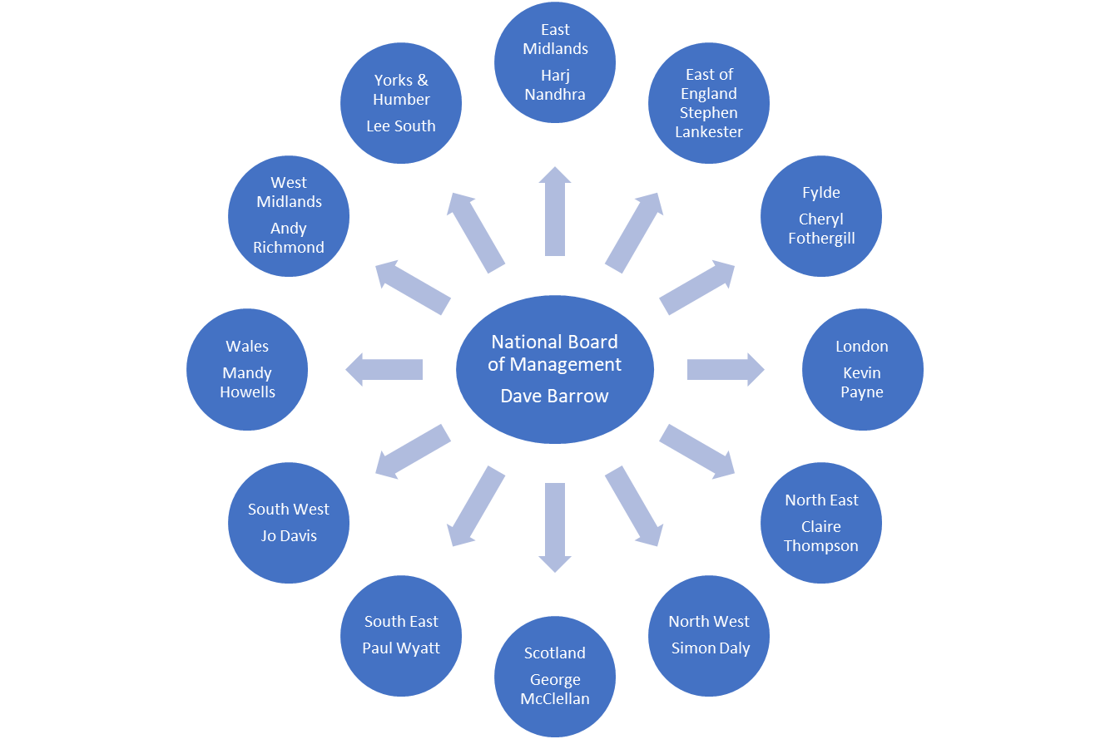

**Appendix 2: 2024/2025 National HASSRA Decision Making Bodies**

## National Officers Subject to Election

Chair Dave Barrow n/a

Operations Director Dawn Crow n/a

Finance Director Harvey Clarke n/a

## Board of Management

Chair Dave Barrow n/a

Operations Director Dawn Crow n/a

Finance Director Harvey Clarke n/a

Elected Member Nigel Thomas May 2026

Elected Member Justine Brown May 2027

Elected Member Sean Mulgrew May 2025

Elected Member Nicki Stowe May 2025

Elected Member Vacant May 2027

Co-opted Member Maria Lane

Secretariat Jenny Richardson

## Finance Committee

Chair Harvey Clarke n/a

Elected Member Di Grossey May 2026

Elected Member Helena Whitehead May 2025

Elected Member Willie Hunter May 2027

Elected Member Martin Gale May 2027

Elected Member Jay Saleem May 2026

Elected Member Sarah Fairclough May 2025

Co-opted Member Dave Lees

## Awards Committee

Elected Member (Chair) Tina Earp May 2025

Elected Member Irena Gorbun May 2027

Elected Member Marilyn McGinty May 2026

## Programme and Delivery Committee

Chair Laura-Jade Cox n/a

Elected Member Simon Jowitt May 2027

Elected Member Jo Jones May 2027

National Team Ann Cook

National Team Claire Metcalfe

## Diversity and Inclusion Committee

Chair Gary Thorogood n/a

Elected Member Nishan Jeyasingam May 2027

Elected Member Karen Sinden May 2027

Elected Member Nikki Densham May 2027

Elected Member Jason Foley-Doherty May 2026

Elected Member Ann Nash May 2026

# Appendix 3: Report from Awards Committee

As Chair, I would like to begin by expressing my heartfelt gratitude to Irena Gorbun and Marilyn McGinty for their unwavering dedication and support. The interest of HASSRA members and ensuring opportunities for their growth has always been our committee’s top priority.

**HASSRA Development Fund (HDF)**

The management of HDF applications has now transitioned to the National HASSRA team, streamlining the process and aligning it with other areas of the business. However, the Awards Committee remains available to offer advice and guidance to individuals, local clubs, or regions regarding any part of the application process.

In 2024, we received 44 HDF applications, resulting in 43 awards that supported the development of HASSRA members. A total of £13,237 was distributed, including £5,662 allocated to the CSiS Charity Fund, which assists applicants who are disadvantaged. This represents a notable increase compared to 33 applications and 32 awards in 2023. I attribute this growth to the increased promotion of the HDF by the National HASSRA team, which has helped raise awareness and expand understanding of the application process.

The diversity of activities members requested support for was truly impressive, ranging from mainstream sports to drumming and foreign language qualifications. Notably, a large percentage of applicants were over the age of 40, many returning to a sport they had previously enjoyed or embarking on a new activity to replace one they could no longer pursue. I am confident that both the National HASSRA Board of Management and the National HASSRA Team will continue to ensure the HDF remains an attractive resource for current members, while also enticing new members to get involved.

**National HASSRA Awards**

While we saw improvement over 2023, certain categories still showed a significant gap in submissions, notably the Wellbeing Award. Following the success of the Wellbeing Inclusion Award, presented for efforts during Wellbeing Inclusion Week in September 2024, the Awards Committee will continue working closely with the Diversity and Inclusion Committee to find ways to increase submissions in this category.

In 2023, we piloted a new voting process for two of the awards: Best Arts, Crafts and Non-Sporting Contributor and Best Sportsperson, which allowed members to vote via HASSRA Live. Given the success of this initiative, we replicated it this year and will continue to monitor and refine the process.

In 2024, we introduced the HASSRA Heroes award to recognise the invaluable contributions of our volunteers. These individuals dedicate their time and energy to supporting members and delivering a wide range of benefits, events, and activities. Although not typically considered for the Volunteer of the Year Award, their contributions are essential to ensuring an exceptional member experience. Nominations for HASSRA Heroes are accepted quarterly from regions, with the Awards Committee selecting a winner and runner-up. All nominees will be featured on HASSRA Live.

The wealth of talent and dedication across HASSRA continually astounds me. We are fortunate to have an extraordinary group of volunteers, and as Chair of the Awards Committee, it is my honour to thank and celebrate their incredible contributions.

**Acknowledgments**

In addition to Irena and Marilyn, I would like to extend my sincere thanks to Dawn Crow for her significant contributions in 2024. I am also deeply grateful to the National Board of Management and the National HASSRA team for their ongoing support of the Awards Committee’s work. Finally, I would like to recognise and thank our regional committees and volunteers at the regional and local levels for their hard work and commitment to the National HASSRA Awards. I wish you all the very best of luck.

Tina Earp

Committee Chair

**Appendix 4: Report from Programme and Delivery Committee**

The Programme and Delivery Committee is a HASSRA committee set up to review and plan future events. The committee met several times in 2024 to review both July and September festivals. The review took into consideration existing festival activities, participant numbers and several new activity suggestions from HASSRA members.

The committee identified that some of the previous festival activities had low attendance and needed to be discussed to see if they were going to be re-run or replaced with something new. The Drama activity was one that wasn’t doing so well in previous years with attendance, but members were asking to bring it back, so the PDC discussed a few options proposed to them for a new style Drama workshop which will be tried out in July Festival this year. This will include script writing and organisation of a play.

Another activity that wasn’t doing too well with attendance and event feedback was the Fitness workshop, so it was decided to look at another alternative that is dance/fitness related. A member proposed a Bhangra workshop and the proposal was discussed at a PDC meeting. The workshop will include learning how to Bhangra dance aswell as learning about Bhangra culture. This will run in September festival this year. An activity that went well in 2024 that’s been brought back for 2025 is Wild Swimming as it scored really high in the post event survey and was something different for our members.

The Activity Alliance involvement was also discussed, in particular how we can get our event organisers to work with all members regardless of disability. The Activity Alliance have online training to cover this aspect to make all events inclusive when organising an activity, which has been sent to all festival organisers to complete. The format of their sessions was also reviewed as they had previously just been running adapted taster sessions of various activities for disabled members at the 2024 festivals. For 2025, the Activity Alliance will be running games (Pickleball and Boccia) in the Tennis and Squash Courts so that all members regardless of disability can join in, making the events fully exclusive.

Festival ideas have already been received for activities for 2026 festivals and the PDC will meet later in 2025 to discuss again.

## Laura-Jade Cox

## Committee Chair

**Appendix 5: Report from Finance Committee**

During the year we completed a trial of contactless card machines (CCMs) with one of our clubs. The outcome was that DWP’s Financial Assurance and Control Team approved the use of CCMs for all HASSRA clubs, subject to certain governance and security conditions. This development provides our clubs with a modern and efficient extra option for collecting monies from members for events and activities, should they wish to use them. I wish to record special thanks to Debra DeNegri, the Treasurer of the Telford Newtown House HASSRA club, for her help in conducting the trial.

The committee held its regular main meeting in October to undertake key tasks, such as reviewing the annual budget, subscription rate and lottery prize fund. When looking at options for setting the subscription rate we must balance affordability for members while delivering a programme which continues to be valuable and supports recruitment and retention. No one wants to see the subscription rate going up, and we avoided it again this year, despite higher programme costs. Unlike the previous few years where we’ve relied on using lottery income, this time we avoided it because we recruited so many new members last year. Consequently, we were able to use the growth in lottery income to increase the annual prize fund to over £1million with more monthly prizes.

The committee also reviewed the Association’s travel and subsistence policies and recommended increasing the day and evening meal allowance rates which were endorsed by the National Board and came into effect from November 2024.

The FC continues to play an important role in financial planning within the Association. I wish to record my thanks to all the committee members for their contributions.

## Harvey Clarke

## Committee Chair

**Appendix 6: Report from Diversity and Inclusion Committee**

The Diversity and Inclusion (D&I) Committee have had a busy year and communicated by online Team meetings, e-mail and What’s App messages.

HASSRA is fully committed to being a diverse and inclusive Association which respects difference, promotes positive physical, mental and social wellbeing and provides an environment where its members can thrive, knowing they have a voice, that they belong and can be their true, authentic selves.

Earlier in the year partnership working was established with DWP’s Centre of Expertise for Equality, Diversity, Inclusion and Wellbeing (EDIW) Team.

To reflect HASSRA’s commitment to the D&I Statement and responding to the findings of the 2023 survey; where a number of members said they felt excluded from certain HASSRA events and competitions; one of the major things the Diversity and Inclusion Committee did this year was to highlight 2024 National Inclusion Week in September. A new online competition using HASSRA Live was launched, the Committee worked in partnership with the HASSRA National Team and DWP’s EDIW Team to put together the competition entry criteria and to publicise the competition via HASSRA Live.

Individual HASSRA members, groups and regions were invited to submit examples of events or activities they had organised during 2024 which demonstrated at least one of the following:

* meeting a range of individual needs to include and bring together everyone with maximum impact
* Promoting a sense of belonging, where taking part is recognised as just as important as winning
* Supporting positive wellbeing and promoting a healthy lifestyle
* Encouraging colleagues to be their authentic selves
* Considering the diverse needs of others

The judging panel, which included a representative from the EDIW team, looked in particular for examples that demonstrated innovation and creativity and a strong awareness of individual needs that would help bring colleagues together in an inclusive way with maximum impact on wellbeing. The panel was not disappointed, receiving 39 entries from across the Regions with wonderful examples ranging from Diwali, PRIDE and other celebrations to organising Summer Olympics events, well-being walks, a sustainable fashion show, 3 peaks challenge and a Mile Race. Some events & activities were held in Offices, and some were external. In the end the panel decided upon two joint Winners and two ‘Highly Commended’ - all excellent entries, although very different. All entries showing HASSRA organisers and volunteers going over and above in their efforts to raise awareness of inclusion and diversity, bringing people together and engendering a heightened sense of wellbeing and belonging. Full details of the competition and winners will be published in the LiveLife magazine.

In parallel with the competition, the Committee built strong links with the 13K strong Civil Service Wellbeing community, using its online channel and taking part in their twice weekly calls to promote HASSRA and explore potential areas of mutual support. These links have built a very positive partnership.

The D and I Committee are currently reaching out to the Civil Service Retirement Fellowship Charity to look at how best we can maximise the synergies between our two organisations, in particular around volunteering and ‘befriending’, becoming donors and using HASSRA members to identify retired colleagues who could benefit from the “befriending service”.

In 2025 the D and I Committee wants to build on the achievements of 2024 and will be looking to further develop an updated, modernised D&I Statement for HASSRA.

With plenty more also in our plans for 2025, watch this space!

Gary Thorogood

Committee Chair

# Appendix 7: Membership Benefits



































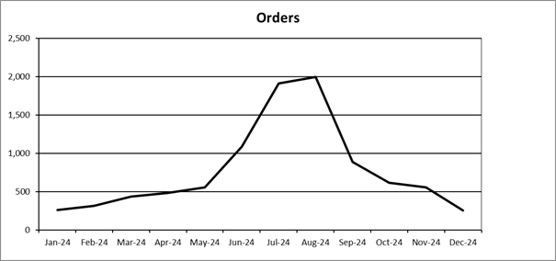

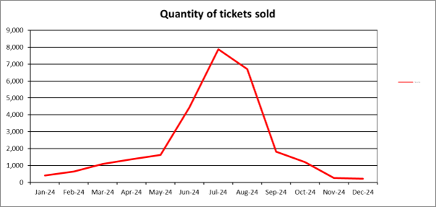

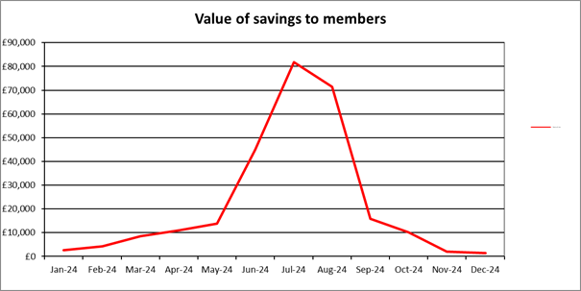



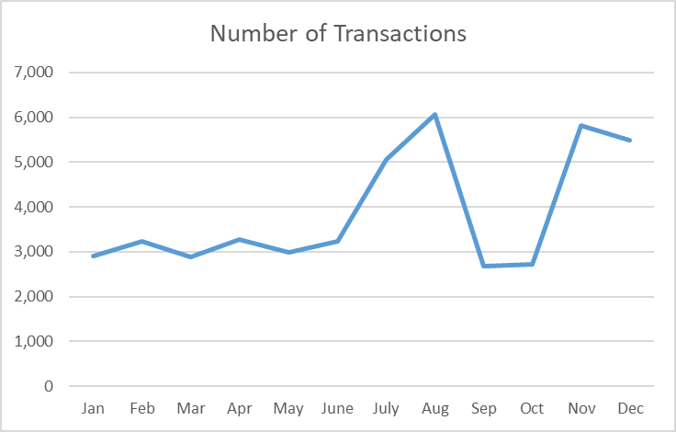

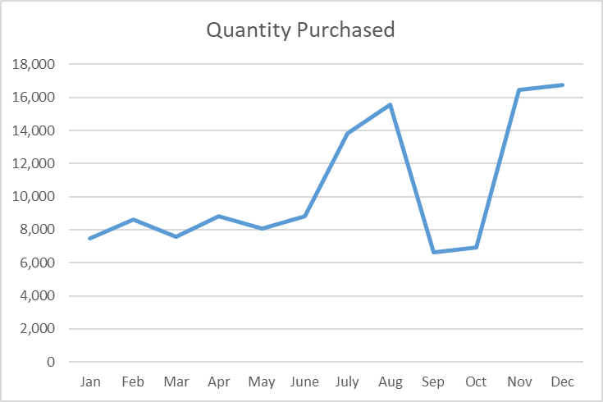

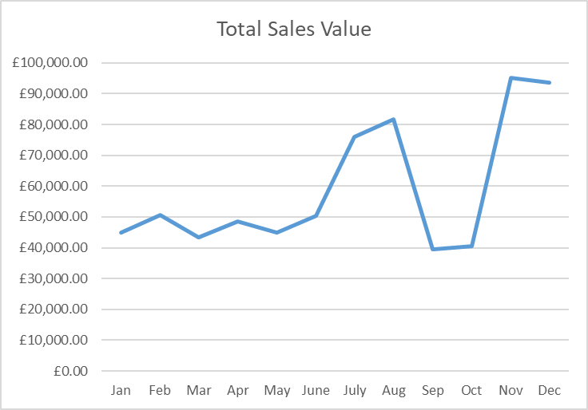

**Appendix 8: HASSRA Membership**



Membership breakdown at December 2024









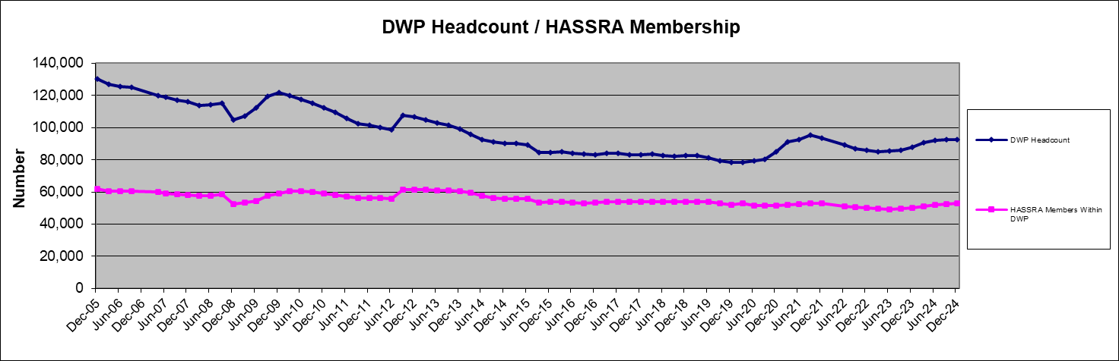

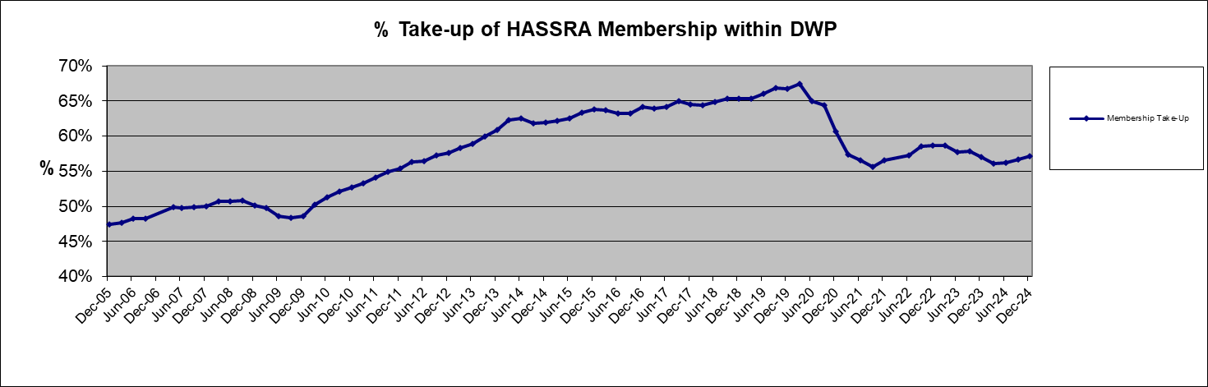

**Appendix 9: HASSRA Live Visitation**

# 

# 

**Appendix 10: Finance Transactions**





**Appendix 11: Online Programme**





**Appendix 12: Development Fund**



|  |  |  |  |  |  |
| --- | --- | --- | --- | --- | --- |
| **Region** | **Approved Applications** | **Activities** | **Total Awarded £** | **CSIS inc. in total** |  |
| East Midlands | 2 | Footgolf, Drumming | £715 | £215 |  |
| East of England | 0 |  | £0 | 0 |  |
| Fylde | 2 | Cricket Umpiring, Screenwriting | £650 | £500 |  |
| London | 3 | Running, Over 40's Cricket, Massage | £1,300 | £800 |  |
| North East | 6 | Languages, Football Coaching*, Target Rifle Shooting, Ice Skating | £995 | £0 |  |
| North West | 1 | Disability Pool | £500 | £500 |  |
| Scotland | 3 | Football Coaching, Foot Golf, Walking | £1,250 | £500 |  |
| South East | 3 | Cricket, Netball Coaching, Cycling | £1,050 | £0 |  |
| South West | 6 | Running, Hockey, Tennis, Mindfulness Training, Swimming, Pottery | £1,040 | £720 |  |
| Wales | 8 | Athletics Coaching, Over 50's Touch Rugby, Golf, Military Baton Twirling, Open Water Swimming, Football Coaching | £2,357 | £977 |  |
| West Midlands | 2 | Over 50's Hockey, Art & Design | £1,000 | £500 |  |
| Yorks & Humber | 7 | Cricket, Para Powerlifting. Football Coaching**, Aquafit Instructor Training, Running Leader Training. | £2,380 | £950 |  |
| **Total Awarded** | **43** |  | **£13,237\*** | **£5,662** |  |
| **Total Amounts Paid** | **41** | **\*Totals awarded less any unpaid - see below** | **£12,912** | **£5,662** |  |
| **Nil decisions** | **1** | North East - Tennis - does not meet HDF Criteria. | Total above includes CSIS Awards | CSIS total only |  |
| **Awaiting decision** | **0** |  |  |  |  |
| **Total Applications Received** | **44** |  |  |  |  |
|  |  |  |  |  |  |

*Football Coaching award of £75 not taken up despite numerous contacts for payment details.

**Football Coaching award of £250 declined due to course not being fully FA supported for 2024, they will reapply next season once course details and FA links confirmed.

**Appendix 13: Charity Fundraising**

