Staff Clubs Training for HASSRA Officials

This training package can be used by regional volunteers to instruct club officials on how to complete and check HASSRA accounts.
It can be used by new treasurers to teach themselves how to complete HASSRA accounts.
Local club and Single activity club chairs and Business Sponsors can use it to understand how to check club accounts have been completed correctly.

Club account spread sheet
The spread sheet HASSRA recommends is published in the running staff Club guide and on the HASSRA Live website. Below is a copy of the spreadsheet that you can download and use.
Or go to https://www.hassra.org.uk/accounts-package
This is an excel spreadsheet package on which you to record your transactions. It calculates Income & Expenditure totals and completes a Balance sheet from the transaction information input.
It needs to be completed correctly. It can look a bit confusing to start with but is relatively simple once you start. This training package gives you a step by step guide so you will be able to confidently keep accurate accounts for your club.
It has separate tabs for each month, Notes, Income/Expenditure, the Balance Sheet as well as one giving you Examples of how to complete the spreadsheet.

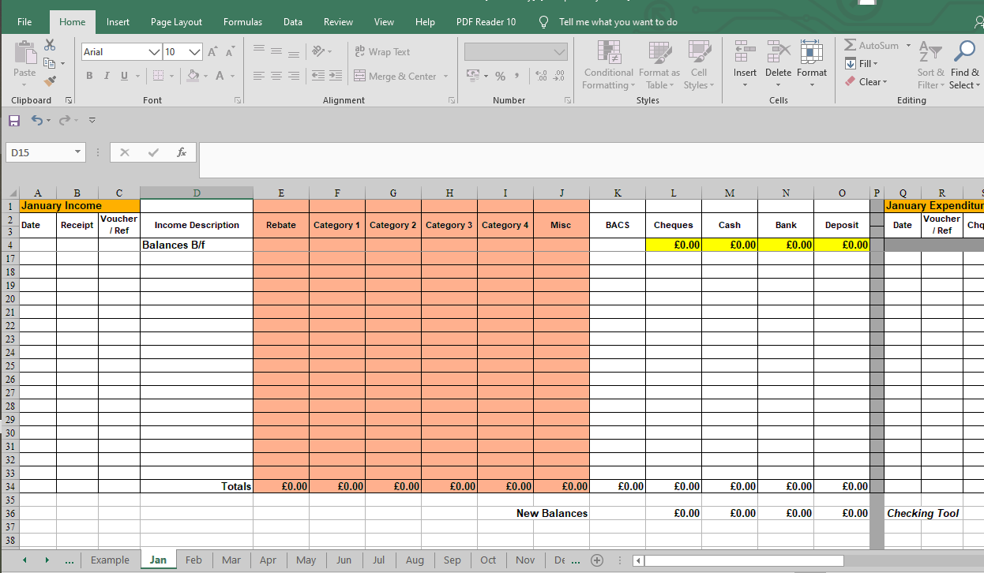

To start using it, you need to save a copy to your folder. Then enter you Club name on the Balance Sheet.
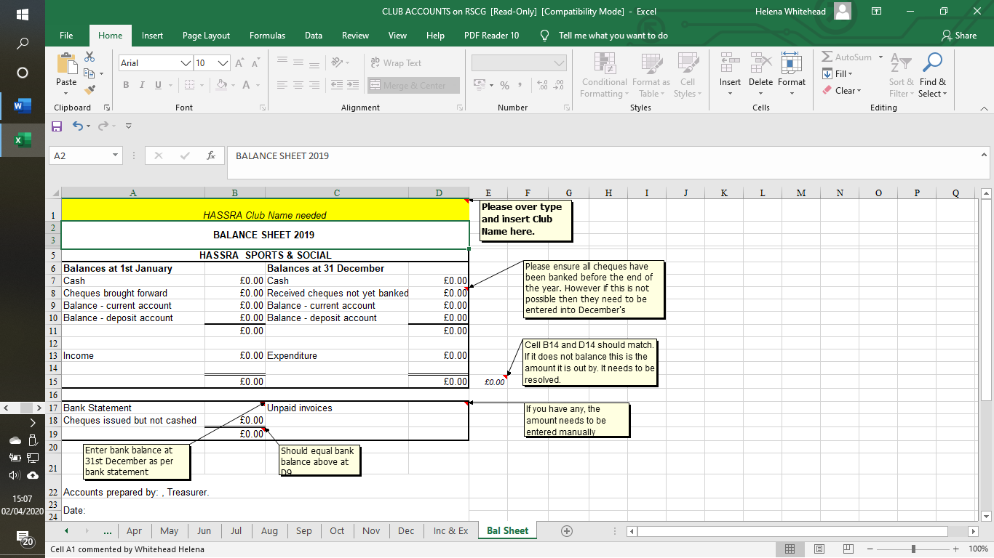
The next thing you need to do is decide which categories you want your entries to go into, so go to Inc/Exp tab.
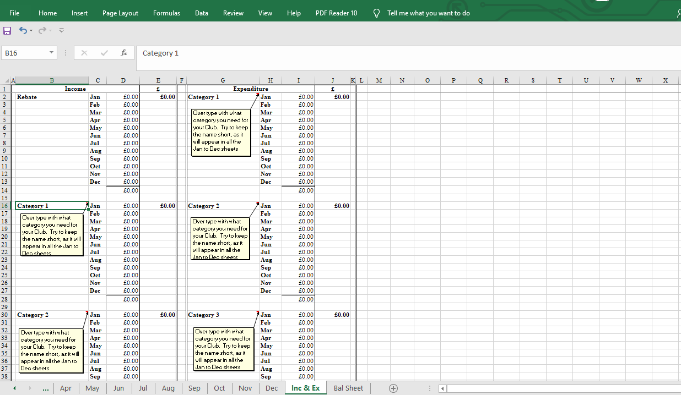
Here you will find a list of categories headed up Rebate, Categories 1 through to 5 and Misc. for both income and expenditure. You can decide which events to record here. Where events attract income and involve expenditure, they will need to be shown in both columns. For example, a raffle would involve income from the sale of tickets and expenditure for the purchase of prizes. Others may only involve expenditure so would only need to be shown in the Expenditure column. Just overtype the category with what you want to use. Try and keep the descriptor short as it will then appear in each of the months in the coloured columns. You should not change these during the course of the year as it will affect all the months. The number of categories is limited as any more would make the spread sheet too big.

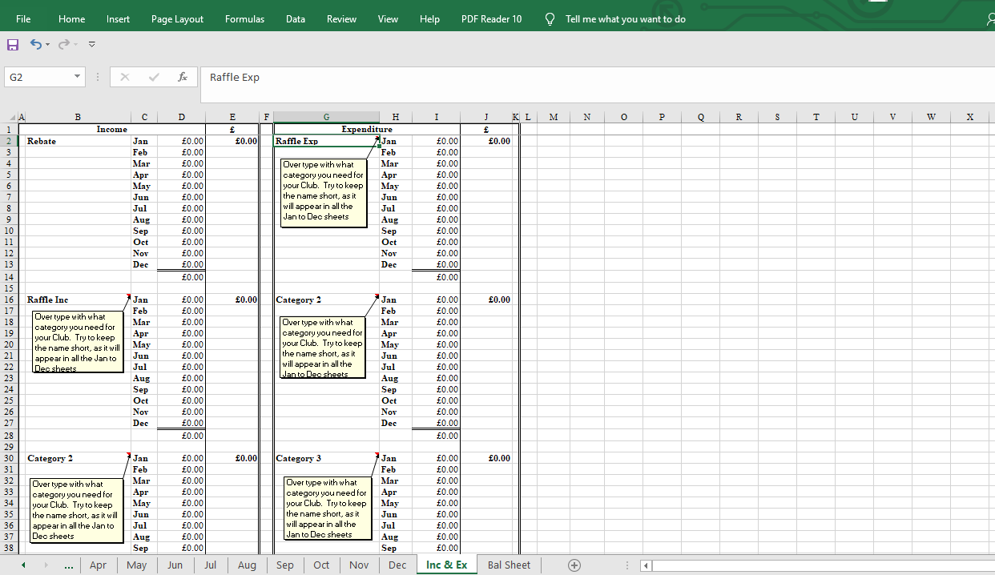
This is what it looks like on each month

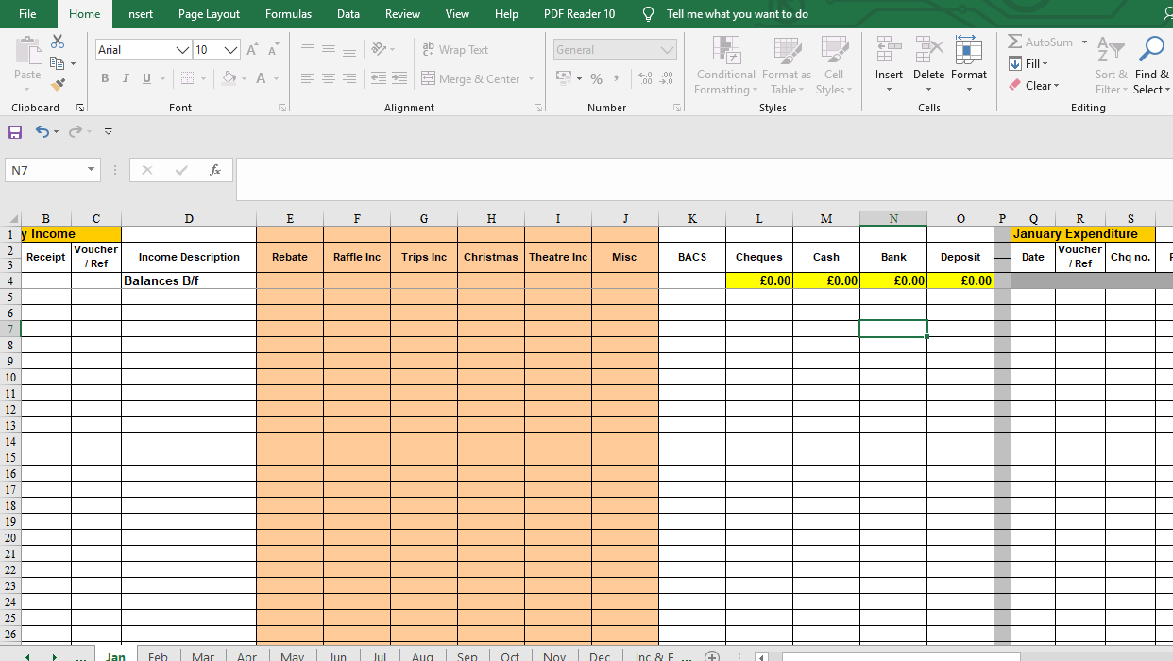

You now need to enter in January tab the amount that has been brought forward from last years audited accounts. These are the cash and bank account and go in the highlighted boxes. If you have received cheques that were not paid into the bank the previous year then they need to be added in in the cheques box, but we do recommend all cheques are paid in before the final accounts are done.
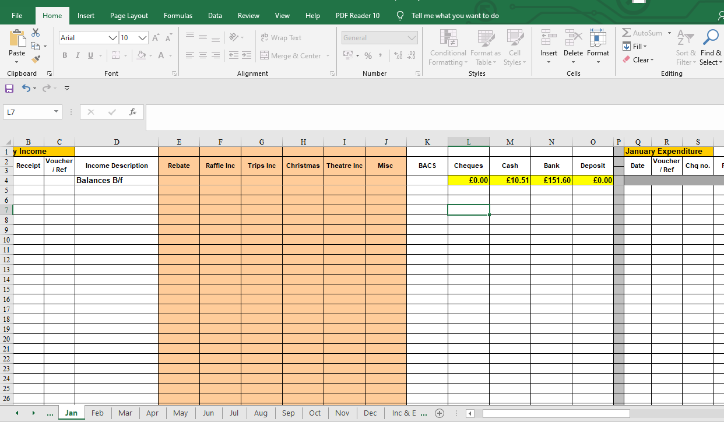

When you look at each of the monthly tabs, the left hand side of the spread sheet is for all income – money in and the right had side is for all expenditure – money out. When printed it is set to print on 2 pages, one for income and one for expenditure.

Income
A receipt should be issued for all income and the receipt number is entered in column B, (receipt pads can be obtained from HASSRA – see website for details https://www.hassra.org.uk/receipt-pads ).
An income voucher should be completed with details of who the money was from and what it was for, number these yourself starting from 1 each year. This helps the auditors when they are doing their checks. Enter this in Column C. The person’s name goes in Column D. Make one entry into the coloured boxes in the appropriate category or use the Misc column if there is not one with the right heading. Then enter the amount in either the cheque or cash column, depending what it is.
You may have several cheque receipts at a time, so enter them all and then when you go to the bank with the cheques you put a minus figure in the cheques column and a positive figure in the bank column. This example below shows 3 cheque payments and one cash. Then the cheques being banked the next day. The new balances are then showing. However, that is just the position if you have had no expenditure.

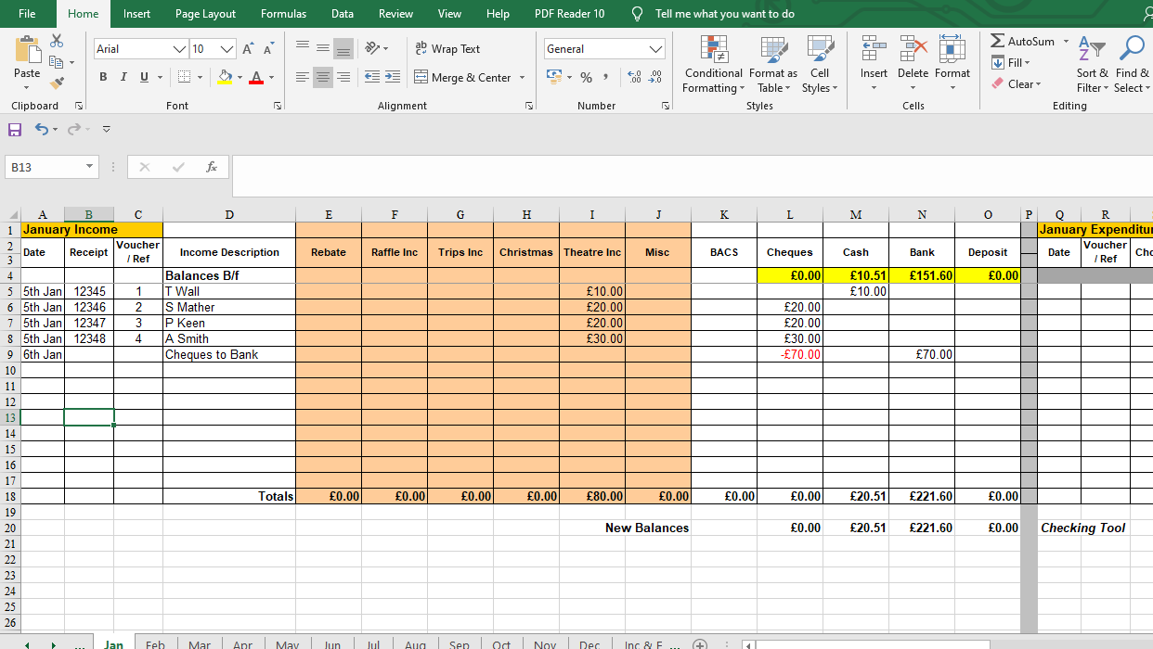

The same principle applies when you want to bank cash, put a minus figure in the cash column and a positive figure in the bank column with an explanation in the income description as Cash to Bank. Transfers between accounts do not need to be put in the coloured columns.
If you went to look at the Inc & Exp tab you will see the income appears in January details.
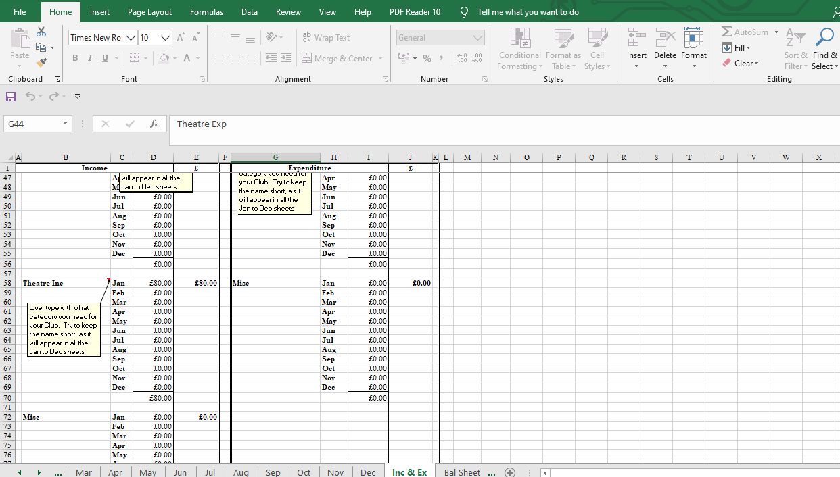

The Bal Tab also reflects these figures..
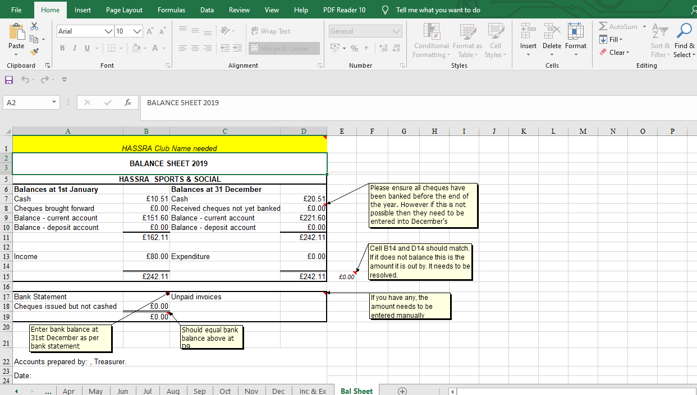

Expenditure
You need to keep an expenditure voucher for each payment you make, you can number these yourself. Go to Appendix 49 https://www.hassra.org.uk/list-of-appendices
You also need to keep a record of who approved the payment. This may be a Committee decision and is recorded in the minutes – keep a copy in the accounts to help the Auditors. It could be just the invoice, but you need to know the item has been received. If it is passed to you by email asking you to pay, keep a copy in the accounts with the appropriate voucher. If it is passed by hand, get the person to annotate the receipt that it is to be paid and for them to sign it, again retain with the voucher for the Auditors.
The entries for expenses are on the right hand side of the spread sheet, so scroll across. It looks similar.
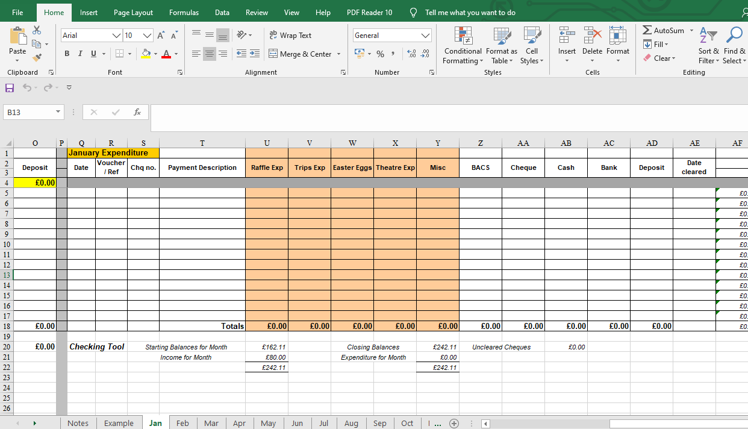
Enter in the date, voucher number, cheque number (if paying by cheque) and payment description. Then the amount needs to be added into the appropriate coloured column. If a bank payment, enter the amount into one of the columns headed up Bacs & Cheques and then also in the bank column. Cash needs just one entry into the cash column.
This shows an entry for 2 cheques and one cash payment, each has been included in the coloured section under the appropriate spend. You will notice the column AF has figures in it. It is for Bank reconciliation and we will deal with that later.
The other think to note is that there is a Checking tool under the columns. These 2 figures should balance, if they don’t there has been an error in entering the details so go back and check.
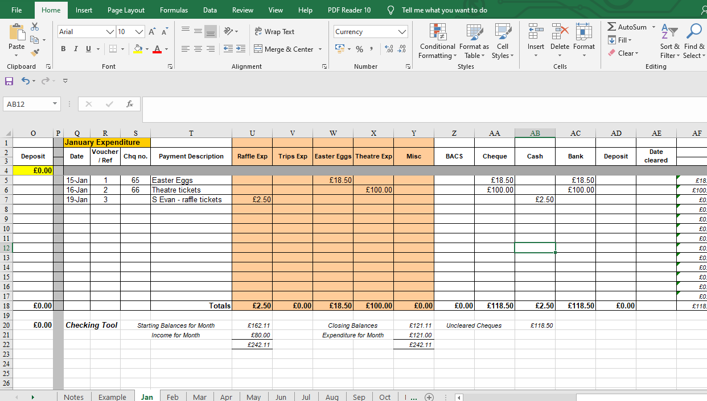
If we go back and look at the Income side of the spread sheet the balances have changed to take account of the payments made.
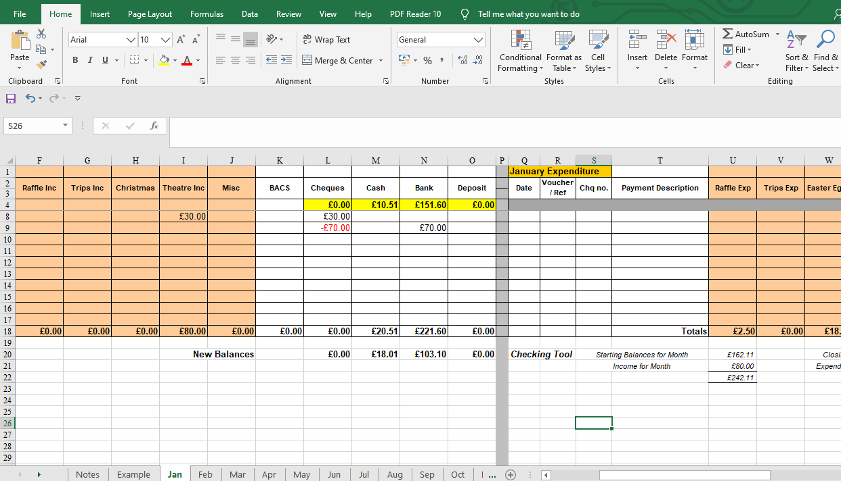

The Inc & Exp sheet now includes these expenses
Income |  |  |  | £ |  | Expenditure |  |  | £
 | Rebate | Jan | £0.00 | £0.00 |  | Raffle Exp | Jan | £2.50 | £2.50
 |  | Feb | £0.00 |  |  |  | Feb | £0.00
 |  | Mar | £0.00 |  |  |  | Mar | £0.00
 |  | Apr | £0.00 |  |  |  | Apr | £0.00
 |  | May | £0.00 |  |  |  | May | £0.00
 |  | Jun | £0.00 |  |  |  | Jun | £0.00
 |  | Jul | £0.00 |  |  |  | Jul | £0.00
 |  | Aug | £0.00 |  |  |  | Aug | £0.00
 |  | Sep | £0.00 |  |  |  | Sep | £0.00
 |  | Oct | £0.00 |  |  |  | Oct | £0.00
 |  | Nov | £0.00 |  |  |  | Nov | £0.00
 |  | Dec | £0.00 |  |  |  | Dec | £0.00
 |  |  | £0.00 |  |  |  |  | £2.50
 | Raffle Inc | Jan | £0.00 | £0.00 |  | Trips Exp | Jan | £0.00 | £0.00
 |  | Feb | £0.00 |  |  |  | Feb | £0.00
 |  | Mar | £0.00 |  |  |  | Mar | £0.00
 |  | Apr | £0.00 |  |  |  | Apr | £0.00
 |  | May | £0.00 |  |  |  | May | £0.00
 |  | Jun | £0.00 |  |  |  | Jun | £0.00
 |  | Jul | £0.00 |  |  |  | Jul | £0.00
 |  | Aug | £0.00 |  |  |  | Aug | £0.00
 |  | Sep | £0.00 |  |  |  | Sep | £0.00
 |  | Oct | £0.00 |  |  |  | Oct | £0.00
 |  | Nov | £0.00 |  |  |  | Nov | £0.00
 |  | Dec | £0.00 |  |  |  | Dec | £0.00
 |  |  | £0.00 |  |  |  |  | £0.00
 | Trips Inc | Jan | £0.00 | £0.00 |  | Easter Eggs | Jan | £18.50 | £18.50
 |  | Feb | £0.00 |  |  |  | Feb | £0.00
 |  | Mar | £0.00 |  |  |  | Mar | £0.00
 |  | Apr | £0.00 |  |  |  | Apr | £0.00
 |  | May | £0.00 |  |  |  | May | £0.00
 |  | Jun | £0.00 |  |  |  | Jun | £0.00
 |  | Jul | £0.00 |  |  |  | Jul | £0.00
 |  | Aug | £0.00 |  |  |  | Aug | £0.00
 |  | Sep | £0.00 |  |  |  | Sep | £0.00
 |  | Oct | £0.00 |  |  |  | Oct | £0.00
 |  | Nov | £0.00 |  |  |  | Nov | £0.00
 |  | Dec | £0.00 |  |  |  | Dec | £0.00
 |  |  | £0.00 |  |  |  |  | £18.50
 | Christmas | Jan | £0.00 | £0.00 |  | Theatre Exp | Jan | £100.00 | £100.00
 |  | Feb | £0.00 |  |  |  | Feb | £0.00
 |  | Mar | £0.00 |  |  |  | Mar | £0.00
 |  | Apr | £0.00 |  |  |  | Apr | £0.00
 |  | May | £0.00 |  |  |  | May | £0.00
 |  | Jun | £0.00 |  |  |  | Jun | £0.00
 |  | Jul | £0.00 |  |  |  | Jul | £0.00
 |  | Aug | £0.00 |  |  |  | Aug | £0.00
 |  | Sep | £0.00 |  |  |  | Sep | £0.00
 |  | Oct | £0.00 |  |  |  | Oct | £0.00
 |  | Nov | £0.00 |  |  |  | Nov | £0.00
 |  | Dec | £0.00 |  |  |  | Dec | £0.00
 |  |  | £0.00 |  |  |  |  | £100.00
 | Theatre Inc | Jan | £80.00 | £80.00 |  | Misc | Jan | £0.00 | £0.00
 |  | Feb | £0.00 |  |  |  | Feb | £0.00
 |  | Mar | £0.00 |  |  |  | Mar | £0.00
 |  | Apr | £0.00 |  |  |  | Apr | £0.00
 |  | May | £0.00 |  |  |  | May | £0.00
 |  | Jun | £0.00 |  |  |  | Jun | £0.00
 |  | Jul | £0.00 |  |  |  | Jul | £0.00
 |  | Aug | £0.00 |  |  |  | Aug | £0.00
 |  | Sep | £0.00 |  |  |  | Sep | £0.00
 |  | Oct | £0.00 |  |  |  | Oct | £0.00
 |  | Nov | £0.00 |  |  |  | Nov | £0.00
 |  | Dec | £0.00 |  |  |  | Dec | £0.00
 |  |  | £80.00 |  |  |  |  | £0.00
 | Misc | Jan | £0.00 | £0.00
 |  | Feb | £0.00
 |  | Mar | £0.00
 |  | Apr | £0.00
 |  | May | £0.00
 |  | Jun | £0.00
 |  | Jul | £0.00
 |  | Aug | £0.00
 |  | Sep | £0.00
 |  | Oct | £0.00
 |  | Nov | £0.00
 |  | Dec | £0.00
 |  |  | £0.00
 | Sub Totals |  |  | £80.00 |  |  |  |  | £121.00
 |  |  |  |  |  | EIOE/EEOI |  |  | -£41.00
 |  |  |  | £80.00 |  |  |  |  | £80.00

And the Balance sheet includes all of these and still balances.
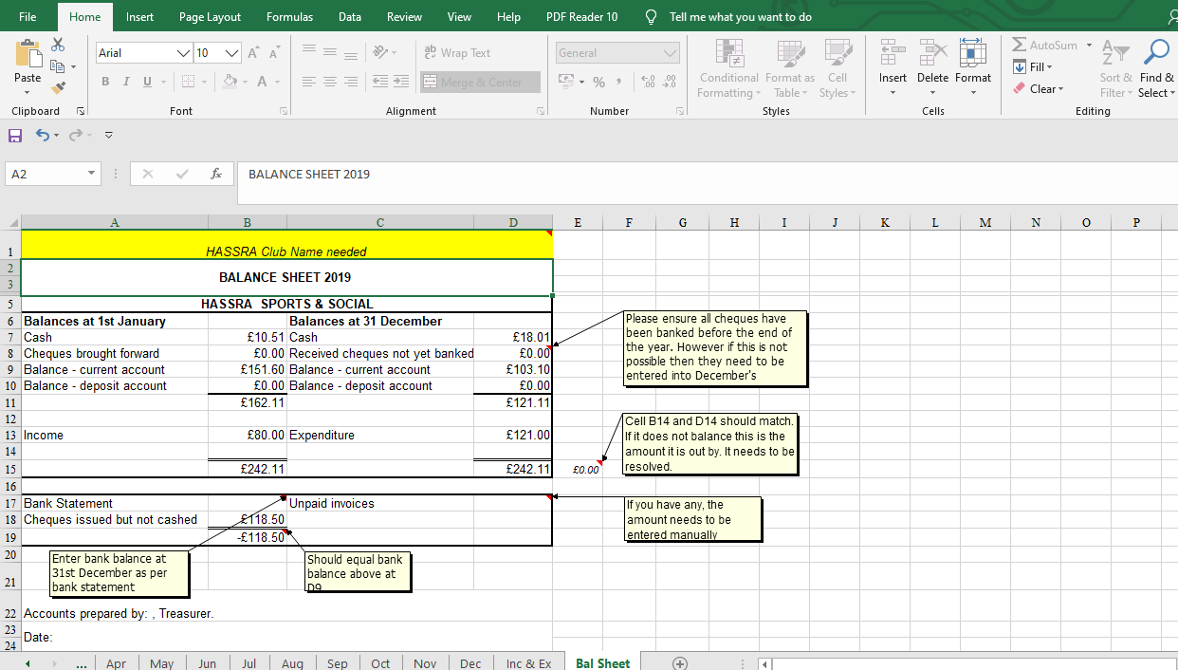

Monthly Bank statement reconciliations.
The Bank statement always goes to the Chair, who needs to copy it and give it to the Treasurer so that they can reconcile the accounts against the bank statement. As per the Staff Clubs Guide the Chair needs to:
Ensure that the actual cash in hand and the bank statement balance against the Cashbook balances at the end of each month and that a certificate to that effect is signed by the Treasurer and by you.

Once the Treasurer has completed the reconciliation for the month, then they need to print a copy off and the Chair and Treasurer can sign it.
The reconciliation needs to be done line by line. Any cheques that have been issued need to be marked on the spread sheet as having gone through the Bank, when it appears on the statement, this is done by putting the date it cleared in the AF column in the appropriate month. This then clears it from the ‘Uncleared Cheques’
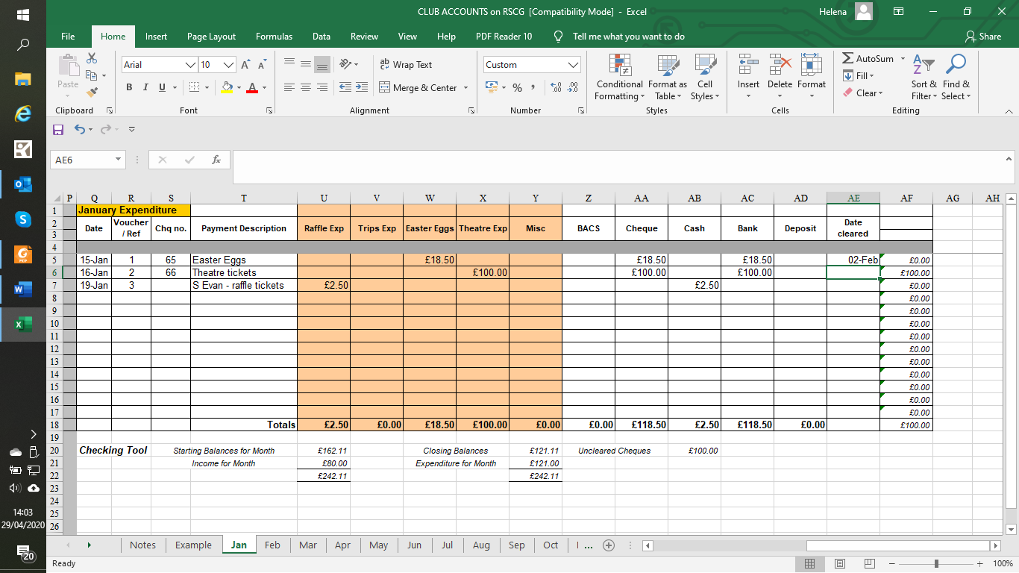
In the example above, one cheque cleared on the February statement but there is a cheque that has not been presented to the Bank yet, so is still outstanding. (Cheques are valid for 6 months so if it is still outstanding after this time it is written back into the accounts in the appropriate month as income with the description ‘Uncashed cheque not cash within 6 months’).

Year End
This always runs been the 1st January and the 31st December for HASSRA accounts. When we look at the end of the year we just need a balanced set of accounts. This spread sheet totals the Income & Expenditure that you have done over the year and that is then drawn through to the Balance sheet.
It is a simple statement of what you started with, plus what you have had in as income, against what you have spent and what you have left.
The spread sheet does your year-end but you need to be aware that if entries have been made incorrectly then it won’t balance. The easy way to look is in column E, if the accounts balance then this should show £0.00, if it is anything else then there is an error with the inputting of the information, look back at each month at the checking tool, that will show you where it went wrong.

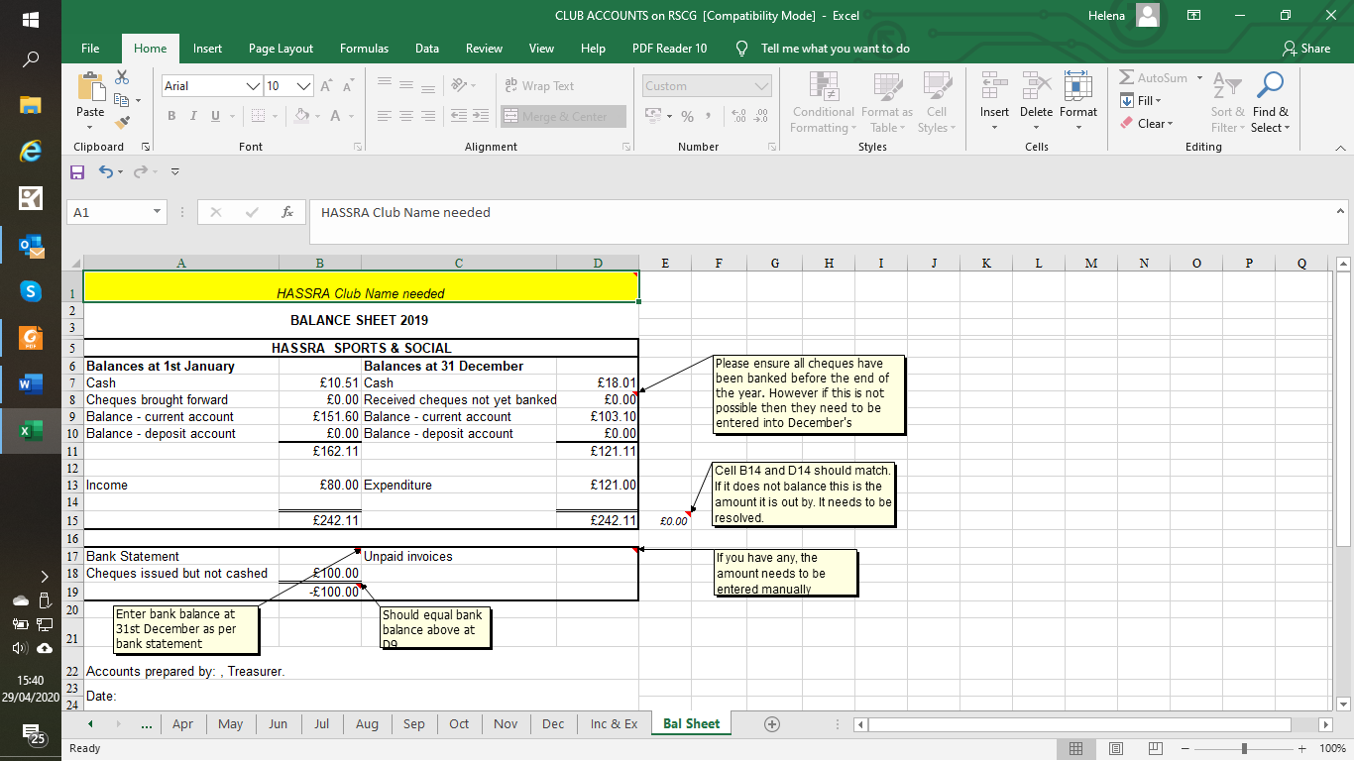
You need to enter in the bank statement entry as at 31st December into the appropriate box on line 17 as this may not be the same as the amount in your accounts. This would be because cheques you have issued have not been cashed. The spread sheet has taken account of that. The figure on line 19 should match the Current account balance.

Audits. The Auditors role is to check that all is in order with the accounts. This is done by 2 Auditors, one nominated by your Sponsor and the other is elected at the previous year’s AGM. The Running Staff Club guide gives details of checks needed to be done, as does appendix 39 found on the HASSRA Live https://www.hassra.org.uk/list-of-appendices It is easier for them if you can keep all the paperwork together in date order, if there is a lot it may be better to sort it and label it up into months. If you can keep in mind when you are doing the accounts that the Auditors need to follow what you have done, so remember to do all the paperwork correctly. The starting point should be the previous years audit so include a copy of that. This give details of the amounts of cash and what is in the bank.
Once the audit has been done a copy of the signed balance sheet needs to be sent to National HASSRA. It can be a scanned copy sent by email. Contact details of where to send it can be found at https://www.hassra.org.uk/bulletins Bulletin 4. The accounts can then be issued locally for your Club AGM. It has to be available 14 days before the AGM.
Go to HASSRA Live https://www.hassra.org.uk/list-of-appendices and then Appendix 36 for the summary of the roles and responsibilities of the Treasurer.

Further information

Unpresented cheques from the previous year’s accounts

These do not need to be brought through to the new year’s accounts as they have been accounted for, but you do need to remember to clear them still as they will show on the bank statements. And if they are never cashed then it will mean that your accounts will not balance against the bank statement.
As you should never alter a set of accounts that the Auditors have signed off then I suggest you make a copy of that year’s accounts and save it as ‘Accounts 20** Unpresented Cheques’ or similar in the title.
When the cheques appear on the bank statement clear from the duplicate set of accounts. If after 6 months you still have unpresented cheques, then the cheques have expired and cannot be cashed. These need to be written back into the current years accounts as an income, i.e. enter as ‘Cheque number ?? not presented, now over 6 months old and the amounts entered in one of the coloured column, probably Misc and in the bank column.

