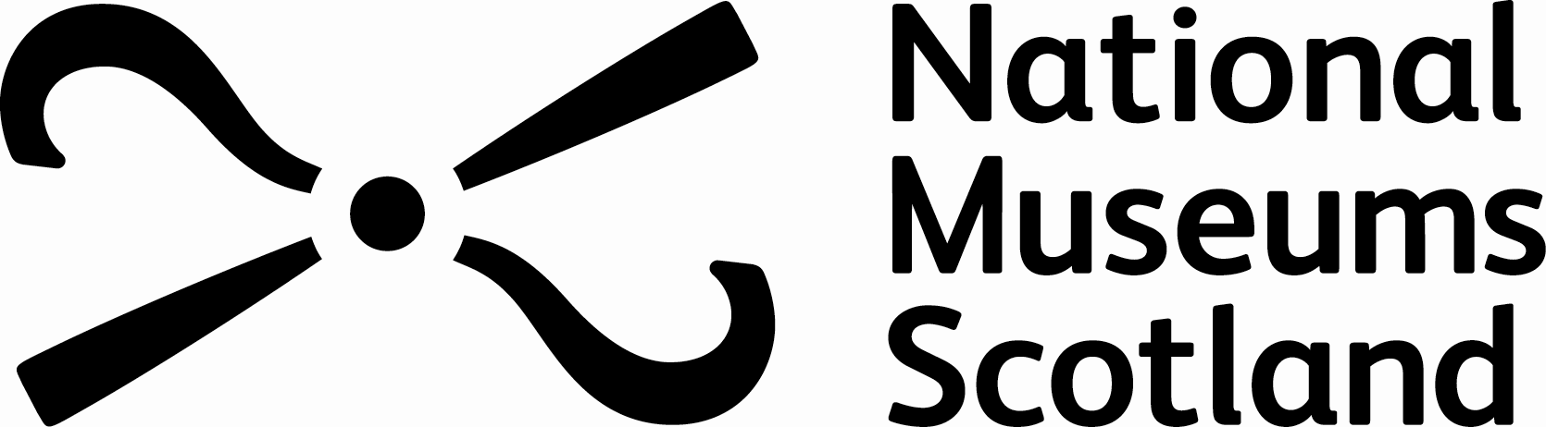

A reminder of your Membership Benefits

All Members enjoy

- Free entry to our museums
- Free and priority access to our exhibitions
- Exclusive Museum Member events and special offers
- Discounts in our cafés and shops

National Museum of Scotland, Edinburgh

- Free entry to charging exhibitions
- Discounts on workshops and other public events
- 10% discount in museum shop
- 20% discount in café

National Museum of Flight, East Fortune, East Lothian

- Free entry to museum
- 10% discount in shop
- 20% discount in the Aviator café
- Discounts on annual Airshow

National War Museum, Edinburgh Castle

- 10% discount on Castle admission prices
- 10% discount in the museum shop

National Museum of Rural Life, East Kilbride

- Free entry to museum
- 10% discount in shop
- 20% discount in our country café

