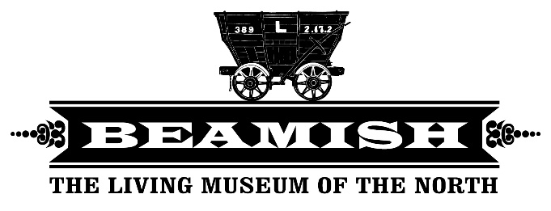

HASSRA North East Beamish Museum Booking Form
Name of HASSRA NE member
HASSRA number
Number of people attending. Please do not include any children under 5yrs
Contact Email
Contact Number
Booking date
(first preference)
Please put this in your email title
Booking date
(second preference)
Booking date
(third preference)

HASSRA North East has 25 corporate passes for all HASSRA North East members to use for free entry to Beamish museum. Do not include children under 5 in the number of your party
We ask you to provide up to 3 preferences for your booking date as due to the popularity of the passes we may not be able to guarantee your first choice. Dates must be submitted at least 1 week in advance.
Once completed please send this form to hassranortheast.beamish@dwp.gov.uk
Please put your first option date in the email title to enable us to prioritise emails

