Chocolate Orange Challenge – Team North East
2019
Chocolate Orange Challenge
The Chocolate Orange Challenge was started in 2008 by Chris Lamb, DWP (Peel Park, North West). This is Chris’ story…………My son Elliott was in Alder Hey hospital with pneumonia. The physiotherapist looking after him did such a good job in taking care of Elliott that I bought them a Chocolate Orange each to say thank you and word soon got around. Sadly, Elliott passed away at Christmas time 2010. He was such a brave little boy and showed so much courage. I learned so much from him in those four years than I ever did before he came along. He is still an inspiration in death as he was in life and I wanted his memory to live on in others in knowing you are not alone through difficult times.
Team North East - This is our sixth year supporting the Chocolate Orange Challenge. Let’s hope we can smash last year’s total of 2041 to show our ‘Thanks’ and support to the brilliant charities, foundations, hospitals and hospices who support our loved ones in the North East. Here are some of the great people you have thanked over the past 5 years.
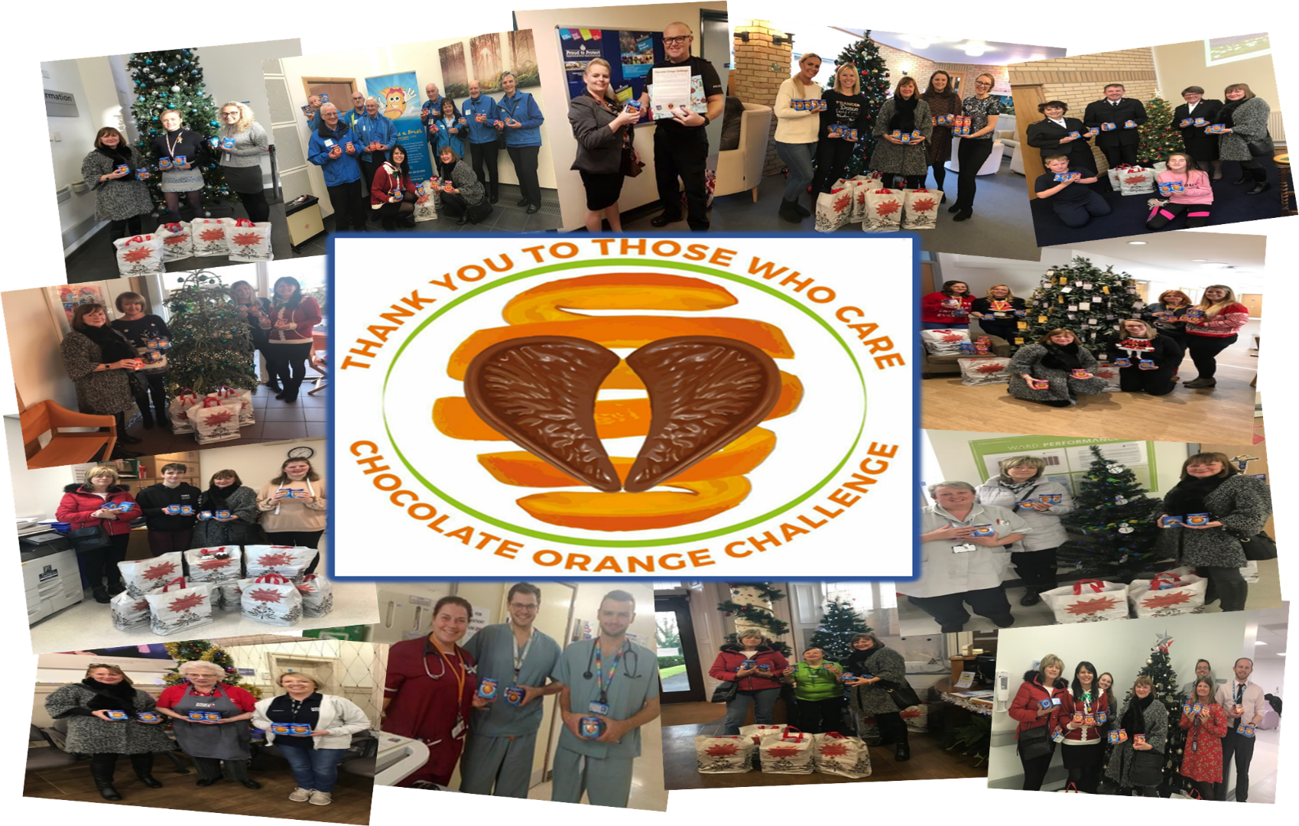
Colin Berry  Dawn Baxter  Alan Soulsby  Lauren Ratcliffe  Lynn Drewitt | colin.berry@dwp.gov.uk  dawn.baxter@dwp.gov.uk  alan.soulsby@dwp.gov.uk  lauren.ratcliffe1@dwp.gov.uk  lynn.drewitt@dwp.gov.uk | BP6002  BP6302  BP9051  BP9202  BP9151 | BPV  BPV  BPV  BPV  BPV
How you can help
If you would like any more information or would like to donate a Chocolate Orange (or you can donate your money and I will purchase the goodies on your behalf), please contact me and I will be happy to collect. You can also drop off donations to any of the team as follows or any tea point across the BPV site where you see the collection boxes.
Caroline Bullivant | caroline.bullivant@dwp.gov.uk | BP5101 | BPV
We could not do this challenge without the huge support from our colleagues across DWP and HMRC and our family and friends across the North East and we are so pleased they continue to support us in this our 6th year as Team North East continues to expand across Benton Park View, Tyne View Park and Waterview Park. Drop off points for Team North East are as follows or the DWP Tech Bar in Building 9 ground floor (BP9051) are happy to take your donations:
Twitter: @chocoranges
#chocoranges

Facebook
Team Chocolate Orange

Social media managed by: Chris Lamb
The Chocolate Oranges will be distributed from Friday 13th December #Make A Difference Friday and your support would be very much appreciated to make this an even bigger event this year in supporting loved ones and the memory of Elliott Lamb.
Thank You from Chocolate Orange Challenge – Team North East

2019 Chocolate Orange Challenge
Team North East
BPV & TVP ‘Thank You’
A huge ‘Thank You’ to everyone who donated to this year’s 2019 Chocolate Orange Challenge. With your generous donations we have collected 2,533 chocolate oranges across DWP & HMRC sites BPV, TVP and WVP, delivering to the following good causes.

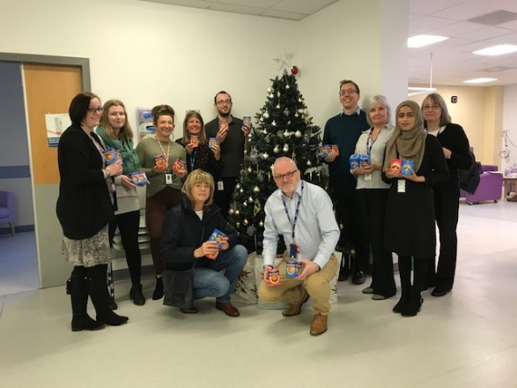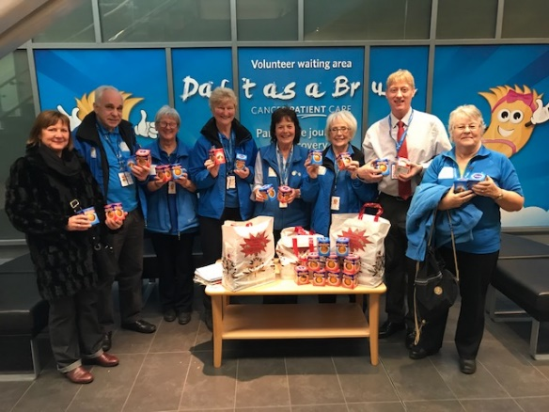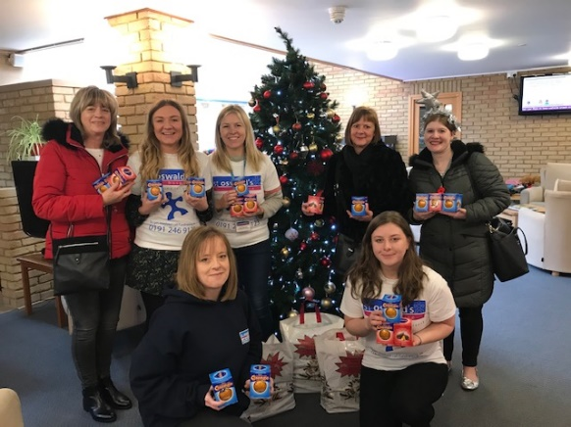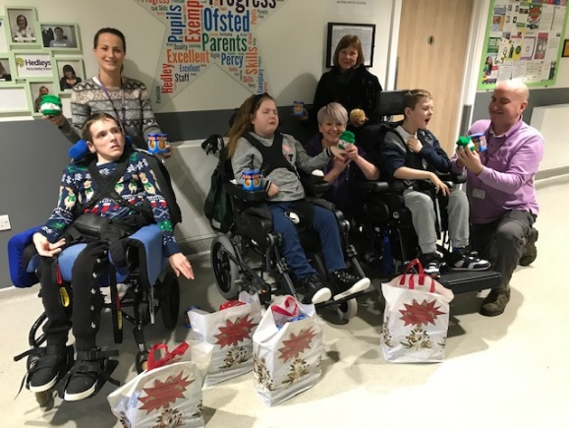
St Oswald’s Hospice & Children’s Hospice
Sir Bobby Robson Foundation Daft as Brush (Freeman Hospital St Oswald’s Hospice Percy Hedley Foundation
& Children’s Hospice
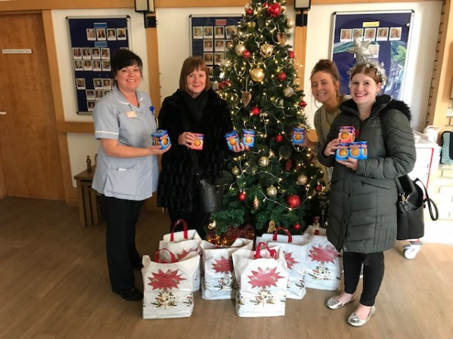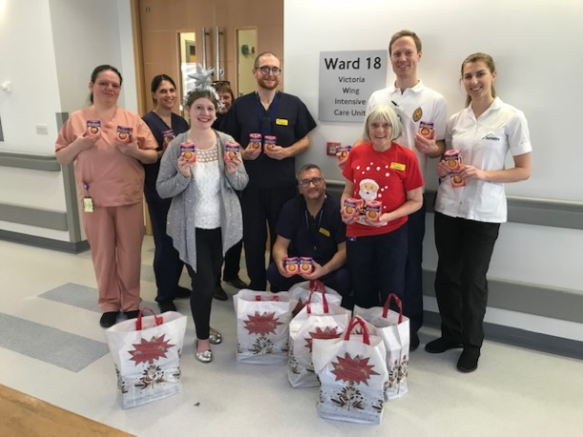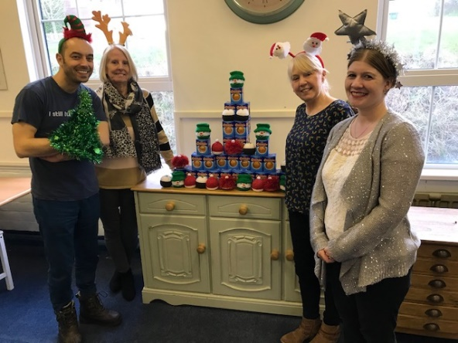
Marie Curie Hospice Alan Shearer Foundation RVI ICU Ward 18 Carers Trust, Rowlands Gill

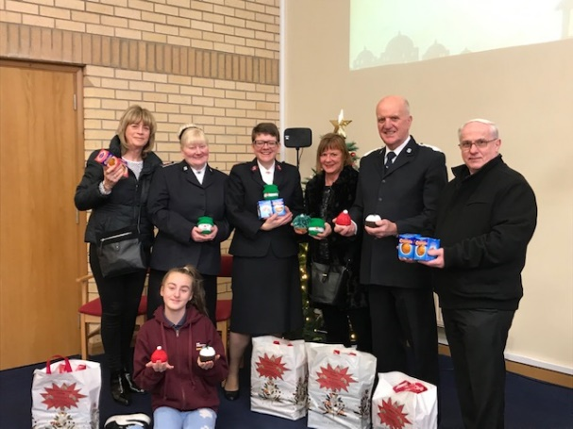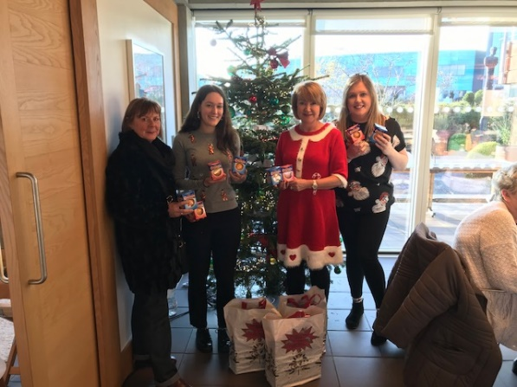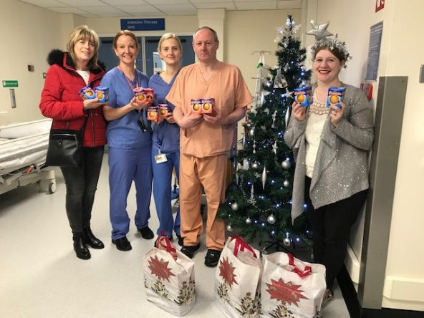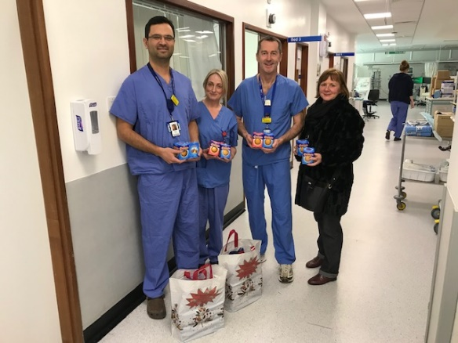

Salvation Army Maggies Freeman Hospital RVI HDU Ward 38 Freeman Hospital ICU
Chocolate Orange Challenge
Team North East

Due to the number of photos taken with the worthy charities, a separate poster has been produced for HMRC WVP.

Thank you to the following volunteers who have supported me once again, I couldn’t have done it without you.

Many thanks,
Caroline Bullivant

DWP Lynn Drewitt, Lauren Ratcliffe, Alan Soulsby, Tanya Reay, Colin Berry, Aaron Schubler, Jackie Dawson, Kay Burns, Gillian Richardson, Doreen Patterson, Dawn Baxter, Darren Maughan, Kyle Calvert, Helen Smith, Kathryn Clark, Zoe Heslop, and Karen Wade.

HMRC Ann Marie Ward, Will Marshall, Amanda Johnson, Catherine Chandler, Wayne Bilbrough, Candy Bowen, Rachel Best, Charlotte Kellacher, Ali Benson, Kelly Poppleton, Shauna Stonehouse, Sharon Collins and Leanne Johnson.

Thank you to Jill Webster (Retired DWP) for making a number of festive covers for the chocolate oranges which were donated specifically to charities with children and her continued support on #Mad Friday delivery day.

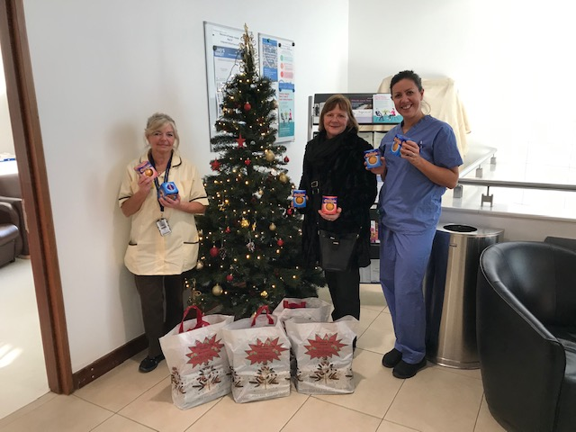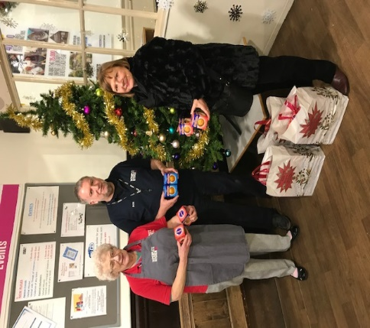
Freeman Hospital HDU The People’s Kitchen
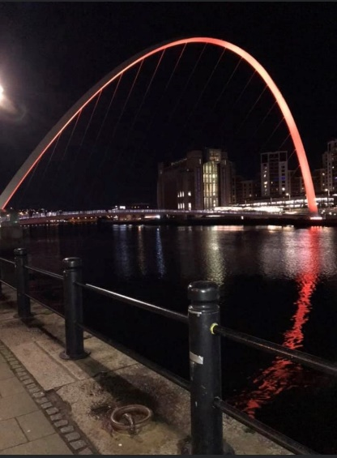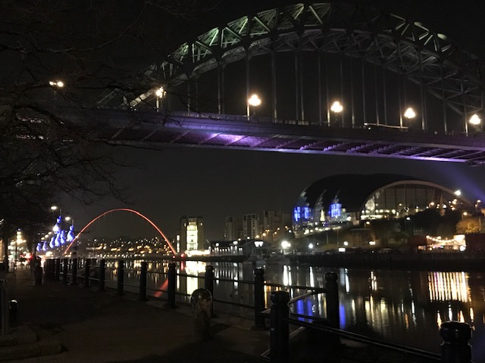
The Gateshead Millenium Bridge lit up orange in memory of
Elliott Lamb who inspired this challenge.
Congratulations to Elliott’s Dad Chris Lamb (DWP North West) who has been awarded with a British Empire Medal (BEM) in the Queen’s New Year 2020 Honours list for services to charity and the Civil Service Lifeboat Fund, a deserving reward – Well Done Chris!
2019 Chocolate Orange Challenge
Team North East
WVP ‘Thank You’
A huge ‘Thank You’ to everyone who donated to this year’s 2019 Chocolate Orange Challenge. With your generous donations we have collected 2,533 chocolate oranges across DWP & HMRC sites BPV, TVP and WVP, delivering to the following good causes.
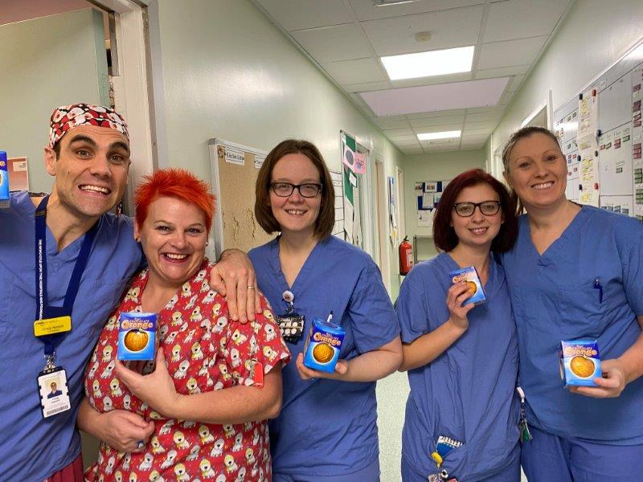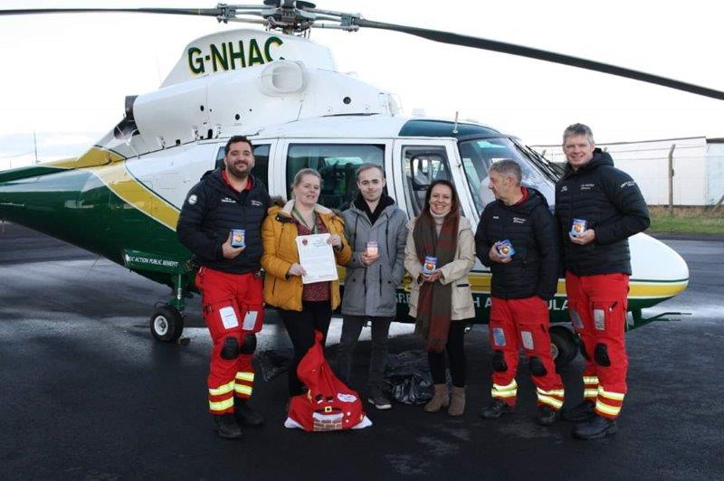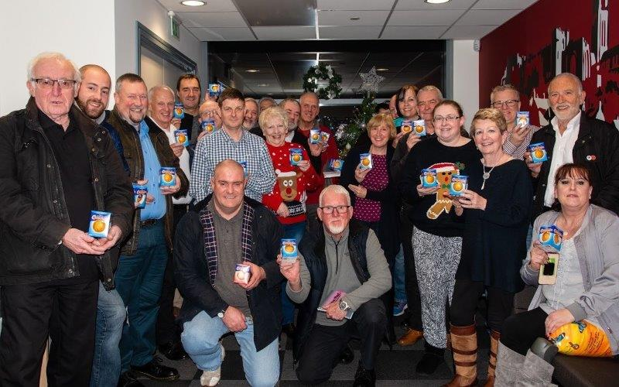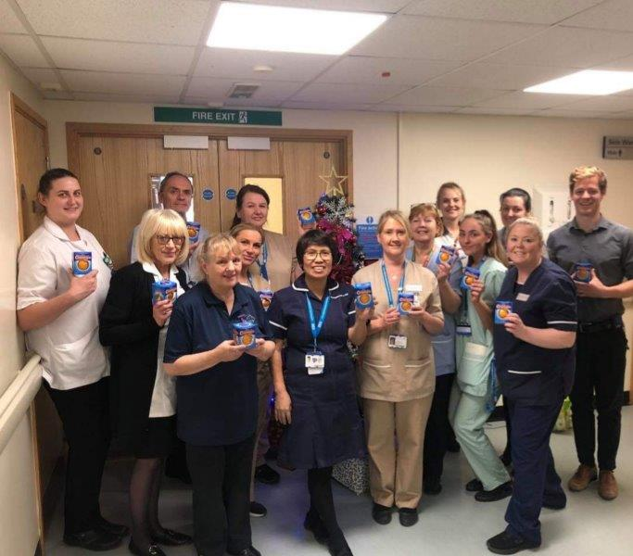
St Oswald’s Hospice & Children’s Hospice
Radiology QE Hospital Air Ambulance North East Blood Bikes Northumbria Ward C36 Sunderland
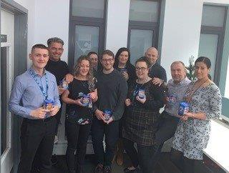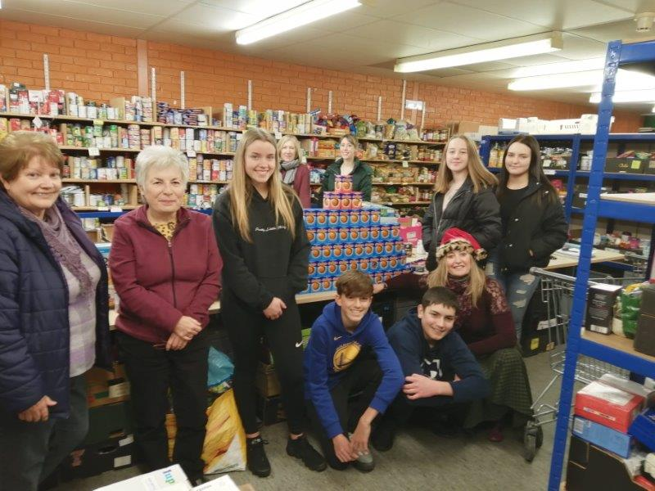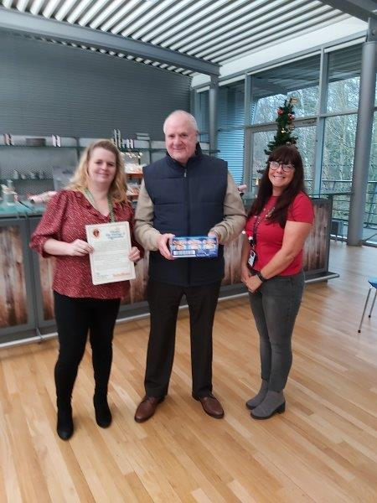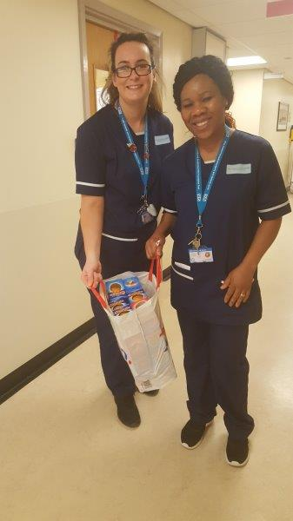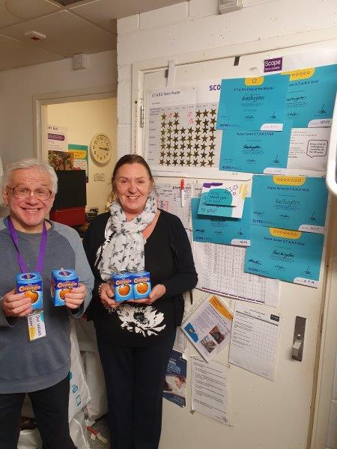
Sunderland Mental Health Hospitality & Hope People’s Kitchen Phoenix Suite Scope
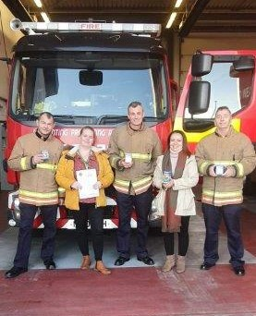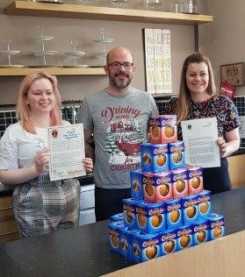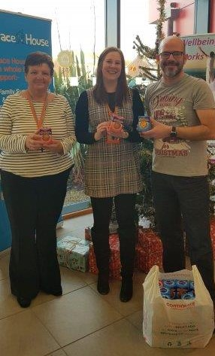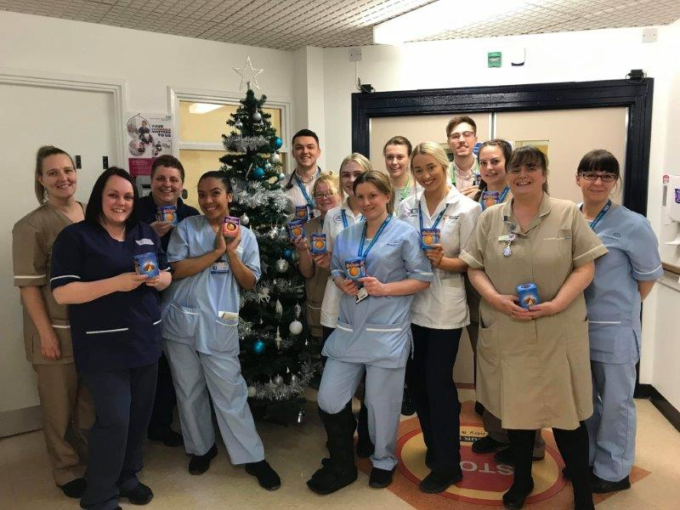

Washington Fire Station Mind Washington Grace House Ward D41 Sunderland
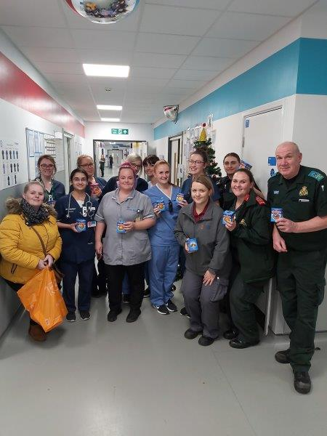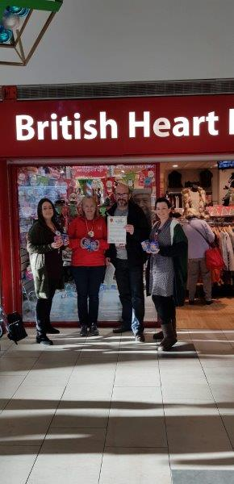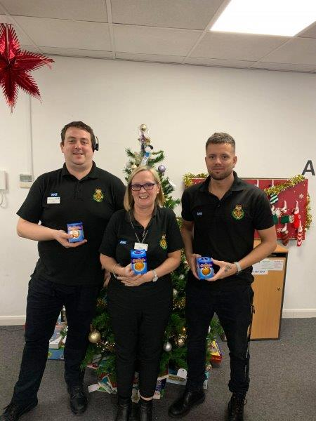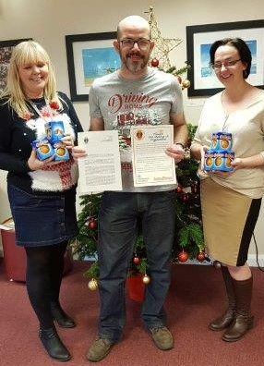
Chocolate Orange Challenge
Team North East
Due to the number of photos taken with the worthy charities, a separate poster has been produced for DWP & HMRC BPV and TVP.
Thank you to the following volunteers who have supported me once again, I couldn’t have done it without you.
Many thanks,
Caroline Bullivant
HMRC Ann Marie Ward, Will Marshall, Amanda Johnson, Catherine Chandler, Wayne Bilbrough, Candy Bowen, Rachel Best, Charlotte Kellacher, Ali Benson, Kelly Poppleton, Shauna Stonehouse, Sharon Collins and Leanne Johnson.
DWP Lynn Drewitt, Lauren Ratcliffe, Alan Soulsby, Tanya Reay, Colin Berry, Aaron Schubler, Jackie Dawson, Kay Burns, Gillian Richardson, Doreen Patterson, Dawn Baxter, Darren Maughan, Kyle Calvert, Helen Smith, Kathryn Clark, Zoe Heslop, and Karen Wade.
Thank you to Jill Webster (Retired DWP) for making a number of festive covers for the chocolate oranges which were donated specifically to charities with children and her continued support on #Mad Friday delivery day.
A&E at the QE Hospital, British Heart Foundation, NEAS Pallion and Care & Support
Centre Washington.
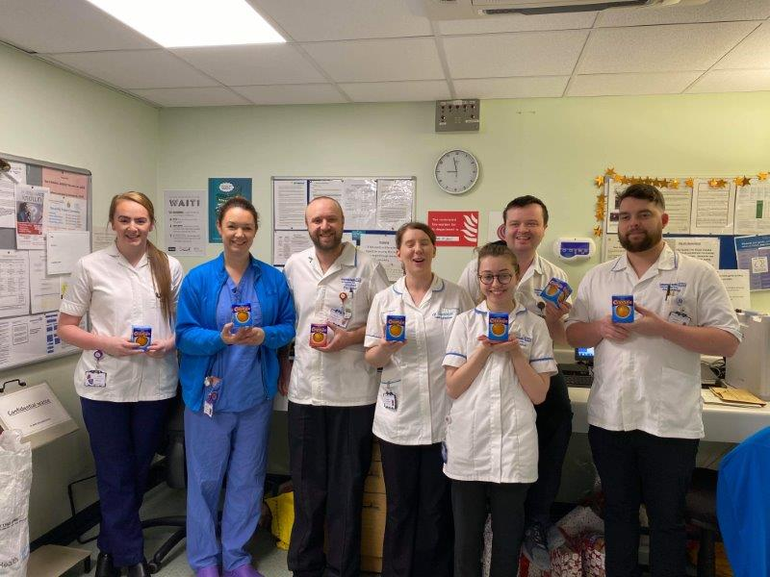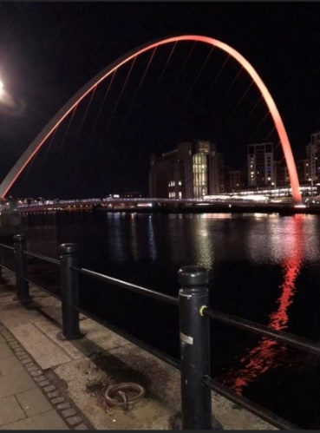
Oncology QE and the Gateshead Millenium Bridge lit up in memory of Elliott Lamb.
Congratulations to Elliott’s Dad Chris Lamb (DWP North West) who has been awarded with a British Empire Medal (BEM) in the Queen’s New Year 2020 Honours list for services to charity and the Civil Service Lifeboat Fund, a deserving reward – Well Done Chris!

