**HASSRA Torbay Sunflower Competition**



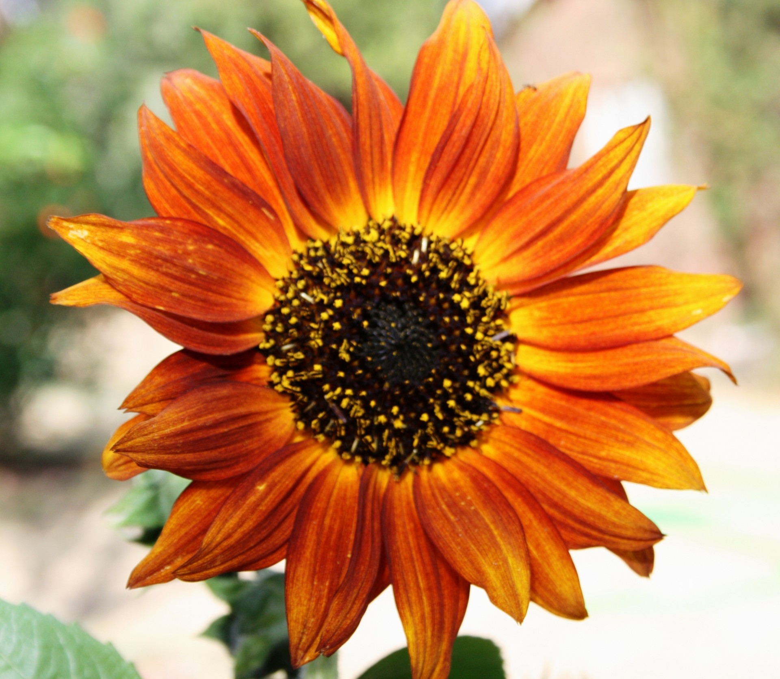

**If you’re looking for a Summer Challenge and are a HASSRA Torbay member, join our Sunflower Growing Competition**

**Grow your own Sunflower seed, or see Mark Rowe (Cotswold House) for your free seed to plant.**

**We don’t necessarily want to see the tallest, we want to see *the best*…perhaps that is the biggest, or the most colourful, or even the Sunflower that attracts the most wildlife! Your HASSRA Torbay Committee will judge once all off the entries are in.**

**Send a photo of you by your Sunflower to** [**mark.rowe@dwp.gov.uk**](mailto:mark.rowe@dwp.gov.uk) **before 02 September 2024 to enter.**

**You have a chance to win a £10 Love2Shop voucher whilst bringing some joy to your garden in the meantime.**

**Free to enter**

**Competition running April to September**

**Your chance to win a £10 Love2Shop voucher**