HASSRA Torbay Newsletter

Spring 2023

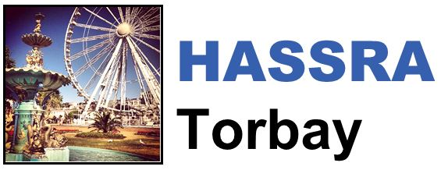

Hello and welcome to the latest edition of the HASSRA Torbay newsletter

**What’s been going on?**

Your HASSRA Torbay Committee has been busy organising various activities for you to get involved in. Thank you for taking part.

|  |  |  |
| --- | --- | --- |
| **Sports Rebate**  Picture of a variety of sporting equipment  Lots of you took advantage of the £10 January/February sports rebate.  We hope you enjoyed getting sporty without all the usual expense. | **Love to Bake**  Picture of a pink cake  Congratulations to our baking competition winners, we hope you enjoy spending your vouchers. Lisa’s prosecco cake came out on top, but they all looked yummy | **HASSRA = Happiness**  Picture of a camera  We’ve loved seeing your photos and reading your stories about why you love HASSRA.  Winners will be announced soon. |

**HASSRA = Happiness**

In each newsletter, one of our members tells us about how they have been making the most of their membership. This Spring, we’ve been talking to Tara Sanders in Torquay Service Centre.

“In February, my partner and I visited Cardiff to see the Wales Vs England 6 Nations Rugby Union match. The atmosphere was amazing…even the atmosphere between me and my partner was friendly, despite me being a Wales fan and him being an England fan! We had a great view from our seats, and even had The Prince and Princess of Wales sat near to us. Despite Wales losing, it was a really fun day out.”



“The day was made even better with us being HASSRA Torbay members and being able to claim rebates on our tickets. We received £10 per member for the January/February HASSRA Torbay Sports Rebate and £5 per member for the HASSRA South West Live Events Rebate. After a fairly expensive day out, receiving that money back certainly helped.”

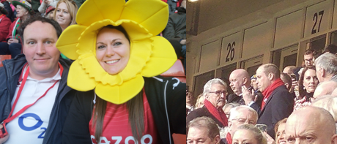

If you would like to be featured in a future newsletter, email your HASSRA story and photos to Tara Sanders



**What’s coming up?**

Keep an eye out for these Spring activities:

* On-site Easter activities funded by HASSRA Torbay
* Visit the Civet: Shaldon Zoo photo competition
* King’s Coronation Quiz

**Featured offers of the month**

* Cinemas – Save up to 40% on Cinema Tickets
* Tastecard – A special price at only £10 for HASSRA Members

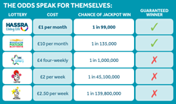

### HASSRA lottery logo in blue and yellowHassra Lottery

As a HASSRA member, you can participate in the HASSRA Lottery. You can buy up to 20 lottery tickets/month at £1 each to increase your chances of winning.

You’ve got to be in it to win it…we see regular South West winners, so sign up now!

Find out more through this link: [HASSRA Lottery](https://www.hassra.org.uk/lottery)

Remember to regularly check your HASSRA Live Account for all the latest National and South West offers and competitions: [Link to HASSRA Live](https://www.hassra.org.uk/sign-in?return_url=%2F%3FpxRatio%3D1.5&return_key=2d67aef2f8aedb0c905eedbfda14cfcccea7da3c7f09266af1d4f49828dcbac5)