

HASSRA Torbay Newsletter

Spring 2024

Hello and welcome to the latest edition of the HASSRA Torbay newsletter

**What’s been going on?**

Your HASSRA Torbay Committee has been busy organising various activities for you to get involved in. Thank you for taking part.

|  |  |  |
| --- | --- | --- |
| **HASSRA Live Competition**  A hand picking B from a list of A, B, C, D  Since our last newsletter, we’ve held 3 HASSRA Live Competitions, each giving out a £10 Love2Shop voucher – Keep an eye out as there are more to come! | **Winter activity rebate**    We gave rebates for Winter activities and events of up to £10 each to our members throughout December and January. | **Wellbeing offers**    We gave our 5 HASSRA Torbay sites funding towards Easter or wellbeing activities, promoting the Mental Health ‘Time to Talk’ initiative. |

We have a Sunflower Competition running from April to September.

Grow your own seed or contact [mark.rowe@dwp.gov.uk](mailto:mark.rowe@dwp.gov.uk) for a free seed. The photo of the best sunflower (whether that be the tallest, the biggest, the most colourful or something else) will win a £10 Love2Shop voucher.

**HASSRA = Happiness**

In each newsletter, one of our members normally tells us about how they have been making the most of their membership, but for this edition, we have something a bit different…our committee member Mark Rowe tells us about his recent attendance at the HASSRA South West Annual General Meeting (AGM) where he was **very happy** as HASSRA Torbay won a lot of awards!

“I attended the South West HASSRA AGM in Mid-March which was held at Taunton Racecourse. I was invited by the South West Committee as I had been nominated for an award. HASSRA Torbay Committee Members Jean Davis and Steve Powley also came along – I’d been to this type of event before, but it was their first time. They loved it so much that Steve will be attending the National HASSRA AGM and awards with me in May at the University of Warwick.

It was lovely meeting new HASSRA South West members, and seeing some familiar faces too. The South West Committee members were elected, and then we had productive discussions in groups, talking about what different clubs were doing to retain and encourage membership, and how we could improve HASSRA in general for our members. I picked up some good ideas which I’ve shared with our Committee..so watch this space for some new and exciting HASSRA Torbay activities in the future.

After lunch, we did a team building, Easter bonnet activity, where I ended up being our team’s model for a few moments…I was decorated as well as the Easter bonnet! It was all such good fun.

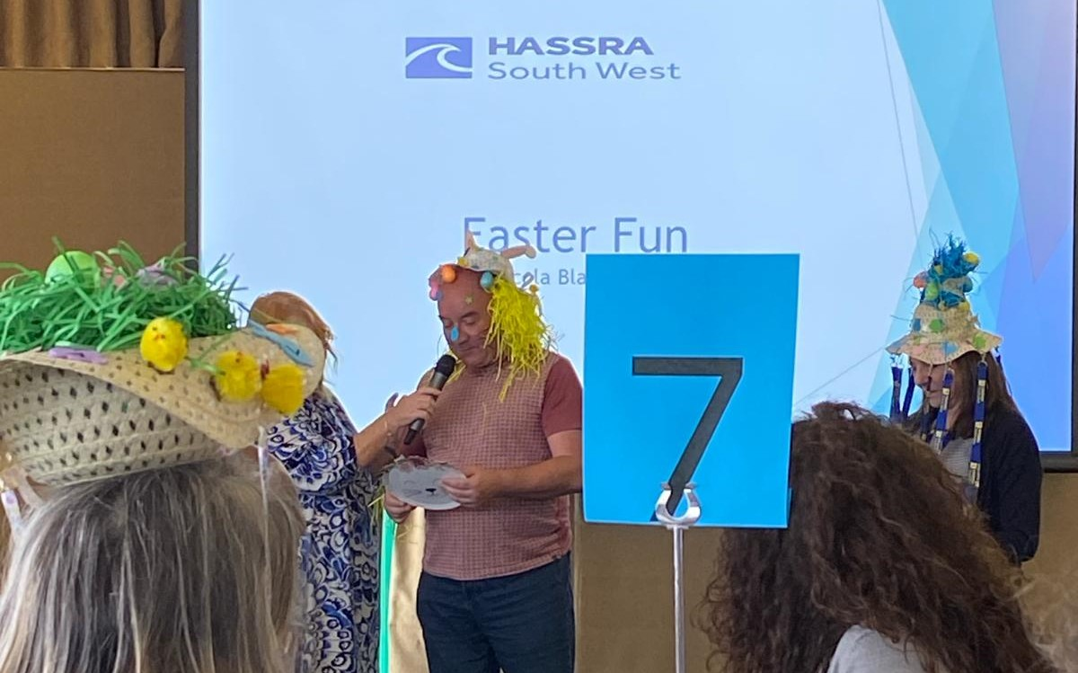

Once the festive activities were over, it was time for the South West Awards Ceremony. HASSRA Torbay had 8 nominations, almost one in every category..and we took home a few awards. Drum roll please….

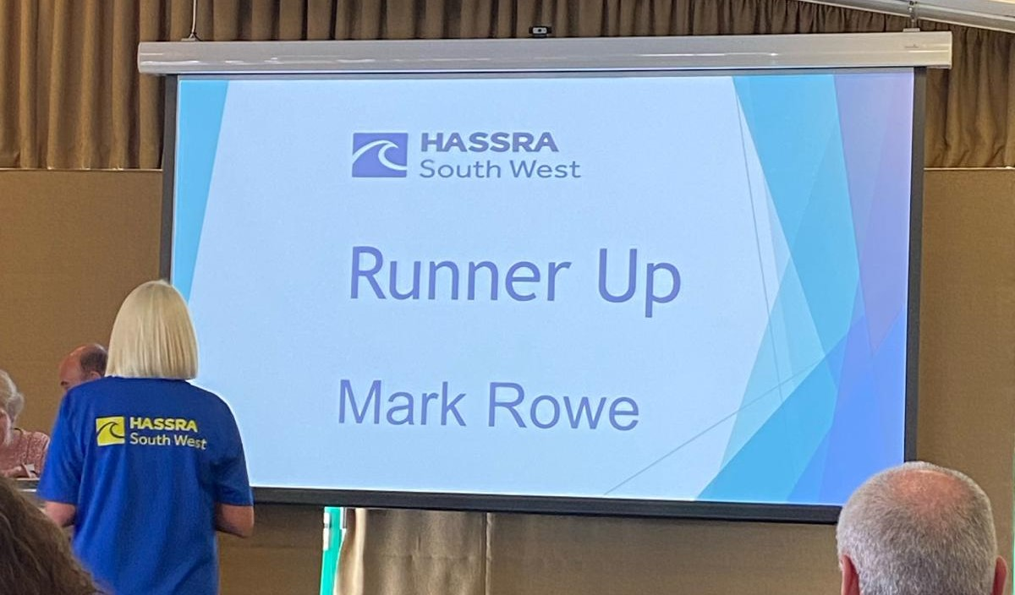

* Steve Powley won best newcomer
* Naomi Pearse won best ‘non-sporting’
* Our club won best innovation award for our SharePoint Page
* I was runner up of volunteer of the year

I feel very proud to be part of this club. The HASSRA Torbay Committee work very hard to provide great value for money for our members, it felt brilliant to be recognised for our commitment to members.”

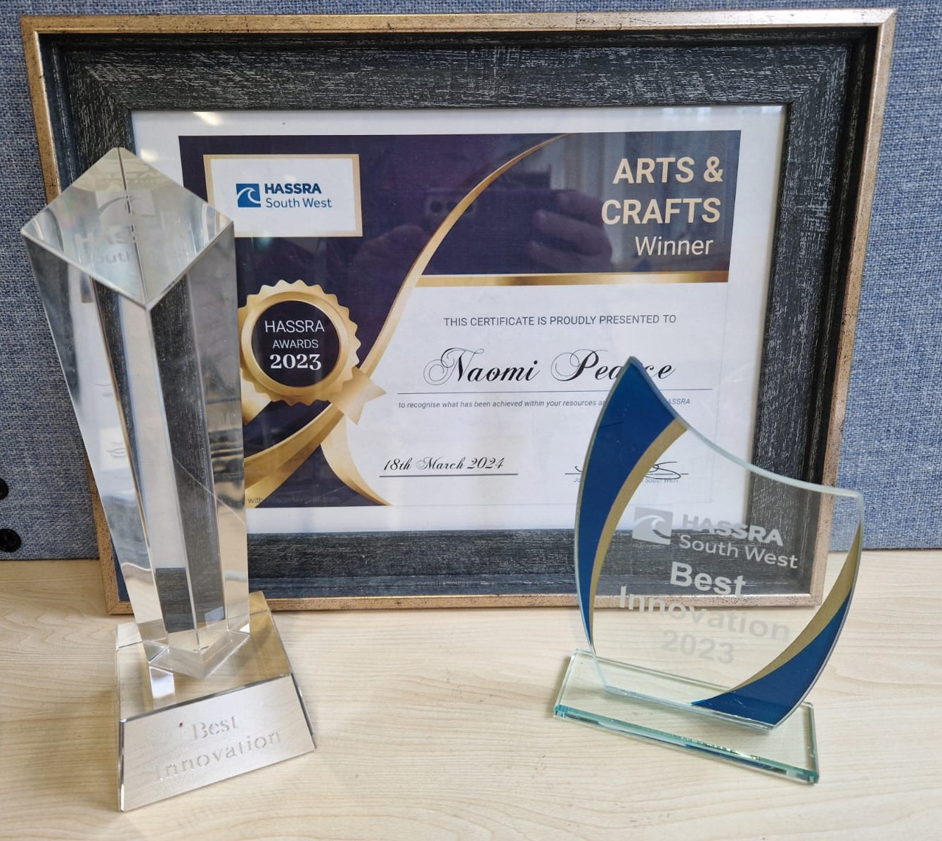

If you would like to be featured in a future newsletter, email your HASSRA story and photos to [tara.sanders@defra.gov.uk](mailto:tara.sanders@defra.gov.uk)

**Featured offers this season**

Are you looking for a fun Spring day out, no matter the weather? How about a trip to a zoo, wildlife park or wetlands centre? Check out the “Animal Encounters” section of your HASSRA Live account for details about the following discounts:

* Discount code for pre-booked tickets to Dartmoor Zoo (then show your HASSRA card on the gate)
* Low-rate Paignton Zoo tickets, bought through the HASSRA Live site
* E-codes for Corporate Partner tickets to Slimbridge Wildfowl and Wetland Trust

As well as these offers on HASSRA Live, HASSRA Torbay members get discounted entry to Wildwood Escot and Shaldon Zoo by showing their HASSRA cards when buying tickets on the gate.

Remember to regularly check your HASSRA Live Account for all the latest National and South West offers and competitions: [Link to HASSRA Live](https://www.hassra.org.uk/sign-in?return_url=%2F%3FpxRatio%3D1.5&return_key=2d67aef2f8aedb0c905eedbfda14cfcccea7da3c7f09266af1d4f49828dcbac5)

Don’t forget to join our HASSRA Torbay Teams Site

[Select this link to request membership](https://teams.microsoft.com/l/team/19%3aIaFc1i1Z6qoPvKzviBInyLeY_4tOtz2khN6aPp1ULTI1%40thread.tacv2/conversations?groupId=6f158267-8bce-4534-adb1-d767e64c3909&tenantId=96f1f6e9-1057-4117-ac28-80cdfe86f8c3): Link