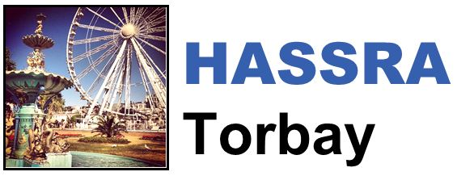

HASSRA Torbay Newsletter

Winter 2023/24

Hello and welcome to the latest edition of the HASSRA Torbay newsletter

**What’s been going on?**

Your HASSRA Torbay Committee has been busy organising various activities for you to get involved in. Thank you for taking part.

|  |  |  |
| --- | --- | --- |
| **HASSRA Live Competition**  A hand picking B from a list of A, B, C, D  Since our last newsletter, we’ve held 3 HASSRA Live Competitions, each giving out a £10 Love2Shop voucher – Keep an eye out as there are more to come! | **Longleat Trip**  A cartoon image of a tiger head with sparkles around it  A discounted coach trip saw members and their families visiting Longleat’s Safari and Festival of Lights together in December | **Pumpkin Carving**  A pumpkin with a smiley face on it  Our Halloween competition saw £40 worth of prizes given out and carved pumpkins featuring Coco, Spiderman and a monkey being admired by everyone. |



Remember we still have our £10 Christmas activity rebate running until the end of January. Send proof of purchase to Helen Bridgman before 31.01.24 to claim your rebate.

**HASSRA = Happiness**

In each newsletter, one of our members tells us about how they have been making the most of their membership. For this edition, we’ve been speaking to our Treasurer,Helen Bridgman from Cotswold House, about organising and attending the HASSRA Torbay Longleat Coach Trip.

“We’ve not been able to hold a HASSRA Torbay coach trip event since 2019 due to the Covid-19 pandemic, so we were very excited that there was a lot of interest in a Christmas outing. Following feedback from our Summer HASSRA Torbay survey, we decided to visit Longleat, where we’d not only be able to visit the safari, but the Festival of Lights too.

We were able to offer the trip (coach and entry) to members at a discounted rate of **only £30…when entry alone would normally cost someone £49.95!** This generated a lot of interest and 43 people came along on the trip.

After a bit of a delayed start (the coach was frozen, and therefore late getting to its first pick up at Paignton), and a maintenance job (the ‘dodgy door’ needed to be fixed before we entered the lion enclosure!), we were well on our way to Longleat.

A group of lions lying on grass


The safari was absolutely brilliant. A lot of the animals took interest in our coach (something a bit bigger than the cars that they’re used to!) so we were able to get some close-up photos. The weather was very chilly, but clear all day. After the safari, everyone went off and did their own thing, at their own pace. We enjoyed our time in the sunshine, but were looking forward to it getting dark so we could see the lantern display….and it was worth the wait!

An ostrich bird standing on the road, looking up at the coach window


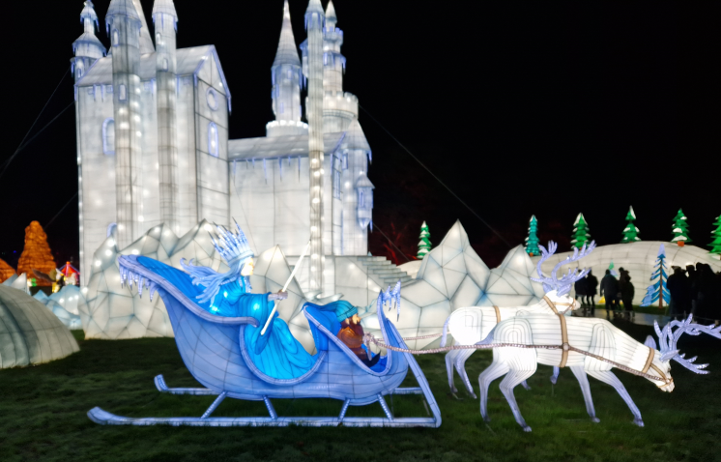

The theme of this year’s Festival of Lights was ‘Treasured Tales’ and we saw displays showing childhood stories…Everything from The Chronicles of Narnia to Winnie The Pooh. I think the adults on the trip enjoyed it just as much as the children. We took ages walking around, looking at all of the details in the displays.

As well as the safari and the lantern display, there were plenty of other things to do at Longleat, such as the boat trip and watching the musical Christmas Tree. It was such a magical day out for everyone, there was a real a buzz on the coach home with quotes such as “what a lovely time”, “we have had a fantastic time” and “thanks for organising the trip, we’ve had a great day”.

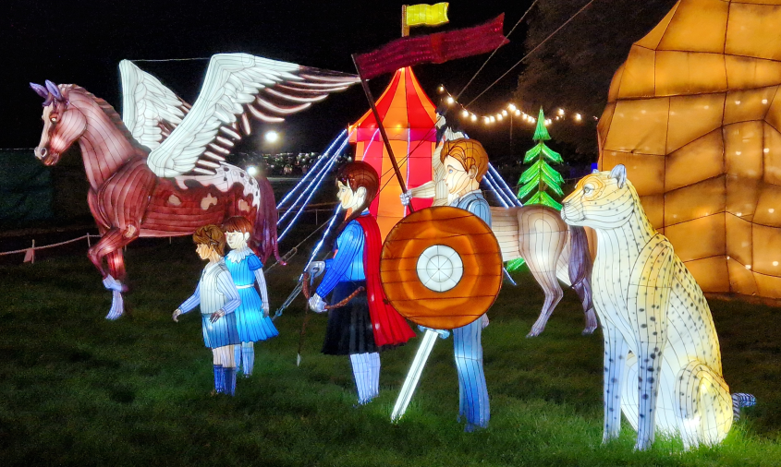

We hope everyone who went on the Longleat trip enjoyed it. We’re looking forward to organising more coach trips in the future. Why not encourage your friends to become HASSRA members, so they can also come along and enjoy these discounted events too.

If you would like to be featured in a future newsletter, email your HASSRA story and photos to Tara Sanders

**What’s coming up?**



We look forward to giving our members more chance to win, save and take part in 2024. Look out for:

* More Competitions
* More Rebates
* More Events

Thank you for being a member of HASSRA Torbay throughout 2023.

Happy New Year from your HASSRA Torbay Committee.

**Featured offers this season**

Are you looking to do a post-Christmas detox? Don’t forget to check out the “Body and Mind” section of your HASSRA Live account for details about the following discounts:

* Half price guest passes, discounts on treatments, and access to a corporate membership rate at the Cornwall Hotel Spa
* Reduced cost access to PureGym
* Discounted membership to the online support service for mental health and wellbeing, The Happiness Club
* A 7-day free trial with Nuffield Health

Remember to regularly check your HASSRA Live Account for all the latest National and South West offers and competitions: [Link to HASSRA Live](https://www.hassra.org.uk/sign-in?return_url=%2F%3FpxRatio%3D1.5&return_key=2d67aef2f8aedb0c905eedbfda14cfcccea7da3c7f09266af1d4f49828dcbac5)