

**NEWSLETTER October 2019**

[**hassra.southwest@dwp.gsi.gov.uk**](mailto:hassra.southwest@dwp.gsi.gov.uk)

**A message from our Regional Chair – Lorraine Jackson**

It’s been a very sad month in SW HASSRA, with the loss of our Plymouth Chair, Steve Cawse.  We have discussed at the regional Board of Management meeting today how we can honour his memory.  There will be more details to follow about this soon.

Steve was Mr HASSRA always getting a great deal for his members and the wider SW HASSRA Community.  He was an inspiration and a lovely man. We’ll miss him greatly.  Our thoughts go to his family and all the Plymouth members.

We will be starting our annual awards process shortly, recognising achievements and contributions of our members/clubs.  Would be great if you could give it some thought and if you know someone in SW HASSRA who you would like to nominate please contact your local committee.

We have an amazing Fun and Free competition coming up.  Look out below for more details of our £2K GIVEAWAY!


**Recent HASSRA Festival results**

We had some great results during the recent Festival at Warwick University**.** Well done to all the winners and everyone that took part.

**Winners from South West HASSRA:**

Golf Ladies Handicap                       Amanda Ballinger

Snooker Winner                                James Popplewell

Ten Pin Bowling Ladies Handicap   Maggie Gaughan

Men’s Handicap Bowling                  Jeff Griffin

Bowling Team                                   South West HASSRA

Photography Runner Up                  Alex Perciato

**Meet your HASSRA Board of Management**

Each HASSRA region is led by a ‘Regional Board of Management’ made up of elected volunteers and a chairperson.  The ‘BOM’ take a strategic view of the running of the region and how its resources should be used for the benefit of members. Regional boards also support local clubs and play an important part in decision-making at national level on behalf of their members.

Your SW Regional BOM members pictured left are:

Lorraine Jackson – Chair

Di Grossey    Taunton    Jeff Griffin  Horfield JCP
Julie Rickard  St Austell   Kath Sullivan  St Austell
James Wilkes  St Austell   Sadie Steadman  Honiton
Lisa Borthwick  Plymouth   Joanne Davis  Avon, Somerset and Gloucester
John Goodall  Plymouth   Angela Rowell Bristol
Tamsyn Wetherall Bridgwater


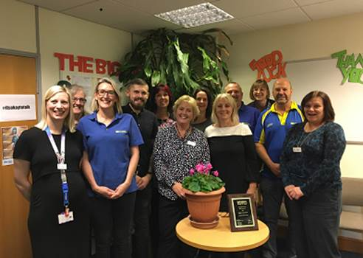

Every HASSRA members can influence what’s going on in our regions and clubs– we just have to get involved! HASSRA regional associations and clubs are always on the look-out for

volunteers who can spare time to help make the local and regional scene as active and vibrant as it can be.  But whether you want to become a volunteer or just make a suggestion for a local activity,

you can always contact your local club committee or regional board of management.

And don’t forget, every HASSRA club and region holds an Annual General Meeting where you can find out what’s happened over the past year, what’s planned for the next year, and make your views

known about what you want from your HASSRA.

So get involved and make the most of your membership!

**Fun and Free Competition**

Winners have been drawn today using a random number generator!  HASSRA SW received 597 entries for the competition. Your winners from across the SW region are:

Jess Hefford, Michelle Tate, Lynn Yard, Amy Harvey, Louise Denbing, Ruth Derban, Tracey Hendry, Sharon Grigg, Jenny Korwin, Andy Robinson, Jane Holgate, Janice Ward, Shaun Edwards, Mark Allery,

Natalie Harries, Emma Brown, Carrie Sykes, Debbie Barsby, Julie Hearn, Cherry Clarke, Lisa Borthwick, Neil wood, Hannah Hutchins, Sarah Swain

**\*\*\* 2K Giveaway!! \*\*\***

The next Fun and Free competition will run from 10th Oct to 30th November.  We are giving away a **MASSIVE £2000** worth of prizes. First prize £250, 5 x £100, 20 x £50, 10 x £25. To be in with a chance of

winning one of the fantastic Love to Shop vouchers, please email your full name, email address and HASSRA number to [HASSRA.SOUTHWEST@DWP.GSI.GOV.UK](mailto:HASSRA.SOUTHWEST@DWP.GSI.GOV.UK).

Winners will be drawn on 4th December to enable vouchers to be received in time for Christmas.

Good luck everyone, and remember “You have to be in it, to win it”

**Bristol Hippodrome Theatre tickets:**

* We will Rock You on 19th March 2020 – tickets £29 for HASSRA, £39 for guests
* The King and I on 26th March 2020 – tickets £43 for HASSRA, £53 for guests

Email [HASSRA.SOUTHWEST@DWP.GOV.UK](mailto:HASSRA.SOUTHWEST@DWP.GOV.UK) to order.

**Plymouth Theatre Royal**

MAMMA MIA Saturday 1st August 2020 – tickets £45 for HASSRA, £55 for guests – email [YVONNE.E.ROBERTS@DWP.GSI.GOV.UK](mailto:YVONNE.E.ROBERTS@DWP.GSI.GOV.UK)

Please see details of other theatre offers below.  If you wish to secure a ticket please email [HASSRA.PLYMOUTH@DWP.GSI.GOV.UK](mailto:HASSRA.PLYMOUTH@DWP.GSI.GOV.UK)

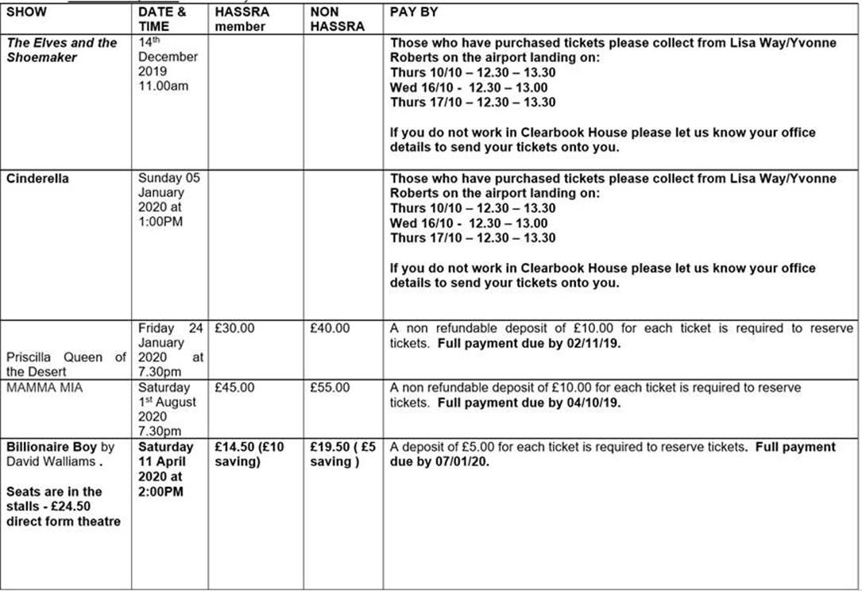

**Bath Spa**

Members tickets are just £15 each, guest tickets are £36 email [HASSRA.SOUTHWEST@DWP.GOV.UK](mailto:HASSRA.SOUTHWEST@DWP.GOV.UK)

**Other Attractions**

Cattle Country Adventure Park – members and family £1 entry per person when you show your HASSRA card

Don’t forget we have lots of local offers for the October half term, Weston Pier, Crealy, Digger land, Cattle Country, Wetlands, Weymouth Sealife Centre, Flambards, Cheddar Gorge, Longleat, Zoo’s in Bristol,

Paignton or Newquay, Pennywell Farm and many more – speak to your local committee for more offers.

**HASSRA LIVE**

If you haven’t managed to log onto HASSRA Live (Online Shop) let us know and we can talk you through how to do it – you are currently missing out on 80+ benefits – all for just £2.24 per month.

**Discounts:**

**Fancy some Fresh fish delivered to your door?**

We are delighted to tell you that we have extended our 10% discount and FREE delivery with ‘Fish for Thought’ online seafood company.  Check out their website at fishforthought.co.uk.

Use code HASSRAFFT10 at the online checkout to receive free delivery and 10% off all orders above £35**.**

**Historic Royal Palaces**

Please note that Historic Royal Palaces is terminating all corporate deals with all organisations, including HASSRA, on 30 November 2019. So make the most of the current offer between now and 30 November and enjoy free entry to London palaces and landmarks, plus big savings on some great days out.   Visit the [**Offers and Discounts**](https://www.hassrashop.org.uk/offers-and-discounts?eref=mail) page of the HASSRA Online shop to obtain your Historic Royal Palaces vouchers

**Find us on Facebook  - HASSRA South West**

Don’t forget to check our HASSRA FB page where you will find offers, event photos and details of new discounts.

If you have any feedback or content you would like to see included in future newsletters please email [Julie.rickard@dwp.gov.uk](mailto:Julie.rickard@dwp.gov.uk)

**Find us on Twitter**

@HASSRAsouthwest      @HASSRAsouthwest      www.hassrashop.org.uk