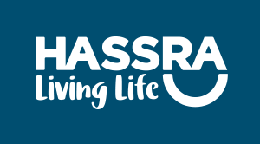

HASSRA WALES AWARDS 2019

HASSRA Wales are currently in the process of organising the next AGM & Awards evening, which will be held at the Park Inn Hotel, Cardiff on Friday 27th March 2020.

We need your help to recognise and reward the outstanding contributions of your local clubs, members, organisers and event participants during 2019.

Please take a little time to read the attached documents, which provide some information about the HASSRA Wales awards and how to make nominations.

Nominations for the Large & Small Club awards should be submitted by an official of your club.

Nominations for Business Sponsor, Volunteer, Participant, Sportsperson, Footballer, Rugby Player, Flat Green Bowls Player can be made by any member.

The final entry deadline is 31st January 2020 but you are encouraged to make your submission sooner.

All winners and runners-up will be invited to attend the Awards evening.

Should you have any questions please do not hesitate to contact me.

Many thanks,
Eryl Jones
HASSRA Wales Board of Management

