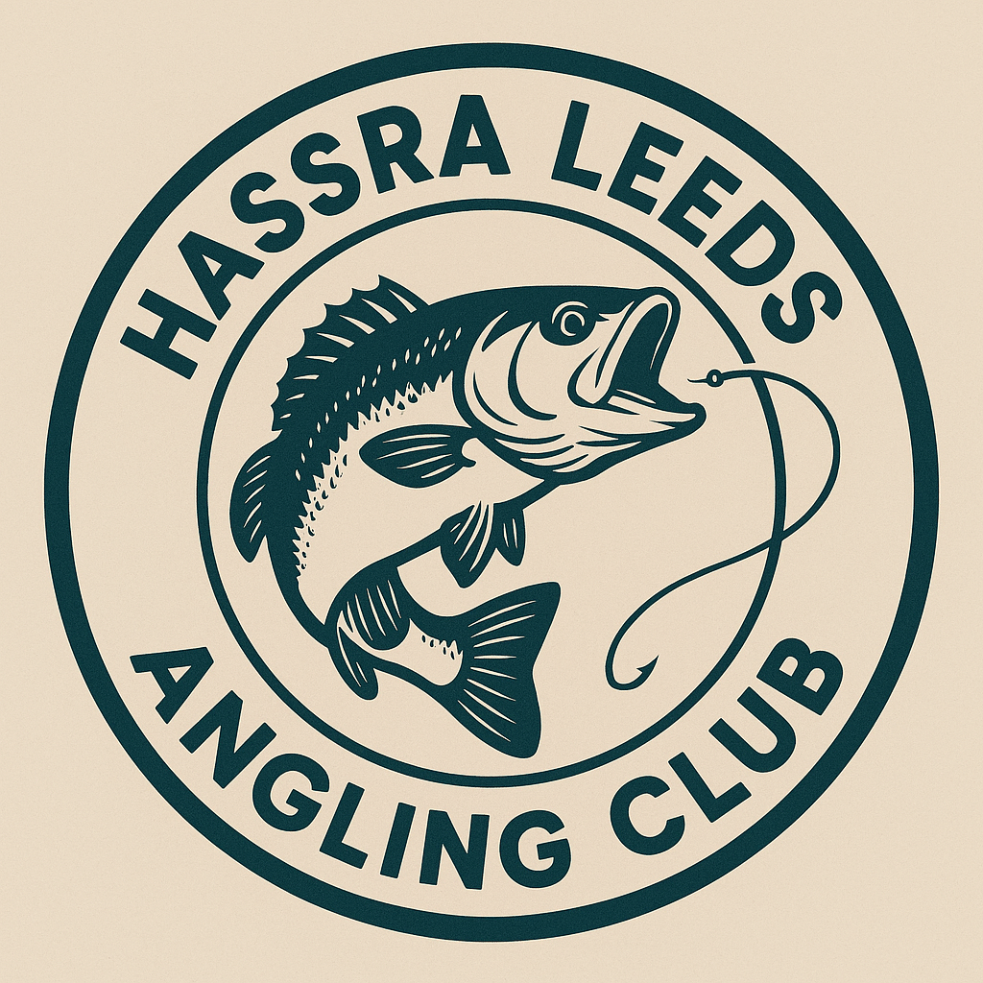
HASSRA Leeds Angling Club

NAME OF TRIP: Three day Derbyshire break Thurs 18th to Saty 20th June 2026

Closing date: 25th April 2026.

Name
Tel No:
Mobile:
Special Requirements:

Please send this booking form together with full payment to George Roe, 18 Heuthwaite Ave, Wetherby, LS22 6RR no later than 25th April 2026. Cheques should be made payable to Quarry House Angling Club. Any questions please contact me on georgeroe5180@gmail.com
Please ensure that you provide full contact details. Failure to do so may prejudice your booking.
Applicants requiring confirmation that their booking form & cheque has been received must enclose a self-addressed envelope.

