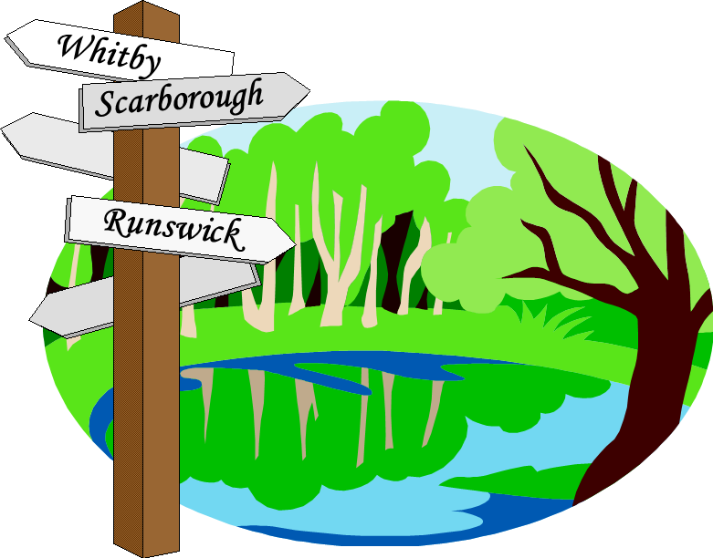
HASSRA Leeds Walking Club

TRIP: Mayrhofen Sat 7th – Sat 14^{h} September 2024
Closing date: 28 February 2024

NOTE: Deposit required with booking of £150 per person

Name | HASSRA member  Number | Type of Room  D/T/S | Amount of Deposit | Balance of cost of Trip

Payment should preferably be made by bank transfer to HASSRA Leeds Walking Club, Sort Code 20 76 92, Account No. 53961680. Please also forward your application to jfbird@btinternet.com.

Alternatively, a cheque for the deposit should be enclosed with the application form, made payable to HASSRA Leeds Walking Club and sent with a hard copy of the booking form to:
Jerry Bird, 35 West Court, Leeds LS8 2JP

Do you have any special dietary or ability requirements? _________________________________________________________

Name of lead contact__________________________________________

Address (Work or Home)_______________________________________

Phone______________________ Mobile___________________________

E-mail_______________________________________________________

Insurance details ______________________________________________

Please refer to full terms and conditions when applying as listed on the HASSRA Leeds website https://www.hassra.org.uk/HASSRA-leeds-homepage (in particular please note that you are liable to pay the FULL price of the trip if you cancel).

