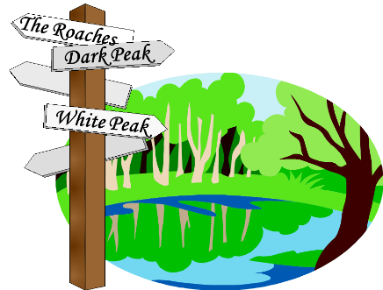
HASSRA LEEDS WALKING CLUB
5 Days in Scotland
Fri 29th May – Tues2nd June 2026.
Closing date: Thurs 25th Sept 2025

NOTE: Deposit required with booking of £30 per person
*further reductions may be applied depending on the numbers travelling

Name | HASSRA member  Number, if appropriate | Type of Room  D/T/S | Amount of Deposit | Balance of cost of Trip

Do you have any special dietary requirements?

Name of Lead Contact:
Tel No:
Mobile:

Payment should preferably be made by bank transfer to HASSRA Leeds Walking Club, Sort Code 20 76 92, Account No. 53961680. Please also forward your application to Jerry Bird at: jfbird@btinternet.com Alternatively, applications can be sent to Jerry by hard copy to his home address which is: 35 West Court, Roundhay, Leeds LS8 2JP. Cheques should be made payable to Hassra Leeds Walking Club.

Please ensure that you provide full contact details. Failure to do so may prejudice your booking.
Please refer to full terms and conditions when applying as per HASSRA Live Leeds pages (in particular please note that you are liable to pay the FULL price of the trip if you cancel).

