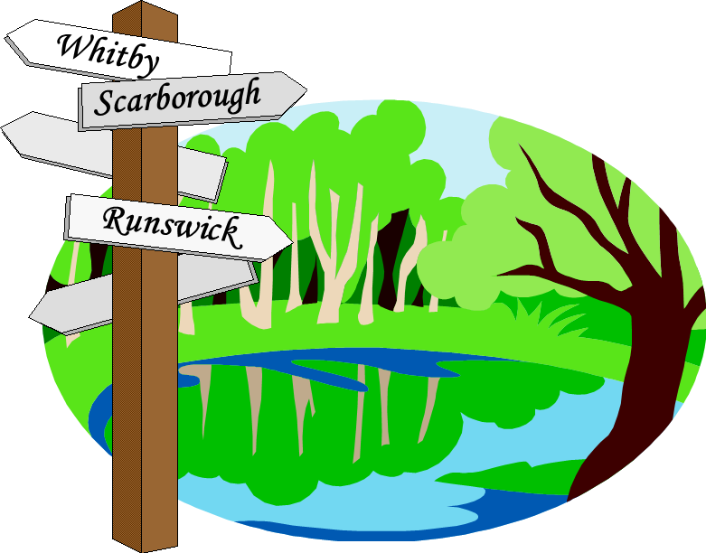
HASSRA Leeds Walking Club

TRIP: Whitby ‘24
Fri 12th – Mon 15th April 2024
Closing date: 31st January 2024

NOTE: Deposit required with booking of £75 per person
*further reductions may be applied depending on the amount of HASSRA subsidy and numbers travelling

Name | HASSRA member  Number | Type of Room  D/T/S | Amount of Deposit | Balance of cost of Trip

Do you have any special dietary requirements?

Name of Lead Contact:
Tel No:
Mobile:

Payment should preferably be made by bank transfer to HASSRA Leeds Walking Club, Sort Code 20 76 92, Account No. 53961680. Please also forward your application to luisa.panetta@dwp.gov.uk.

Please ensure that you provide full contact details. Failure to do so may prejudice your booking.
Please refer to full terms and conditions when applying as per HASSRA Live Leeds pages (in particular please note that you are liable to pay the FULL price of the trip if you cancel).

