HASSRA LIVE DESK AID

Setting up a HASSRA Club competition on HASSRA Live.

Introduction.
This desk aid provides step-by-step instructions for approved club officials to run competitions on HASSRA Live.

Step 1 – Access.
For a club official to access the ‘Organiser Activity’ section of HASSRA Live the club chair must contact the National HASSRA Team via the ‘Make an enquiry’ at the bottom the ‘My Profile’ page. The National HASSRA Team will email with the necessary access to allow you to organise your competition.

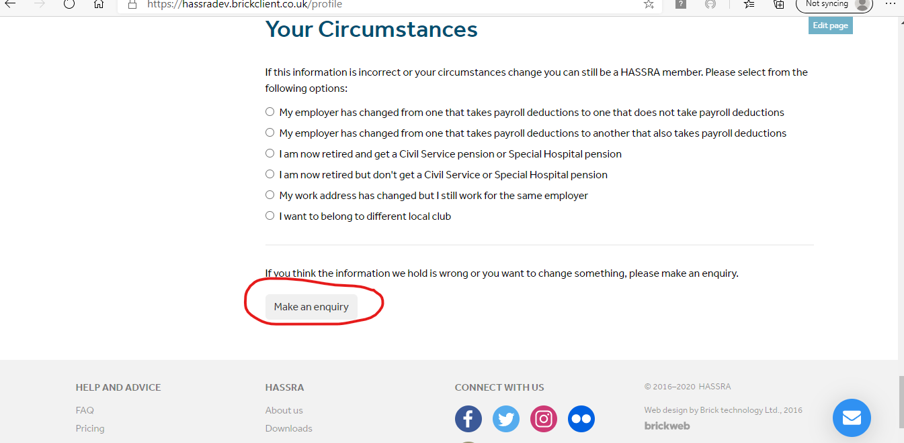

Step 2 – Preparation.
Agree with your club the details of the competition to include the following.
- Start date and finish dates of the competition.
- Date the draw will be run.
- Full details of the prizes.
- Rules of the competition.

Step 3 – Organise Competition.
Log into your HASSRA Live account as normal. Once you have logged into your HASSRA Live account click on your name in the right hand corner.

This will then take you to ‘Your account’ page. Click on the ‘Organiser Activity’ button.

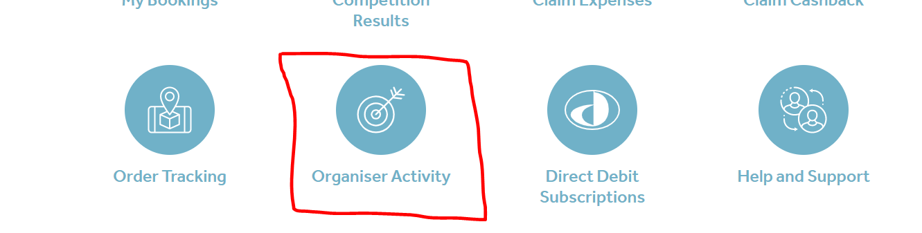

The Organiser Activity page is where you input the details of your club’s competition.

Step 4 – Organiser Activity.
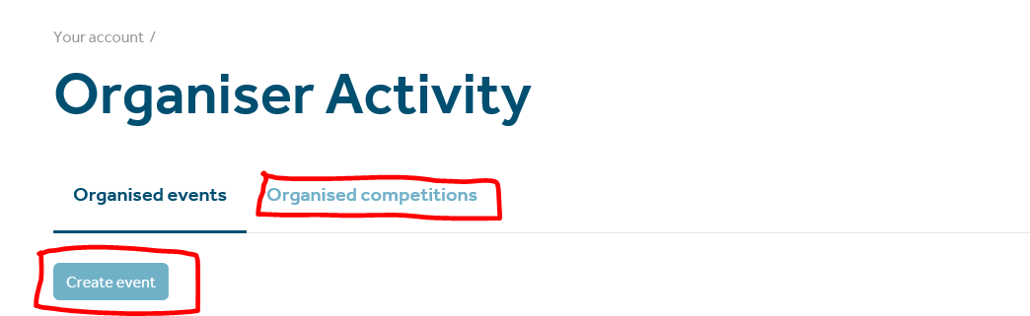

Choose ‘Organised Competitions’ and then the ‘Create Competition’ button.

Step 5 – Create Competition.
This is where you will start to input the details of the competition.
- Enter the title of your competition. Keep the title short and snappy.
- Competition start date. This is the date when the competition starts and is launched on HASSRA Live.
- Enter the date the draw will take place.
- As you are a club volunteer the ‘Type’ will remain protected to ‘Club’.
- Your club will be shown in the local club row but you are still required to tick the box.
- Click the Create button.

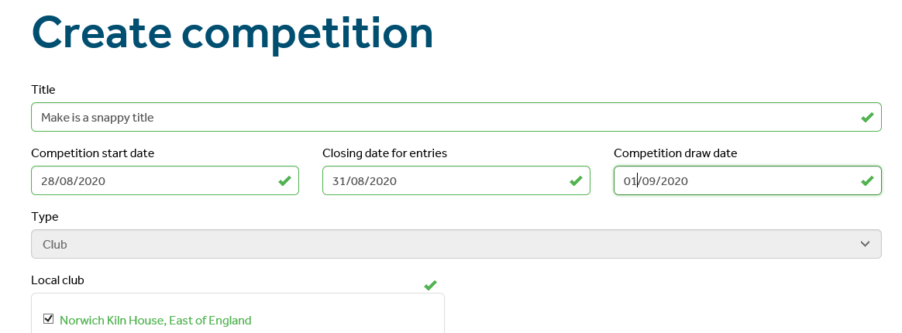

Your competition will be created and be given an unique ID number.
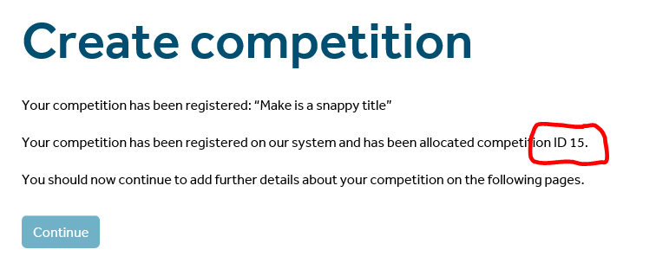
Step – 6 General Details.
Once you have clicked on the ‘Continue’ button you will have the General Details page. This is where you will add more details of your competition. Some of the rows will be already populated from the ‘Create competition’ page but this gives you the opportunity to add more details about your competition.

Step – 7 Design of your competition.
This is where you can enter more details of your competition.
Short Description.
This is displayed as an icon on HASSRA Live so there should just be enough information to get members to click on the icon and enter the competition.
Full Description.
Enter the rules and prize details of the competition. Do not enter the competition question/s here. This is later.

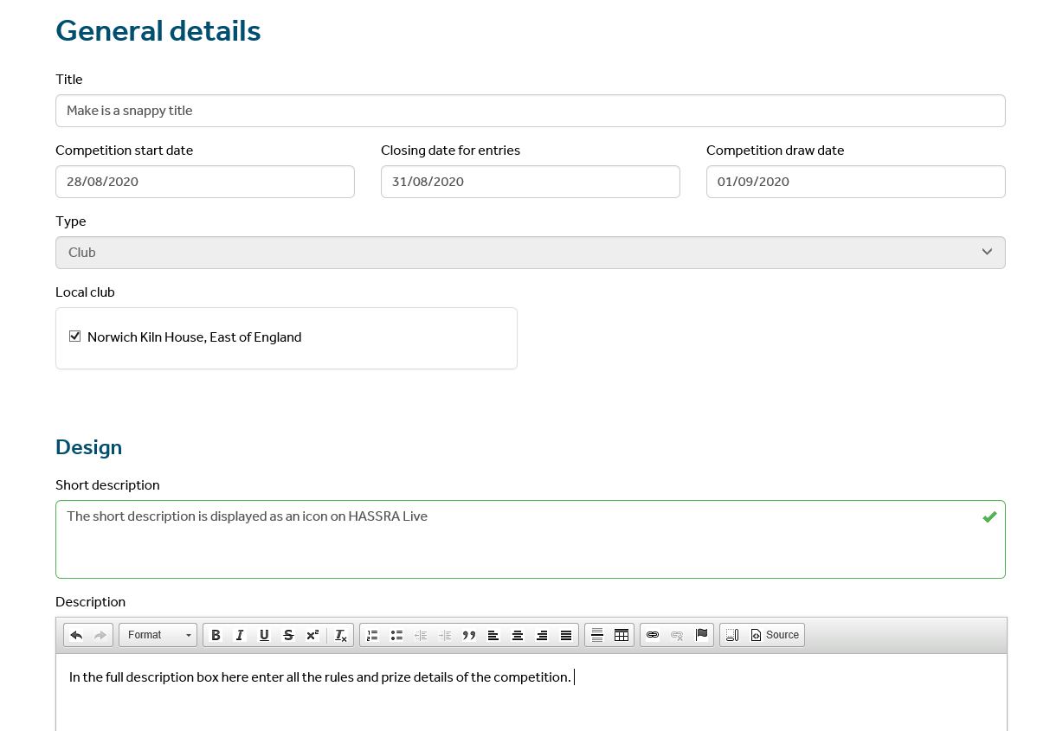

Step – 8 Images and logos.
Once you have completed the design information of your competition scroll down to add images or logo. You are able to upload five images or logos. Click on the browse button to upload the image or logo from your PC. The first image will appear as an icon on your club’s page.

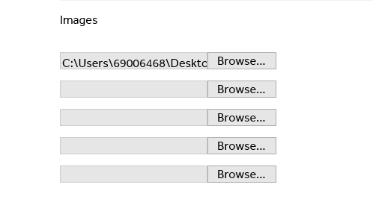
Please note that if you are using an image or logo from a website owned by a company you will need to get their permission to use the image or logo. For more information, please email
HASSRACOMMUNICATIONS.ANDMARKETING@DWP.GSI.GOV.UK

Step – 9 Draw Details.
You should enter the number of winners in the draw details rows. If there is more than one prize tick the box to specify the number of prizes. Boxes will then appear for you to complete. Please note, the number of boxes will depend on the number of prizes you have input. You can then input the prizes.

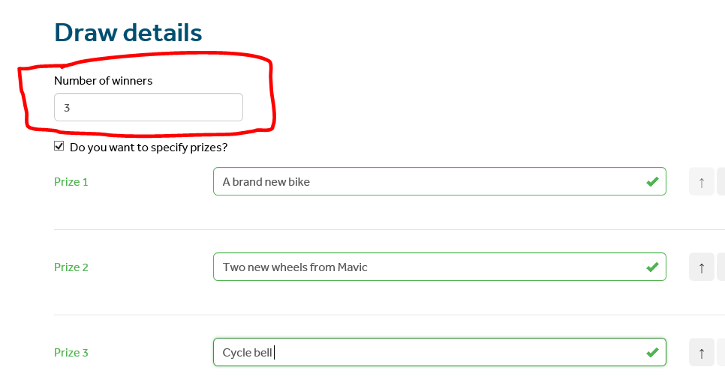

Step – 10 Application Form.
Input the competition questions you want your HASSRA club members to answer.
You are able to include a clue in the optional help row. This may not be necessary in all cases.
You have to give a minimum of at least two multiple choice answers for HASSRA club members to choose from.
The first row will be the correct answer and will appear in the correct answer row.
Please ensure the answer is correct as when the draw is conducted the system will only select the winner from the correct answers.

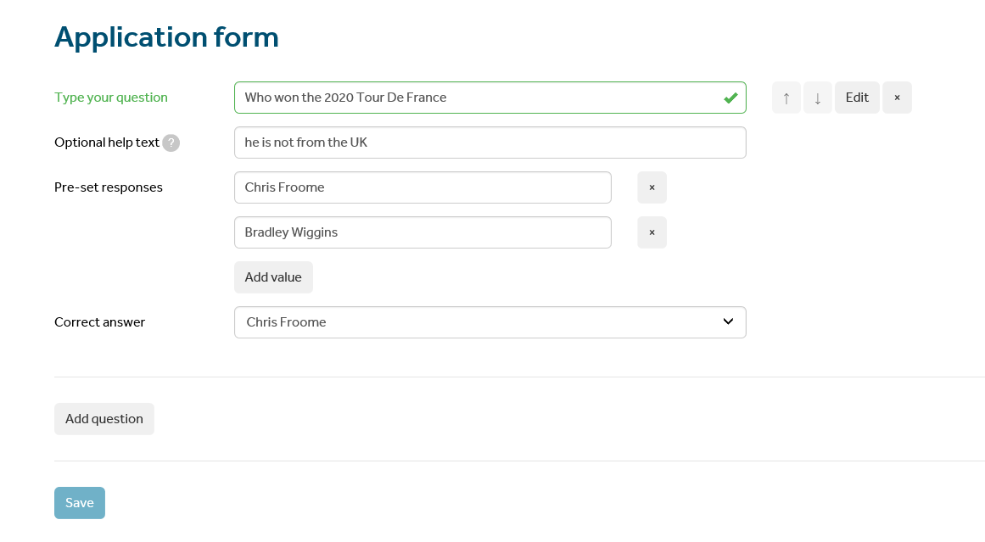

You can add several questions if you wish. Click on the Add question button and repeat the process.
Remember to click on the Save button.
Once you have saved the question you will get an on screen message saying that you competition has been saved.

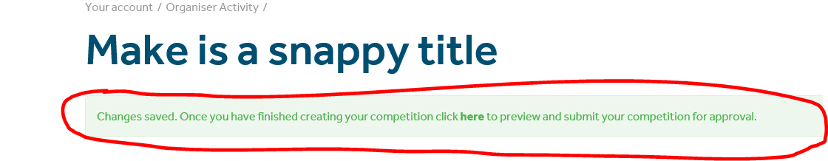

Step – 11 Preview.
Once saved you will need to preview your competition. Click on the word ‘Here’ on the onscreen message.
This will then take you to the Organiser Activity page where you will have basic details of the competition and other actions.

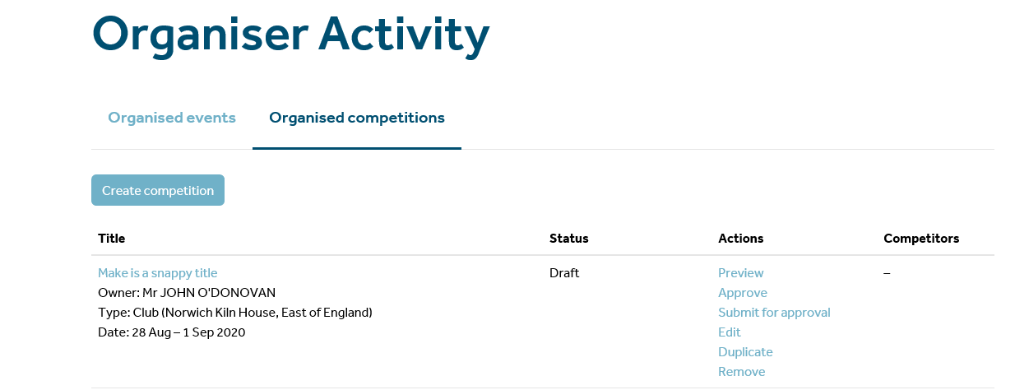
If you click on ‘Preview’ you will see a copy of what your HASSRA club members will see when the click on your competition.

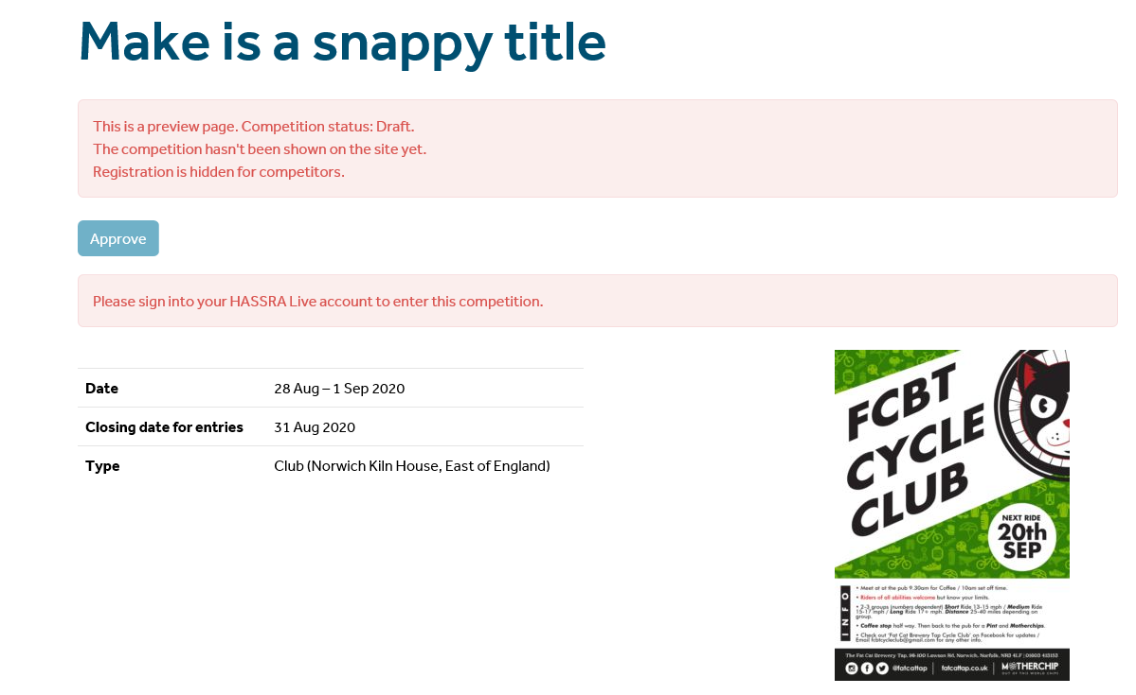

Step – 12 Amendments.
There will be a number of warning messages in red. These will not be visible to the members. If there is anything that needs to be amended, you will need to go back to the ‘Organiser Activity’ page by clicking at the top of the page.

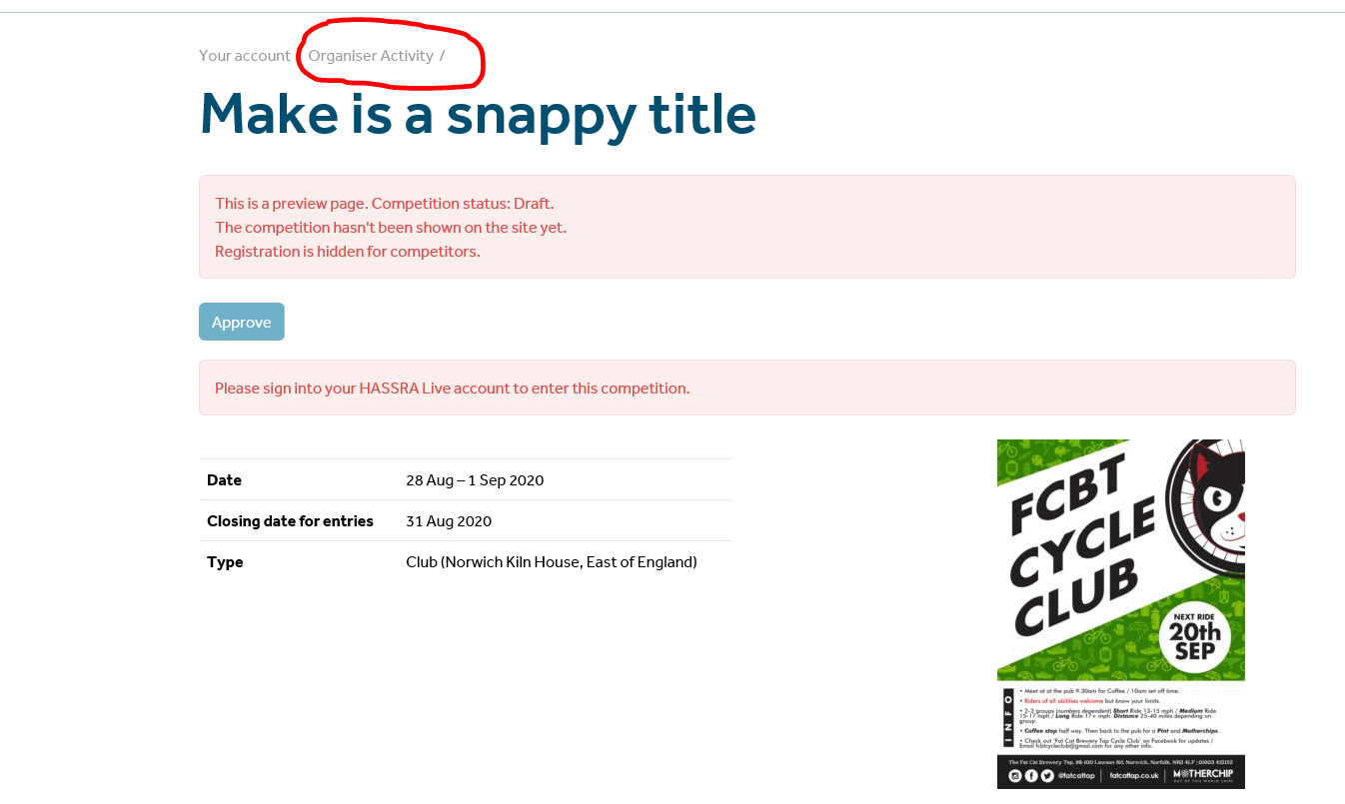
Click on ‘Edit’. This will take you back to the general details page where you would have originally input the competition details. You will be able to make the necessary amendments.

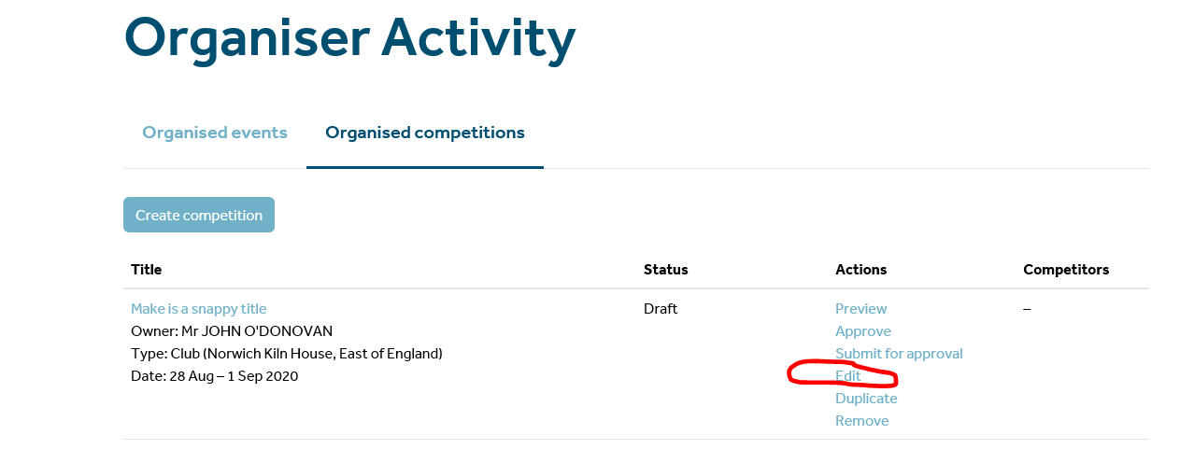

Step -14 Approve.
Once you have checked the competition’s details are correct and you are happy you will need to click on ‘Approve’.
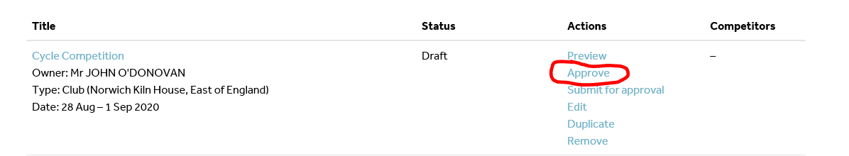
You will then see an onscreen box confirming that you are happy and that you want to approve the competition.

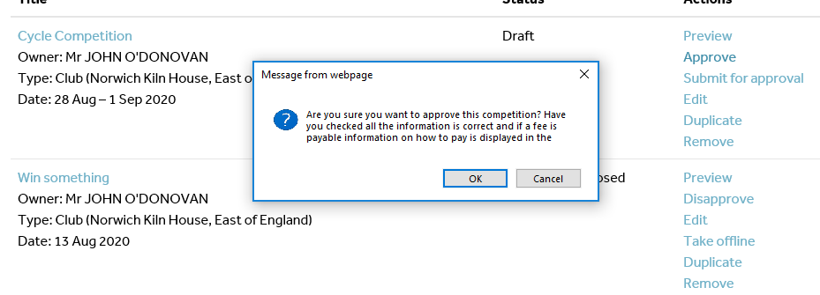

Once you have clicked on OK the status will change to ‘Approved’.

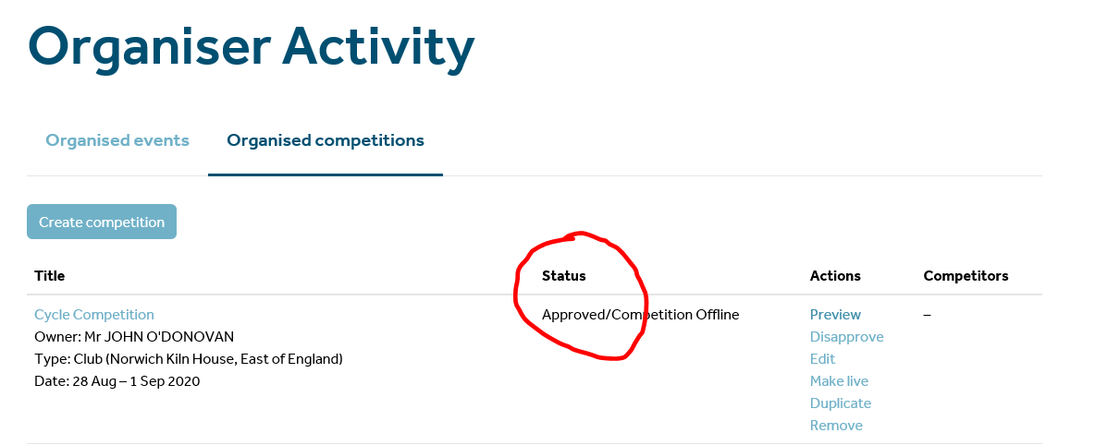
Step – 15 Make Live.
To ensure your competition appears on HASSRA Live you will need to click on ‘Make Live’. Once you have done this your HASSRA Club members will be able to see your competition.

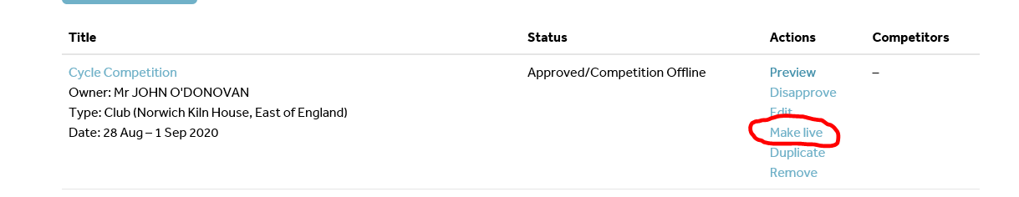

Step – 16 Win page.
The page on HASSRA Live where the competition will appear is on the ‘Win’ page of your HASSRA Live profile.
Click on the ‘Win’ tab and ensure the drop down is changed to ‘Club’. Also you need to ensure the name of your club appears.

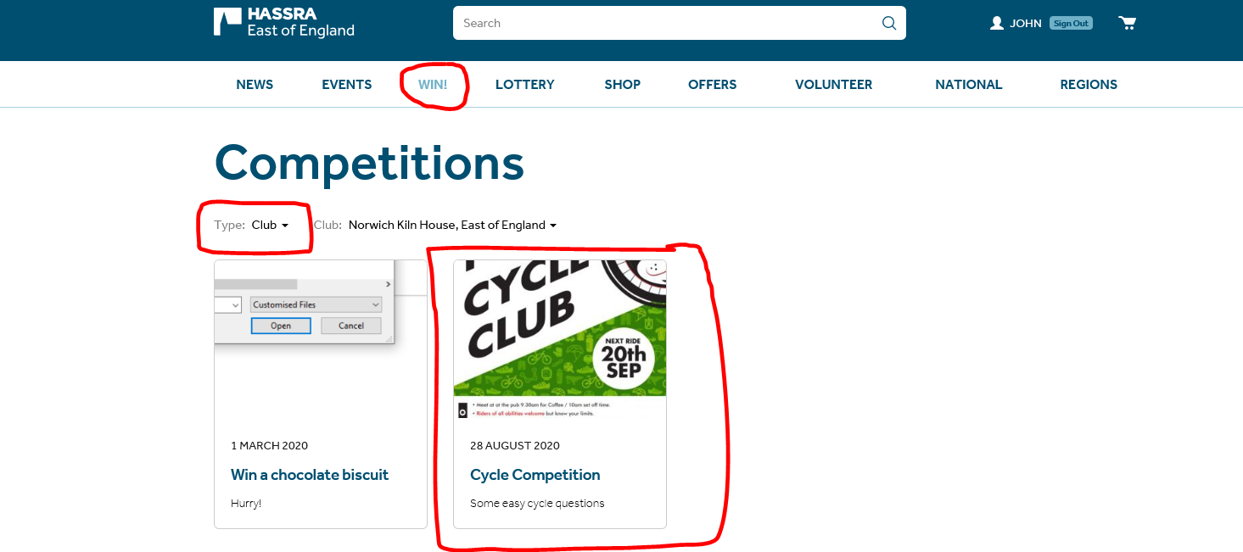

Your HASSRA Club members will be able to click on the link which then will take them into the competition. They will have up to midnight on the closing date to enter the competition.

If you have any concerns or issues, please contact the HASSRA National Team via the ‘Make Enquiry’ on HASSRA Live. Leave your details and one of the team will get back to you.

