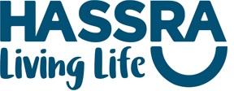

HASSRA Festivals 2026 – Referee - Umpire Application
Name
HASSRA Membership Number
HASSRA Region
Contact Number and Email Address (personal email address only)
Please indicate which event you would be available to referee/umpire  Delete those N/A. | Ladies Netball - July  Men’s 5 a Side Football - July  Mixed Rounders - September
Please indicate any qualifications, experience, that you have. | Men’s 5 a Side Football – FA Qualified current serving a level 4 or 5, we can accept 6 to 7  Ladies Netball – B Award and above  Mixed Rounders – National Rounders Association (NRA) qualified, level 2, 3 or 4
Please provide any other information that will support your application.

Experience is very important. If you would like to speak to the organiser, prior to applying please drop us an email.

Once completed please send to: hassra.programmeandrecruitmentteam@dwp.gov.uk
Closing date for applications is Sunday 8th February 2026.

