OUTSTANDING CLUB ACCOUNTS – GUIDANCE FOR REGIONS

Background

- Club accounts can be outstanding for many reasons but typically because the club:

- has folded - for want of officers/volunteers or office closure
- is in limbo - exists but is inactive, perhaps for want of volunteers
- is active but has failed to submit accounts, perhaps because auditors cannot be found.

- Where a club has folded our aim is to:

- prepare final accounts
- close bank account
- recover residual funds, if any [and return to the parent Region].

- Where a club is in limbo our aim is to:

- encourage volunteers to join the committee
- support them in finding auditors and preparing accounts
- put in place a regime to ensure accounts are submitted on time in future.

- Where a club is active our aim is to:

- find out why accounts are not being submitted
- support them in finding auditors and preparing accounts
- put in place a regime to ensure accounts are submitted on time in future.

Steps to Take

Tracing Club Records

- Whether a club needs to close, be resurrected or bring its accounts up to date, it is necessary to locate records of officers or former officers, last audited accounts and details of bank accounts. That may be possible through local contacts with local knowledge. If it is not, contact the National Finance Team (NFT).

- The NFT keeps copies of each club’s last three years’ submitted accounts. It also maintains a database of the last known known club treasurer, chair, auditors and bank account details (necessary to pay rebates). This database is updated each time accounts are submitted. So if a club has not submitted accounts for a year or more, the database will continue to show the “old” treasurer, chair and auditors (as well as bank account details).

Bringing and Keeping Accounts Up to Date

- The flow chart below describes the actions and escalations routes that regions can take to keep club accounts up to date and ensure appropriate governance.

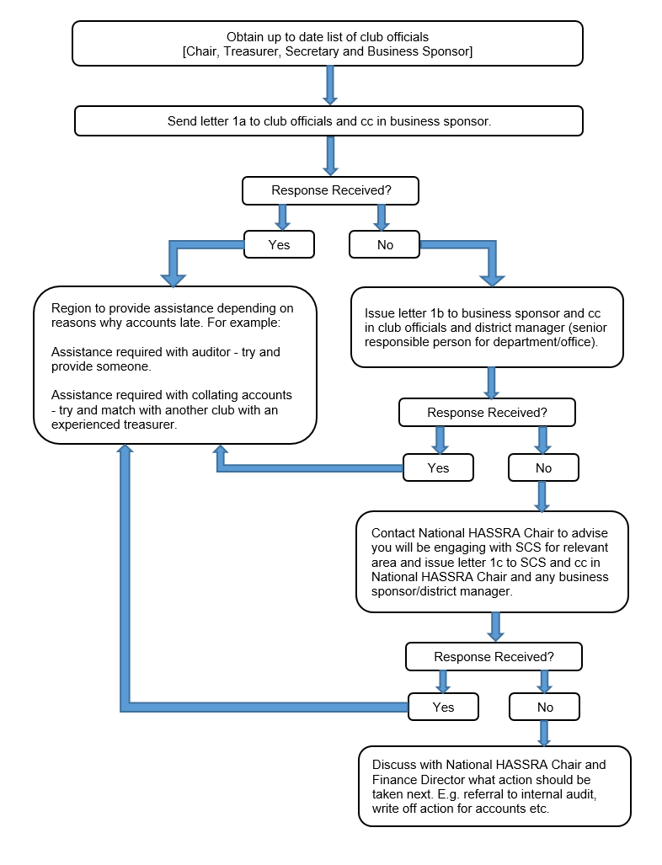

Registering New Signatories at the Bank

- This process may vary depending on which bank you use:

- Contact the Customer Services team for your bank by either telephone or email.

- Ask for a new/change signatory mandate form to either register or remove a signatory from the club’s bank account. They will either email/send via post the mandate form to be completed. This will vary depending on the bank.

- Once the form is received all relevant parts of the form will need completion by the new signatory. Make sure the form is signed and dated.

- You will be required to send documents to prove your identity. This is usually two forms of ID. Either Passport/Driving Licence and also one proof of your address E.g Mobile Phone Bill/Gas-Electric Bill/Council Tax or other utility bill. This can be done by taking in to your local branch for them to take photocopies and verify them (this may vary depending on bank). You will then be able to scan your documents to an email or send in by post depending on how you are applying.

- Once you have completed the mandate and verified your identity the form will then need to be signed by other signatories by either emailing to each one or if using post sending to each signatory to sign. Once the last signatory has signed they will send all the documents either by email or post to the bank for processing.

- Completion by the bank can take anything from 2 to 6 weeks depending on banks and their checking/verifying systems.

Recovering Monies in Bank Accounts

- If the club has closed and you believe there may be monies in a club bank account, you need to establish:

- name of the bank account
- when the bank account was last used. This can be established from paperwork held in the office, cheque book stubs etc. Identify the actual amount of the last transaction if possible.
- names of signatories registered on the bank account. If none of them is still in the office or no one knows who they were, the last Chair’s certificate held by the NFT may shed some light as signatories often include Treasurer, Chair and Secretary.

- Once these details have been established prepare a letter to the bank which includes:

- details of signatories and why they are no longer available to act on the account
- an explanation of how HASSRA works (i.e. club-region structure and funding mechanism) See pen picture at Annex 2.
- a request to close the account and transfer any remaining monies to the regional HASSRA bank account. Don’t forget to include the region’s bank account details.

- If anyone involved with the club still works at the office and knows someone at the bank, it may be helpful to try and deliver the letter in person.

Writing-off Funds Which Cannot Be Traced

- This action should only be considered once it has been established there is no realistic prospect of tracing funds or the bank account.

- You should in the first instance try to trace former officers and any banks accounts in the ways described above. If, having exhausted all avenues of enquiry, former officers and details of bank accounts cannot be established, you should now consider writing off the accounts.

- To write off the accounts you must prepare a business case:

- describing all the steps taken to try to trace former officers and bank accounts
- confirming that there are no further avenues of enquiry available to you
- confirming that there is no evidence to suggest that the sum potentially being written off may have been substantial
- confirming that there is no suspicion of impropriety or dishonesty.
(If there is any suggestion of impropriety or dishonesty you should inform your regional chairperson immediately. S/he should liaise with the NFT and consider whether a referral to DWP Internal Audit is appropriate.)

- The business case should then be submitted to:

- the regional chairperson for information and initial consideration and recommendation, and then to:
- the National Finance Committee for final consideration and sign-off.

See Business Case form at Annex 3.

HASSRA National Team
March 2021

Annex 1 – Letter Templates

Letter 1a

From: [Insert name of Regional Chair]
To: [Insert names of Club Officials]
Cc: [Insert name of Business Sponsor]

Date: [Insert Date]

Dear club officials,

According to our records you are the officials of [Insert name of Club] and the last set of audited accounts submitted for the club was for year ending 20xx [Insert Year].

In order for me to keep our club records up to date, please can you advise when you will submit the audited accounts for the years 20xx and 20xx [Insert Years].

If you are having difficulty in submitting these accounts, please contact me and let me know what issues you are facing and I will do what I can to assist you in resolving this matter. If you are no longer an official for the club stated above, please can you provide me with any information you hold on the current officials for the club so that I can contact them to obtain the up to date accounts.

A response to this letter is required by [Insert date 14 days hence]. If I do not hear from you by this date, I will have to escalate the matter to the business sponsor and/or senior manager of the office to seek their assistance in obtaining up to date accounts for the club.

Regards

[Insert Name]
Regional Chair
HASSRA [Insert Region]

Letter 1b

From: [Insert name of Regional Chair]
To: [Insert name of Business Sponsor]
Cc: [Insert name of District Manager or senior person in business unit]
[Insert names of club officials]

Date: [Insert Date]

Dear [Insert name of Business Sponsor]

According to our records we have outstanding accounts for the [Insert name of Club] HASSRA club for the years 20xx and 20xx [Insert Years].

It is important for financial propriety that I receive a copy of these audited accounts and I am writing to you to ask you for your assistance in obtaining these. I contacted the registered club officials on [Insert Date] and to date I have not received a response.

I would be grateful if you could investigate what the position is with the accounts and advise me accordingly. If the club is having difficulty in pulling together the accounts we can provide assistance to them, however we do need engagement from them in order to do this.

A response to this letter is required by [Insert date 14 days hence]. If I do not hear from you by this date, I will have to escalate the matter via the senior management of your business unit to seek their assistance in obtaining up to date accounts for the club

Regards

[Insert Name]
Regional Chair
HASSRA [Insert Region]

Letter 1c

From: [Insert name of Regional President]
To: [Insert name of SCS]
Cc: HASSRA National Chair
[Insert names of Regional Chair]
[Insert name of Business Sponsor]

Date: [Insert Date]

Dear [Insert name of SCS]

Despite previous attempts to obtain accounts for the [Insert name of Club] HASSRA club by contacting the club officials and the business sponsor we have had no response to our requests.

According to our records we have outstanding accounts for the club for the years [Insert Years] to date. It is important for financial propriety that that I receive a copy of these audited accounts and I am writing to you to ask you for your assistance in obtaining these.

I would be grateful if you could investigate what the position is with the accounts and advise me accordingly. If the club is having difficulty in pulling together the accounts we can provide assistance to them, however we do need engagement from them in order to do this.

If a response is not received from the club we will need to consider whether any financial irregularity may have occurred and we will have to consider escalation options including, but not limited to, involving an internal investigation.

Regards

[Insert Name]
Regional President
HASSRA [Insert Region]

Annex 2 – About HASSRA how it works

HASSRA is the official sports and leisure association for serving and former employees of the Department for Work and Pensions (DWP) and Department of Health & Social Care (DHSC) and their executive agencies. HASSRA offers its members a vast array of sporting, recreational and cultural activities, as well as a valuable package of discounts and membership benefits.

HASSRA is structured into 3 tiers – National, Regional and Local:

- National – Run by employees of DWP, offering a programme of activities and benefits for all members.

- Regional - There are 12 affiliated regional associations run by volunteers, offering a programme of activities and benefits for members located in their region.

- Local - There are over 350 local office clubs/societies run by volunteers, offering a programme of activities and benefits for members located in their local office/area or based on a specific interest.

Members pay subscriptions monthly by salary deduction or direct debit; or annually by credit/debit card.

All subscription income is collected nationally. A percentage of the monthly subscription income is retained nationally to fund the national programme of membership benefits and activities. The remainder is distributed to the each of the 12 regions based on the number of members in each region.

Regions retain a percentage of their allotted subscription income to fund their regional programmes. The remainder is distributed to local office clubs/societies based on number of members in each club.

All HASSRA clubs have a Chair, Secretary, Treasurer and other committee members who ensure the club is run in accordance with official guidelines to maintain effective and practical systems and assurance levels. This includes keeping accurate records to account for monies and ensuring that accounts are audited annually.

Annex 3 – Business Case to write off funds

To. 1. HASSRA Regional Board of Management
2. HASSRA National Finance Committee

Club Name…………………………………………………….

Name of Club Sponsor……………………………………….

Names of club officials and committee members (including former officials):

Name Position Held

Value of funds to be written off: £…………..[Insert Amount]
If exact value not known, please state approximate amount.

Please state in the box below what actions have been taken to trace former officials and recover monies from the bank account(s).

Declaration Must be signed by 2 persons
We declare that…
- There are no more avenues available to recover these funds.
- There is no evidence to suggest that the sum potentially being written off may have been substantial.
- There is no suspicion of impropriety or dishonesty.

Signed………………………..…… Signed……………..………………
Dated……………......................... Dated…………….........................
Position Held…………………....... Position Held…………………......

FOR OFFICIAL USE ONLY
On behalf of the HASSRA Regional Board of Management for…………………[Insert Region] I declare that all efforts to recover monies have been exhausted. I hereby recommend that the unrecovered funds should be officially written off.

Signed…………………………… Dated…………………………….
Position Held…………………....

After sign-off by the regional board, this form should be sent to the National Finance Director.

