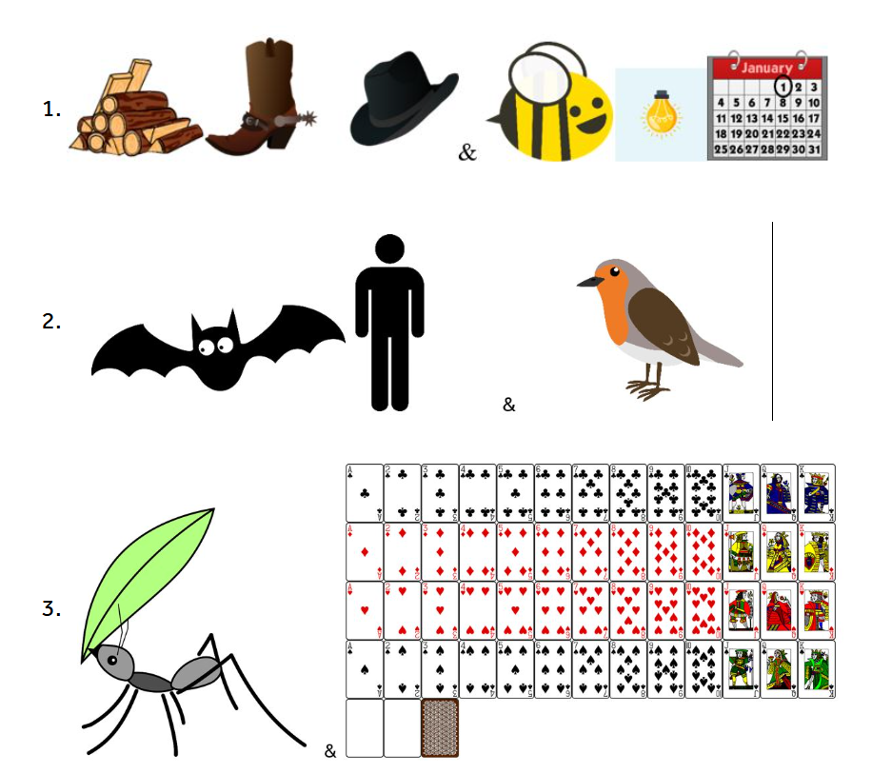
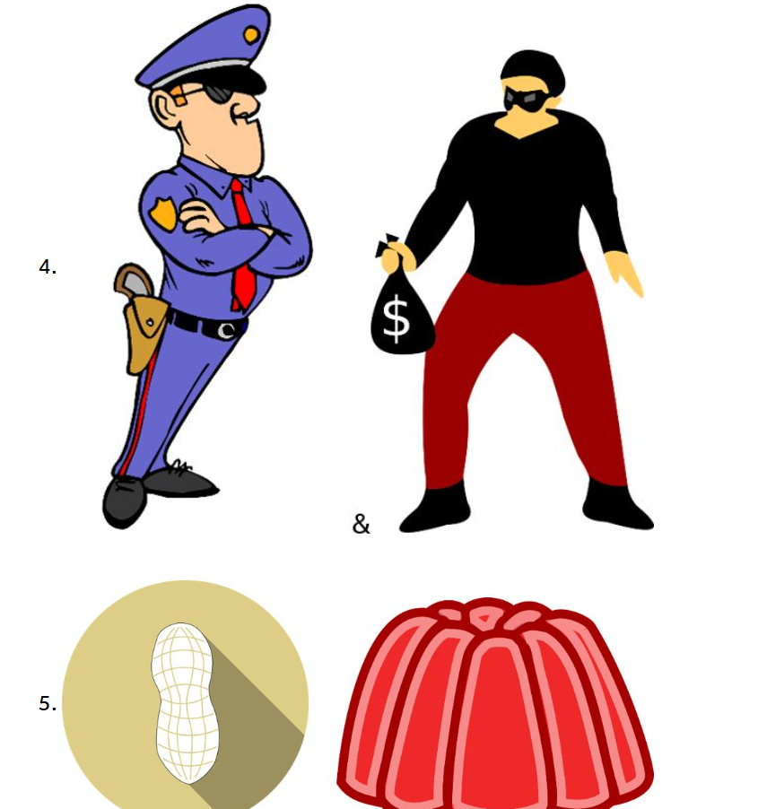

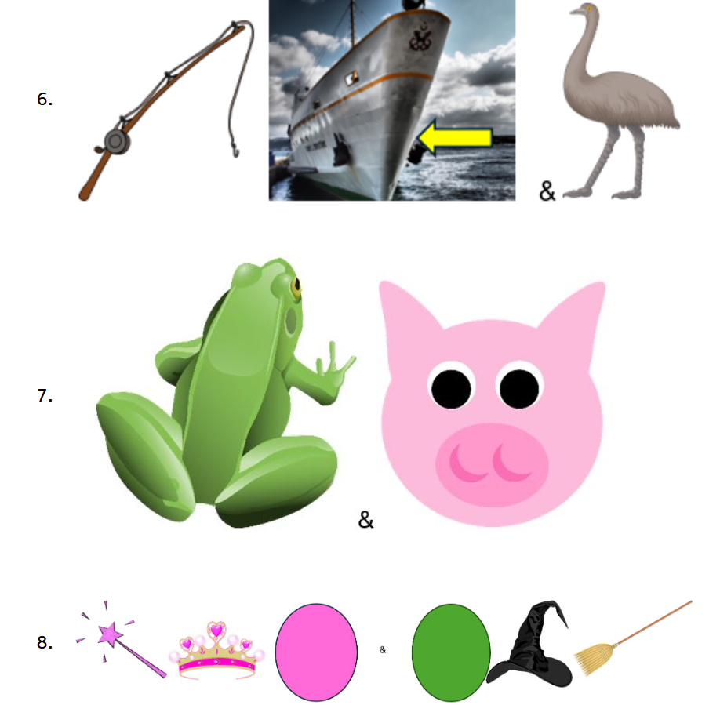

Answers
- Woody & Buzz lightyear
- Batman & Robin
- Ant & Dec
- Cops & Robbers
- Peanut & Jelly
- Rodd Hull & Emu
- Kermit the frog & Mrs Piggy
- Galinda & Elphaba

