HASSRA 1% Club
- When the number 777,777 is written out in words, how many times does the letter 'e' appear?

- 10
- 12
- 14

- John Smith is trying to come up with a stage name to launch his acting career. He is going to use his mother’s maiden name, the name of a shape, and a number. Which of the following must be John’s new name?

- Star Johnson Sims
- Triangle Carter Moon
- James Oval Seven

- Looking at this image, logically, what should fill in the dog’s speech bubble?

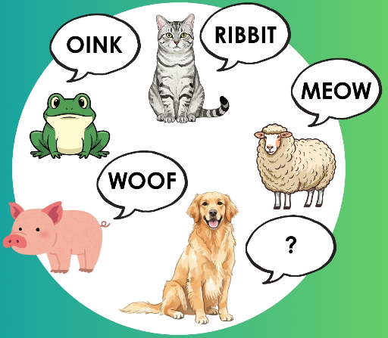

- Baa
- Tweet
- Moo

- 

Jane, Mike, Tess and Joe in that order took turns counting up to the number 25, each saying one number at a time, who said the number 25?

- Jane
- Mike
- Tess
- Joe
- What ingredient is definitely m?issing from Grandma’s Cookie recipe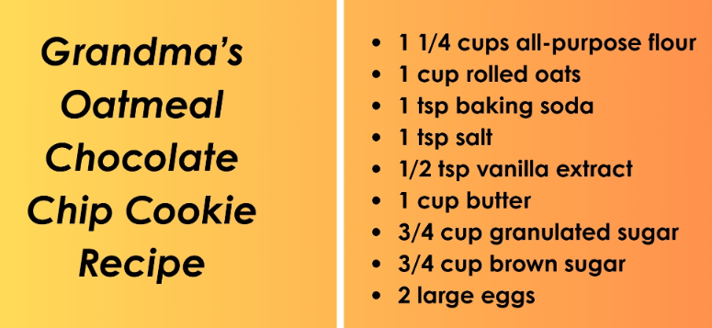

- Almond extract
- Raisin
- Choc Chips
- Cinnamon

- Which of the following words should go in the third shape? 

- Triangle
- Ketchup
- Love
- Hat

- If BZAAZFD is code for CABBAGE, what vegetable is STQMHO code for?
- Spinach
- Turnip
- Radish
- Broccoli

- If yellow = 10, orange = 20, pink = 30, and blue = 35, which of these targets adds up to the most points?

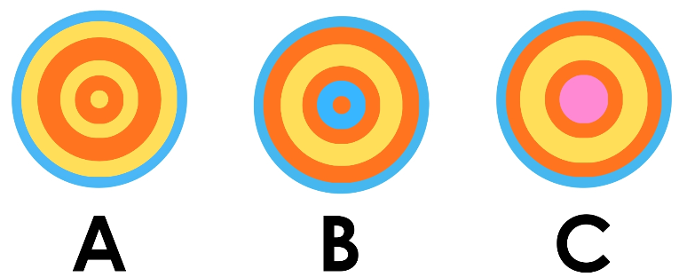

- We are adding another Star to this group. Logically which of these names should replace the question mark?
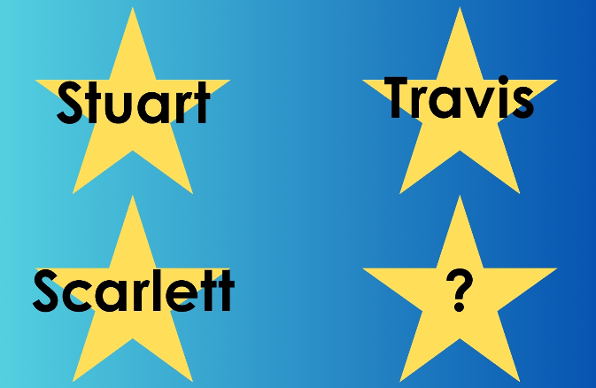
- Cynthia
- Nicholas
- Astrid
- Mikey

- 14
- James Oval Seven
- Baa
- Jane
- Choc Chips
- Love
- Turnip
- B = 140
- Astrid

