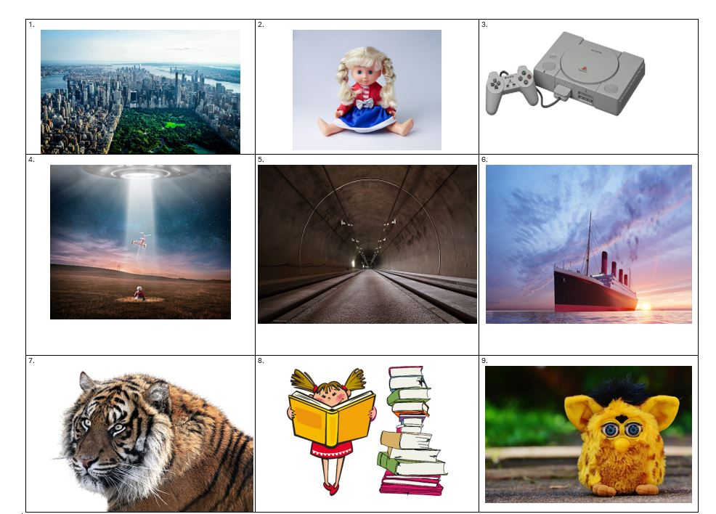

- What was the name of the coffee shop in 'Friends'?
- What was the name of the first cloned sheep, born in 1996?
- What was the bestselling video game console of the 1990s?
- Which 90s movie featured a young boy who befriends an alien?
- Which thoroughfare opened in 1994 connected Britain to France?
- Which movie featured the character, the character Jack Dawson?
- Which young golfer won his first master’s tournament in 1997?
- Which 90s movie featured a young girl who had telekinetic powers written by Roald Dahl?
- What fad toy was feared to be a tool for foreign spies?

Answers
- Central Perk
- Dolly
- PlayStation
- ET
- The Channel Tunnel
- Titanic
- Tiger Woods
- Matilda
- Furby

