Puzzle Number 20 – Rhyme Time
Two set of clues – and the answers must Rhyme!

- 

- 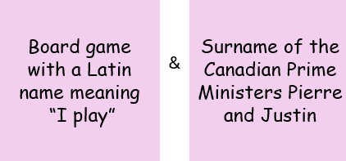

- 

- 

- 

- 

- 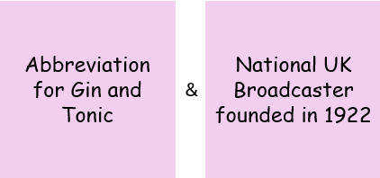

- 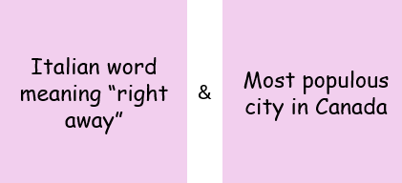

- 

Answers
- Great & Kate
- Ludo & Trudeau
- Dirrty & Thirty
- Disco & San Franciso
- Running up that Hill & Jack n Jill
- Prime & Thyme
- G&T & BBC
- Pronto & Toronto
- Noah’s Ark & Denmark

