Congratulations to all our HASSRA Heroes for Quarter One. Winners, Runners Up and Nominees

 Winner – Rebecca Lewis
Nominees - Catherine Munns, Warren Gardner, Claire Tong, Debbie Ballard

 Nominees – Rachel Grognet, Andrea Edge, Nikki Gallop

 Runner Up - Sohel Ahmad
Nominees – Clive Taylor, Sharon Finan, Michelle Phillip, Felicia Ogunnowo, Teresa Allen, Jennifer Ansa Emim, Lorraine Dowe, Maxine Fields

 Nominee - Elaine Bates

 Runner Up - Suzanne Robinson
Nominees – Paula Quinn, Tracy Hay

 Nominees - Evelyn Mcilhinney, Allan Houston, Clare Tully

 Nominees – Clint Williams, Jane O'Donoghue, Julie Savage

 Nominees – Rachel Evans, Martin Sinfield, Louise Diamond, Hollie Riste, Sue Davies, Claire Williams, Dean Roberts, Carley Jones

 Nominees – Helen Wilkinson, Anne White, Teina Myatt, Louise Gibson, Julie Garbett

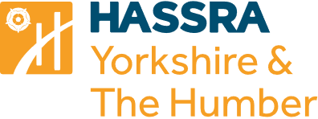 Nominees – Ros Wilkinson, Patricia Lamswood, Linda Ward, Fran Ross, Lyndsey South

